Sequences & Series
Your Own Reality Series Project Name: ________________________


Intro:

Would you like to create your own reality series? What would you do? What kinds of people or things might be involved? Maybe you could focus on seats in a theater or the distance a ball travels when it bounces. What’s that? You thought this project was going to be about a television reality series? Sorry, this project focuses on arithmetic and geometric series (and sequences). In some cases, this might be more interesting than what you find on television!

Objective:

To recognize and analyze an arithmetic and geometric series that arises in real life.

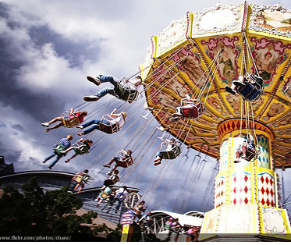
Examples:

· Depreciation of a car can be an arithmetic sequence if the car depreciates by a certain dollar amount every year. The sequence becomes geometric if the car depreciates by a percentage each year.

· Investments can be represented by arithmetic sequences or series if a set dollar amount is added at given intervals.


· If salary increases are given at a particular percentage per year, a geometric sequence can be used.

· It is also interesting to calculate the distance traveled by a ball as it bounces. If a ball bounces to 80% of its previous height, you can use this as the common ratio to evaluate the geometric series. Be sure to take into account the distance up and down between each bounce.

· An athlete in training might add a set distance to each workout. An arithmetic series can be used to calculate the total distance after one month of training.

About:
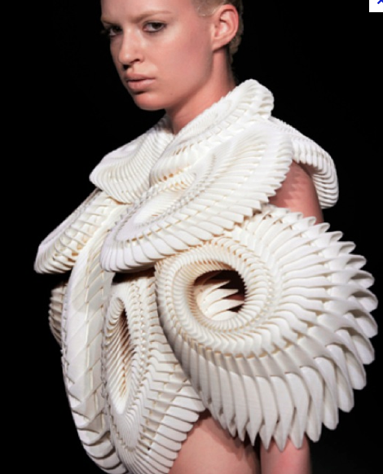
In our studies of Sequences and Series, we discussed many topics about arithmetic and geometric sequences and series. You have seen how to find the nth term, write the general term formula and find the sum of each type of series. You learned that a geometric series can be finite or infinite and depending on the common ratio, the series might have a partial sum or it might not. Now you can use these concepts in real-life scenarios.

Task:


Your task is to choose at least one situation that is arithmetic and one that is geometric. If you wish, search the Internet for real-life scenarios to help you get started. If you choose to use something you find during your research, be sure to change the numbers to make your application unique. Find something fun that you find interesting. Whether it is investment related, physics related, or something else entirely, choose what interests you most to make your own reality series!

Rules:
You must include the following:

· A real-life arithmetic and geometric series. You must have
at least one of each type for this project.

· Research (Include any research you did to discover the real-life applications of sequences and series. If you created the real-life applications yourself, explain your thinking. If you used ideas from other sources, show how you changed the terms, common difference, or common ratio to make your application unique.)

· Diagrams or pictures (Include a diagram or picture of the situations you have chosen. Either write out the 1st several terms, or use pictures to represent what is taking place. For example, if a ball is bouncing you might want to show the distance traveled in the 1st several bounces.)

· Formulas: Write the general term formula for each sequence in the series. Calculate the sum of a selected amount of terms and describe the meaning of the calculation.

· Show what you know! Make up your own word problem about one of the sequence/series and provide the solution.

Final Copy:
For the good copy use an 11 x 17 sheet of paper that is provided. Do not hand in a larger or smaller poster.
Due Date: ________________

Assessment:

 | Beginning | Developing | Accomplished | Exemplary
Arithmetic Sequence/ Series | Three or more components are missing | Two components are missing but the rest are fully included | All components are correctly included – but briefly explained OR one component is missing and the rest are fully included | All components are correctly included – detailed and thorough
- Real world arithmetic sequence
- Description of it’s connection to the real world
- General term formula
- Sum of a specific amount of the arithmetic series is calculated
- Description of the meaning of that sum in context to the real world
Geometric Sequence/  Series | Three or more components are missing | Two components are missing but the rest are fully included | All components are correctly included – but briefly explained OR one component is missing and the rest are fully included | All components are correctly included – detailed and thorough
- Real world geometric sequence
- Description of it’s connection to the real world
- General term formula
- Sum of a specific amount of the geometric series is calculated
- Description of the meaning of that sum in context to the real world
Word Problem | Problem is created and solution is given OR a variety of errors were made | Word problem is created and a solution is provided – errors made throughout or one major error was made | Word problem that is related to the real world sequence/series is created and an accurate solution is provided – minor errors made | Word problem that is related to the real world sequence/series is created and an accurate solution is provided
Images | No images are provided or they do not display a connection between the series and the real world | One image is shown and displays a connection between the series and the real world | Two images are shown but one may not display a connection between the series and the real world | An image is shown for both the arithmetic series and geometric series and displays a connection between the series and the real world
Clarity | In sentence format and/or very disorganized | Point form but somewhat disorganized | Short point form and organized | Detailed but still in point form and very organized
Sources | Citations page included but barely filled out | Website and a couple of pictures are cited  Several blanks in citations | Websites and most pictures correctly cited (one or 2 blanks in citations) | Websites and all pictures correctly/fully cited

