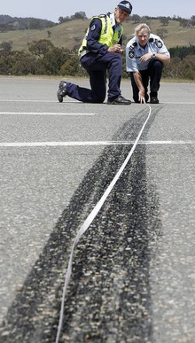
Radical Equations in the Real World
Poster/Movie Project Name: ____________________

Intro:

Radical equations can be used to model a variety of relationships. This project will allow you to review the main concepts involve in this unit and recognize the use of radical equations in the real world.

Task:

Your task is to create a poster or video for other grade 11 students that reviews the main concepts learned during this unit.


# 1: Explain in your own way 2 of the following concepts (you will benefit most from choosing the concepts you struggled with during the unit!):

a) Converting between mixed and entire radicals
b) Comparing and ordering radicals
c) Simplifying radical expressions using addition and subtracting
d) Multiplying radical expressions
e) Dividing radical expressions
f) Rationalizing the denominator
g) Identifying restrictions

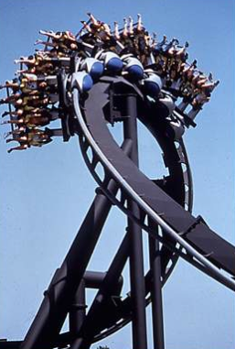
# 2: Research 2 equations in the real world that involve square roots. For each equation include the following:
- An explanation of who uses the formula and why it is used
- What the variables represent including units
- Two images
- Two questions that involve the equation
- Step by step solution to both questions with captions to identify key steps
- Sentences to answer each of the questions

Examples:

· Meteorologists use formulas that involve square roots and cube roots to help describe and predict weather patterns.

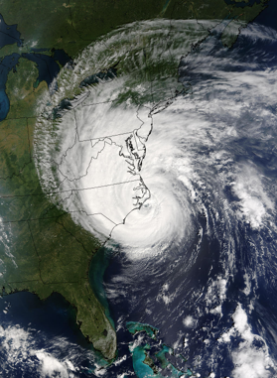
· Medical practitioners use a BSA (Body Surface Area) formula to determine the correct chemotherapy dosage to ensure optimal treatment and to prevent chemotherapy under dosing or overdosing.

· Police use a square root formula to calculate the speed a vehicle was travelling prior to an accident.

· Engineers of amusement park rides use a variety of physics formulas that involve square root and cube roots.

· Drag racers use formulas to calculate the power of a race car at a specific speed.


Final Copy:

Due Date: Day 1: February 19th
Day 2: Febraury 20th

Assessment:

 | Beginning | Developing | Accomplished | Exemplary
Radical Concepts | Three or more components are missing | Two components are missing but the rest are fully included | All components are correctly included – but briefly explained OR one component is missing and the rest are fully included | All components are correctly included – detailed and thorough for 2 concepts
- Concepts Identified
- Detailed step by step instructions provided for each
- Simple example provided for each
- Difficult example provided for each
Real World Radical Equation | Three or more components are missing | Two components are missing but the rest are fully included | All components are correctly included – but briefly explained OR one component is missing and the rest are fully included | All components are correctly included – detailed and thorough
- A detailed explanation of who uses the formula and why it is used
- What the variables represent including units
- Two images
- Two questions that involve the equation
- Step by step solution to both questions with captions to identify key steps
- Sentences to answer each of the questions
Real World Radical Equation | Three or more components are missing | Two components are missing but the rest are fully included | All components are correctly included – but briefly explained OR one component is missing and the rest are fully included | All components are correctly included – detailed and thorough
- A detailed explanation of who uses the formula and why it is used
- What the variables represent including units
- Two images
- Two questions that involve the equation
- Step by step solution to both questions with captions to identify key steps
- Sentences to answer each of the questions
Clarity | Little to no use of titles, sections, color, images | Some titles are used  Some unclear sections  Images don’t relate to questions  Colour used but doesn’t relate well to the math steps | Most titles included  Sections made clear  Images are clear  The use of color is effective in showing the mathematical steps to a solution with minor errors | Clear titles and sections  Logical flow  Images stand out  The use of color is effective in showing the mathematical steps to a solution
Sources | Citations page included but barely filled | Website and a couple of pictures are cited  Several blanks in citations or many errors in citations | Websites and most pictures correctly cited (one or 2 blanks in citations) or citations have minor errors | Websites and all pictures correctly/fully cited

