Polynomial Study Guide!! **KEY**

**Polynomial Terminology:**

|  |  |  |
| --- | --- | --- |
| **Expression** | **How many terms do I have?** | **What’s my name?** |
| 4xy + 3 | **2** | **binomial** |
| 7a2 – 2ab + b2 | **3** | **trinomial** |
| 5x2 + y2 + z2 - x - 6 | **5** | **polynomial** |
| 13 | **1** | **constant** |
| 5j2 | **1** | **monomial** |
| 3 – m2 | **2** | **binomial** |
| ab2 – ab + 1 | **3** | **trinomial** |

**Degree of Polynomials:**

|  |  |
| --- | --- |
| **Expression** | **Degree** |
| 5x2 + 3 | **2** |
| 5x + z - 6 | **1** |
| 7 | **0** |
| 7a2 -2ab +b2 | **2** |

**Adding Polynomials Using Algebra Tiles:**

Ex. Add 2x + 1 and 3x – 2

 + 🡪 

Try: (2x – 1) + (6 – 4x) using models

 + =  = -2x + 5

**Adding Polynomials Algebraically (Combing Like Terms):**

Simplified the following expression by combining like terms:

1. 

**-x2 + 5x -1**

2. 

**4x2 + 2xy**

**Subtracting Polynomials Algebraically:**

Subtract the following algebraically:

1. (5x2 – x + 4) – (2x2 – 3x – 1)

**3x2 + 2x + 5**

1. 

**-2x2y2 + 12x2y – 9xy2**

**Multiplying Polynomials:**

**1.** Write a monomial multiplication statement for each set of algebra tiles.

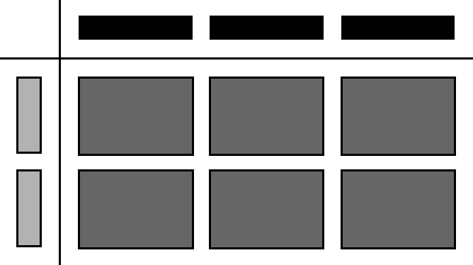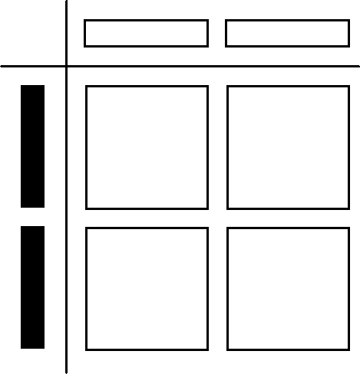**a)** **b)**

**(2x)(-2x) (2x)(3y) or (3y)(2x)**

**2.** Determine the product of each pair of monomials.

**a)** (–4*x*)(2*x*) **d)** (6*m*)(–0.2*m*) **e)** 

**-8x2 -1.2m2 8n2**

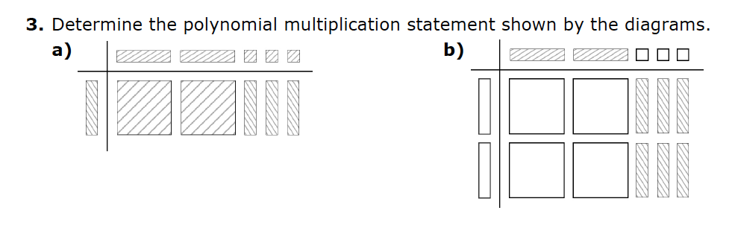

(

**(2x+3)(x)**

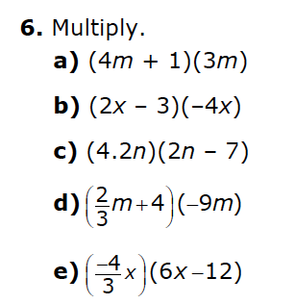  **(2x-3)(-2x)**

1. **12m2 + 3m**
2. **-8x2 +12x**
3. **8.4n2 – 29.4**
4. **-6m2 -36m**
5. **-8x2+16x**

**Dividing Polynomials:**

**1.** Write a monomial division statement for each set of algebra tiles.

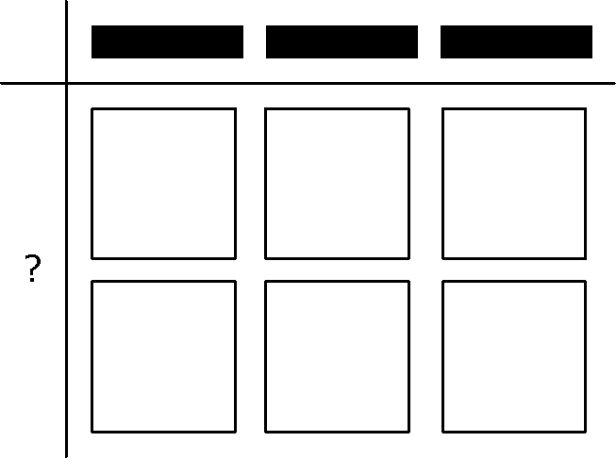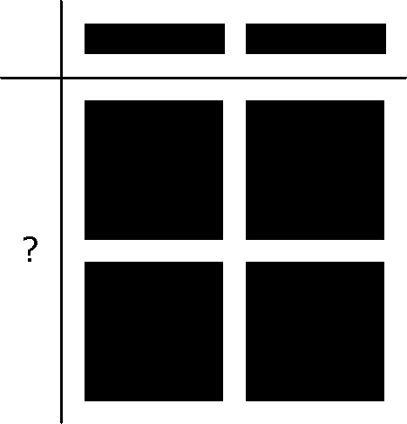**a)** **b)**

$$\frac{{4x}^{2}}{2x}=2x$$

$\frac{{-6x}^{2}}{3x}=-2x$

**2.** Determine the quotient of each pair of monomials.

**a)**  **b)** 

**-2x $\frac{{3y}^{}}{2}$**

**3.** What polynomial division statement is represented by the algebra 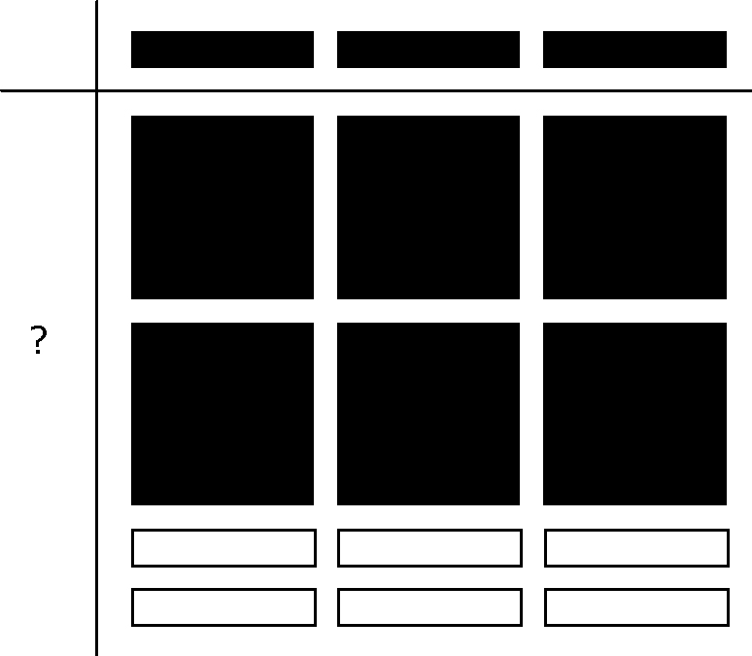tiles? Determine the quotient.

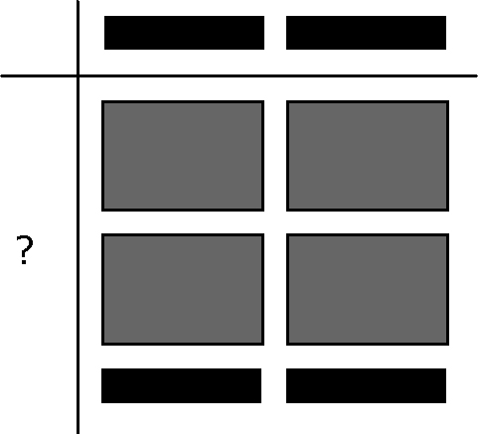**a)**  **b)**

**4xy + 2 ÷ 2x = 2y + 1**

**6x2 – 6 ÷ 3x = 2x - 2**

**4.** Divide.

**a)**  **b)**  **c)** 

**3x – 4 4m + 5n -3c2 + 4c - 2**

**Word Problems:**

1. A rectangle has a width that is 3 m longer than 4 times its length. Write an expression for the area of the rectangle. Simplify your answer.

w = 4l + 3

A = lw

A = l(4l + 3) = **4l2 + 12l**

1. Write an expression for the volume of a rectangular prism if its length is (2x+4), its width is 2x and its height is 5. Simplify your expression.

**V = (2x + 4)(2x)(5)**

**= 10x(2x + 4)**

**= 20x2 + 40x**

1. A rectangular lawn has a width of 3*x* m. The area is 15*x*² + 45*x* m². You wish to put a fence around the lawn.
2. What is an expression to represent the perimeter of the lawn?

L = A ÷ w = $\frac{{15x}^{2}+45x}{3x}$

= 5x + 15

P = 2l + 2w = 2(5x +15) + 2(3x) = 10x +30 + 6x = **16x +30**

b) You are placing a post every 2 m. Find an expression to represent how many posts will be required.

Number of posts = $\frac{16x+30}{2}$

**= 8x + 15**