Polynomial Study Guide!!

**Polynomial Terminology:**

|  |  |  |
| --- | --- | --- |
| **Expression** | **How many terms do I have?** | **What’s my name?** |
| 4xy + 3 |  |  |
| 7a2 – 2ab + b2 |  |  |
| 5x2 + y2 + z2 - x - 6 |  |  |
| 13 |  |  |
| 5j2 |  |  |
| 3 – m2 |  |  |
| ab2 – ab + 1 |  |  |

**Degree of Polynomials:**

|  |  |
| --- | --- |
| **Expression** | **Degree** |
| 5x2 + 3 |  |
| 5x + z - 6 |  |
| 7 |  |
| 7a2 -2ab +b2 |  |

**Adding Polynomials Using Algebra Tiles:**

Ex. Add 2x + 1 and 3x – 2

 + 🡪 

Try: (2x – 1) + (6 – 4x) using models

**Adding Polynomials Algebraically (Combing Like Terms):**

Simplified the following expression by combining like terms:

1. 

2. 

**Subtracting Polynomials Algebraically:**

Subtract the following algebraically:

1. (5x2 – x + 4) – (2x2 – 3x – 1)

1. 

**Multiplying Polynomials:**

**1.** Write a monomial multiplication statement for each set of algebra tiles.

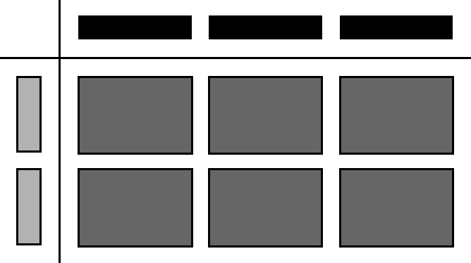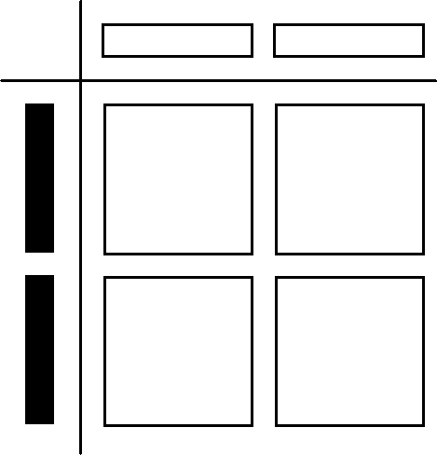**a)** **b)**

**2.** Determine the product of each pair of monomials.

**a)** (–4*x*)(2*x*) **d)** (6*m*)(–0.2*m*) **e)** 

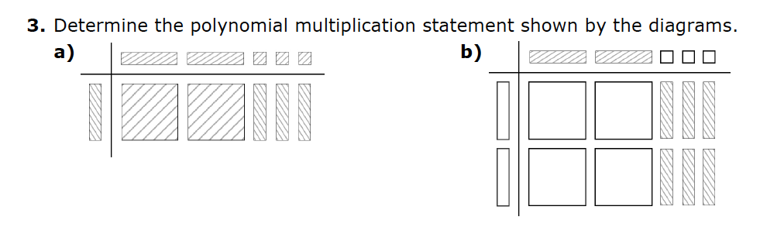

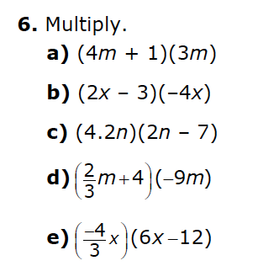

**Dividing Polynomials:**

**1.** Write a monomial division statement for each set of algebra tiles.

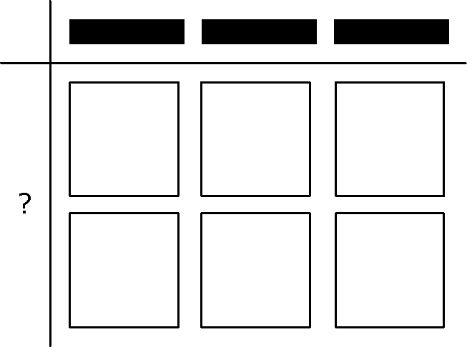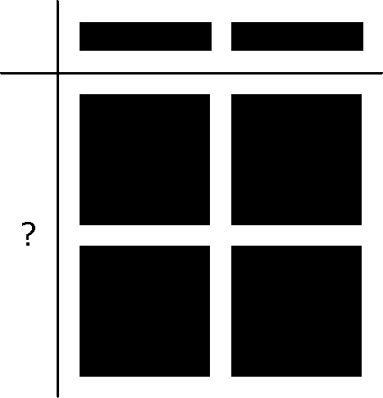**a)** **b)**

**2.** Determine the quotient of each pair of monomials.

**a)**  **b)** 

**3.** What polynomial division statement is represented by the algebra tiles? Determine the quotient.

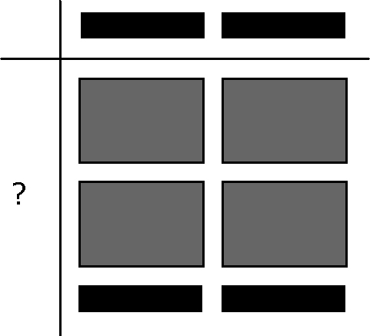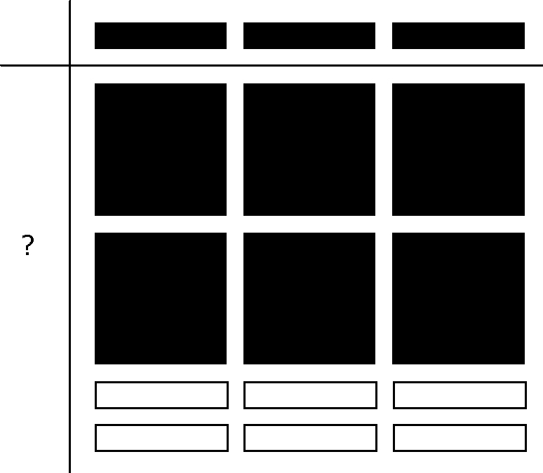**a)**  **b)**

**4.** Divide.

**a)**  **b)**  **c)** 

**Word Problems:**

1. A rectangle has a width that is 3 m longer than 4 times its length. Write an expression for the area of the rectangle. Simplify your answer.
2. Write an expression for the volume of a rectangular prism if its length is (2x+4), its width is 2x and its height is 5. Simplify your expression.
3. A rectangular lawn has a width of 3*x* m. The area is 15*x*² + 45*x* m². You wish to put a fence around the lawn.

a) What is an expression to represent the perimeter of the lawn?

b) You are placing a post every 2 m. Find an expression to represent how many posts will be required.