*Pre-calculus 11 Review Name: _______________________________________*

**REVIEW 1: SOLVING LINEAR EQUATIONS**

What is a linear equation?

Some examples are:

When solving a linear equation we must follow these steps:

1. Simplify. Get rid of any brackets and group like terms on the same side of the equals.
2. Group your variables together by adding/subtracting to one side.
3. Perform BEDMAS backwards to get the variable all alone.
4. Check your solution by plugging back into the equation form the beginning.

In each of the following examples, solve for the unknown, and check your solution.

1.  b) 



c)  d) 

**REVIEW 2: THE EQUATION OF A LINE**

A line is a relation between an **input (x)** and its **output (y).**

A line always has a **degree** of ____ (recall: **degree** is ____________________________________________ )

Any line has a slope. The slope (m) of a line can be found using:

There are 3 forms for the equation of a line:

1. Slope-Intercept form: where: m =

b =

1. Slope-Point form: where: m =

 =

1. General form:

To graph a line you only need to know 2 points!

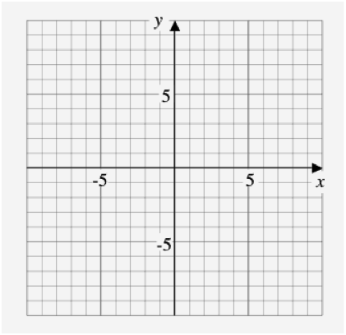

Ex 1. Graph the line 

Ex 2. Graph the line 



Ex3. Write the equation of a line with:

1. slope -7 and y-intercept 
2. slope 1 passing through the point (-1,5)
3. passing through the points (4,5) and (1,6)
4. y-intercept 4 and x-intercept -2

**PRACTICE: Complete Review of Math 10: y = mx + b**