**Chapter 8: Systems of Equations**

1. Examine each system of equations and ***match it*** with a possible sketch of the system. You do not need to solve the systems to match them.

**I)**  ___________

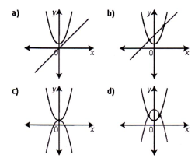

**II)**  ___________

**III)**  ___________

**IV)**  ___________

1. Solve the system of linear-quadratic equations graphically. Express your answer(s) to the nearest tenth.

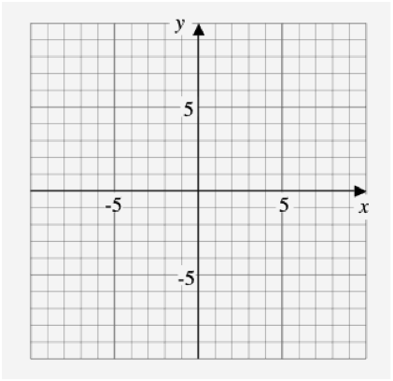



1. Given the quadratic function  and the linear function  , determine all the possible values of *b* that would result in a system of equations with:

**a)** two solutions

**b)** exactly one solution

**c)** no solution

1. The price, *P*, in dollars, per share, of a high0tech stock has fluctuated over a 10-year period according to the equation , where *t* is time, in years. The price of a second high-tech stock has shown a steady increase during the same time period according to the relationship . Algebraically determine for what values the two stock prices will be the same.
2. Explain how you could determine if the given system of quadratic-quadratic equations has zero, one, two, or an infinite number of solutions without solving or using technology.



1. Algebraically determine the solution(s) to each system of quadratic-quadratic equations.

**a)**  **b)** 

**Chapter 9: Linear & Quadratic Inequalities**

1. Match each inequality with its graph.

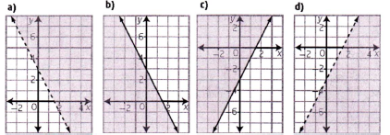

**I)**  _________ **II)**  _________

**III)**  _________ **IV)**  _________

1. Write an inequality to describe each graph, given the function defining the boundary parabola.

**a) b)**

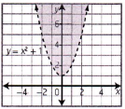 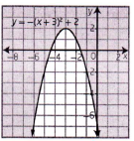

1. Explain how each test point can be used to determine the solution region that satisfies the inequality 

**a)** (0, 0)  **b)** (2, -5) **c)** (-1, 1)

1. What linear inequality is shown in the graph?

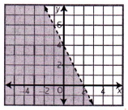

1. Sketch the graph of  . Use a test point to verify the solution region.



1. Use sign analysis to determine the solution of the quadratic inequality .
2. Suppose a rectangular area of land is to be enclosed by 1000 m of fence. If the area is to be greater than 60 000 , what is the range of possible widths of the rectangle?