**7.4: Reciprocal Functions (day 2)**

**Objectives:**

* Determine any vertical asymptotes for a reciprocal function.



* Graph a reciprocal of a given function.



**Ex.1:** Consider 



(a) Determine its reciprocal function 



(b) Determine the equation of the vertical asymptote of reciprocal function.

(c) Graph both  and .

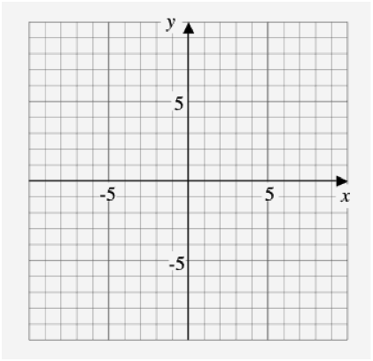



* Check on your graphing calculator

**Graphing reciprocal functions:**

1. Graph the function . Mark the x-intercept(s) and points where  (**invariant points**).
2. Mark the **vertical asymptotes** of the reciprocal function at the x-intercepts.
3. Create the graph through the invariant points tending towards the vertical asymptotes and the x-axis. Check with a table of values or graphing calculator if needed.

**Ex.2:** Consider 

1. What is the reciprocal function of ?
2. State the non-permissible values of x and the equation(s) of the vertical asymptote(s) of the reciprocal function.
3. What are the invariant points where  ?
4. Graph the function and its reciprocal.







**Ex.3:** Given the graph of a reciprocal function of the form :



(a) Sketch the graph of the original function .

(b) Determine the original function .



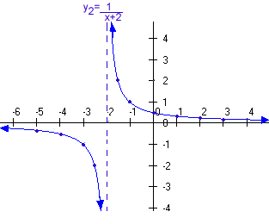



Assignment: Pg. 403 – 406 # 2, 4, 6, 7(a,c), 8(a,c), 9, 10, 11