**5.1: Working with Radicals (Day 2)**



**Objectives:**

* Identifying restrictions on the values for a variable in a radical expression
* Simplifying radical expressions using addition and subtraction

**Restrictions on Variables**



If a radical represents a real number and has an even index, the radicand must be non-negative. The radical  has an even index. So, 4 – *x* must be greater than or equal to zero.



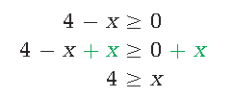

**Isolate the variable by applying algebraic operations to both sides of the inequality symbol.**

The radical  is only defined as a real number if *x* is less than or equal to four. You can check this by substituting values for *x* that are greater than four, equal to four, and less than four.

**Example 1)** State the restrictions on the following radical expressions.

**a)**  **b)** 



***Like Radicals***



Radicals with the same ***radicand*** and ***index*** are called ***like radicals***. When ***adding*** ***and subtracting*** radicals, only like radicals can be combined. You may need to convert radicals to a different form (***mixed or entire***) before identifying like radicals.



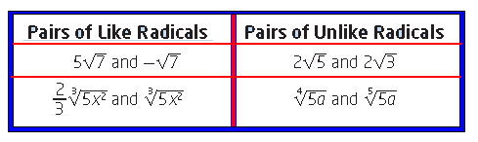

**Add and Subtract Radicals**



**Example 4)** Simplify radicals and combine like terms.

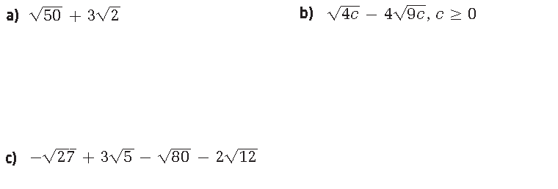



**Example 5)** Consider the following designs shown for a skateboard ramps. What is the exact distance across the base?



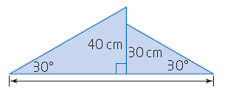 a)

