Lesson 4 Rational Expressions
Solving Equations Involving Rational Expressions

To solve an equation involving a rational expression:
- Factor if necessary;
- Identify the non-permissible value(s);
- Multiply the whole equation by the lowest common denominator (LCD);
- Solve for the unknown.

Eg1. Solve the following.
a) 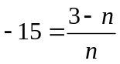 b) 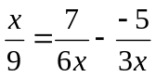

c) 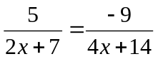 d) 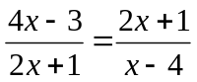

e) 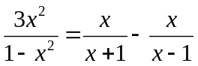 f) 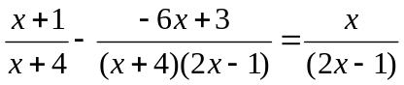

Worksheet L4 #(1, 2)ce, 4ad, 5, 6, 10fg, 11fhi, 13ef

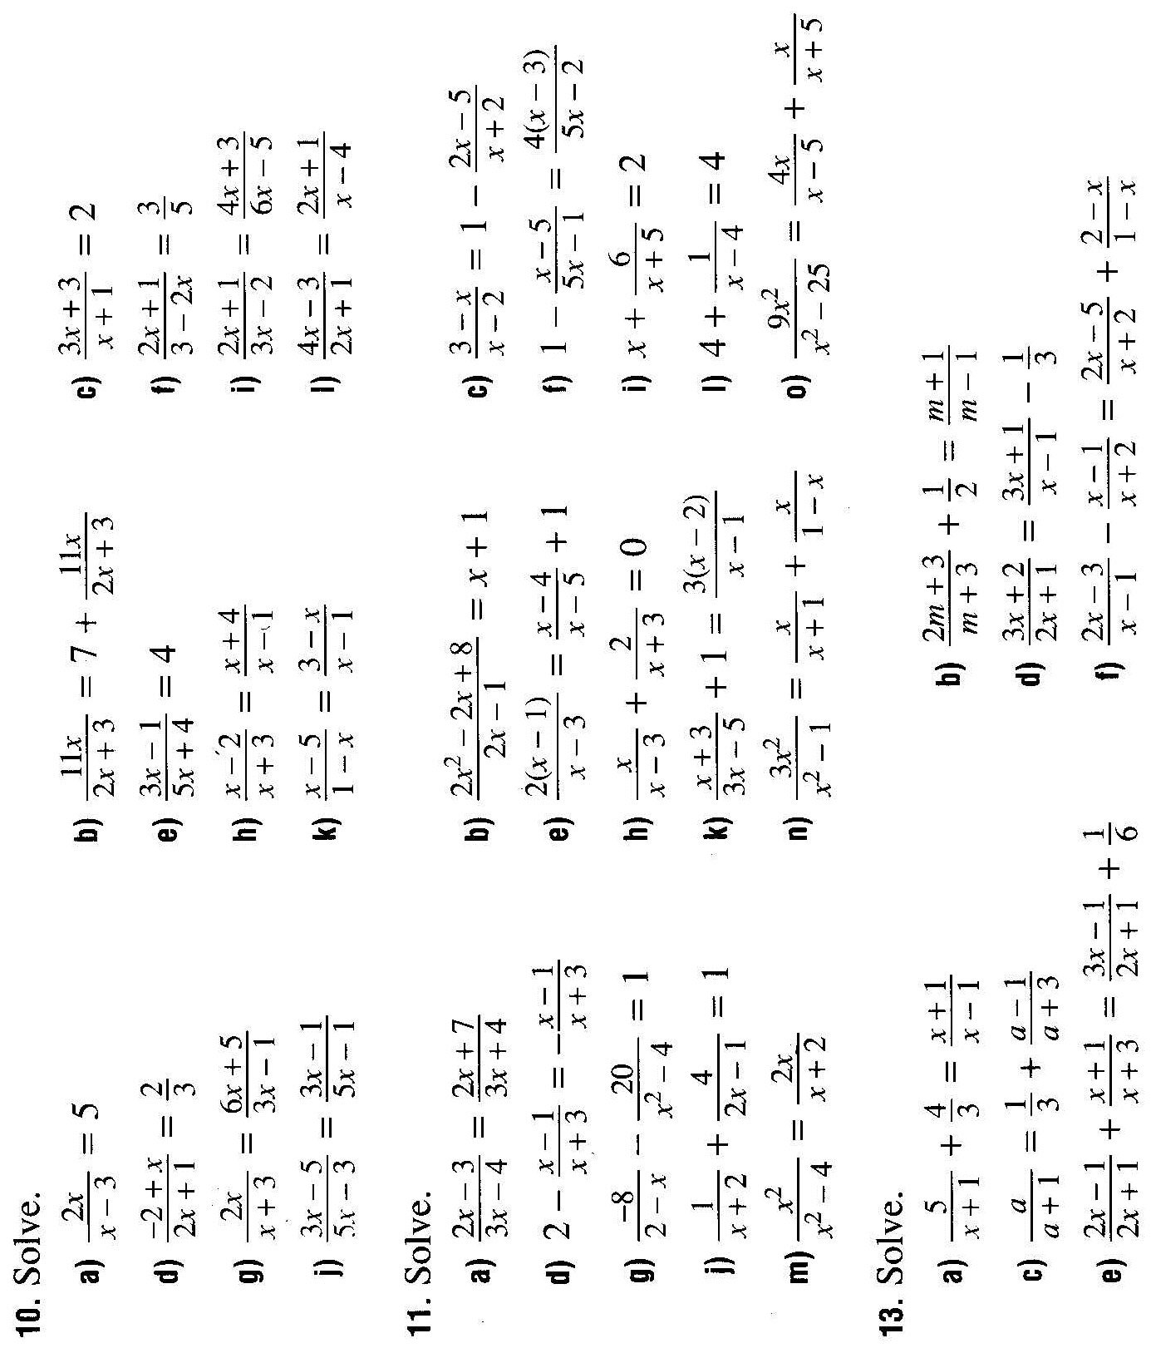
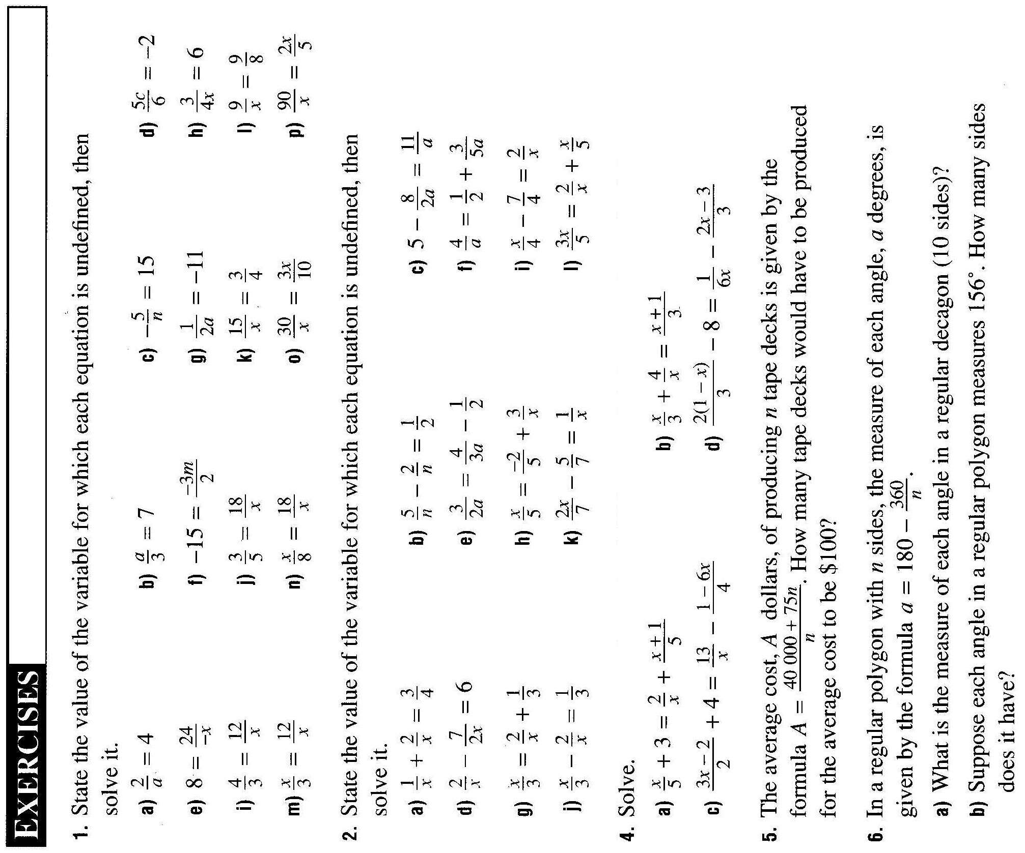Lesson 4 Worksheet
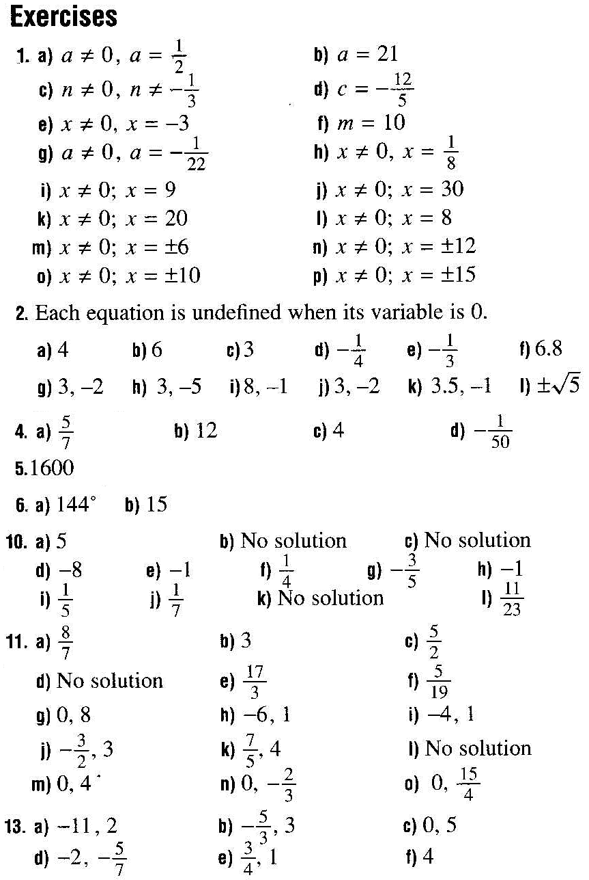

Lesson 5 Rational Expressions
Applications of Rational Expressions

Many problems in reality compare two different objects / methods to complete a task, and very often they involve rational expressions.

Eg1. A hydrofoil travels 120 km in the same time it takes a boat to travel 80 km. The hydrofoil is 10 km/h faster than the boat. Find the speed of the hydrofoil and the speed of the boat, in kilometers per hour.

Let s be the speed of the boat:
 | Speed | Distance | Time
Hydrofoil | s + 10 | 120 | ? →
Boat | s | 80 | ? →

As, and time is fixed (the same), we express “time” in terms of s.
→ = → s = 2 → boat = 2 km/hr, hydrofoil = 12 km/hr.

Eg2. A rectangular poster is to have an area of 6000 cm². If & represent its width and length respectively, write an expression in terms of for:
- the length

- the change in length when the width is increased by 1 cm.

Eg3. Ian swims at 2 km per hour in still water. After swimming down a river for a quarter km, he takes three times as long to return. Find the rate of the current.

Let c be the rate of the current:
 | Speed | Distance | Time
Downstream | 2 + c | 1/4 | ? → (1/4)/(2+c)
Upstream | 2 – c | 1/4 | ? → (1/4)/(2-c)

(1/4)/(2-c) = 3(1/4)/(2+c)

Eg4. Two hoses can fill up the gas tank of a helicopter in 2 min. Using hose A alone, it takes 5 minutes to fill up the tank. How fast can hose B fill up the tank alone?

Let t be the time for hose B to fill up the tank alone.
 | Job | Time | Rate
Hose A | 1 | 2 | I job/5 min
Hose B | 1 | 2 | 1 job/t min

rate x time + rate x time = 1 job
(1/5)2 + (1/t)2 = 1

Read Example 1–3
Worksheet L5 # 1, 4, 6, 7, 9, 10, 13, 14

Lesson 5 Worksheet
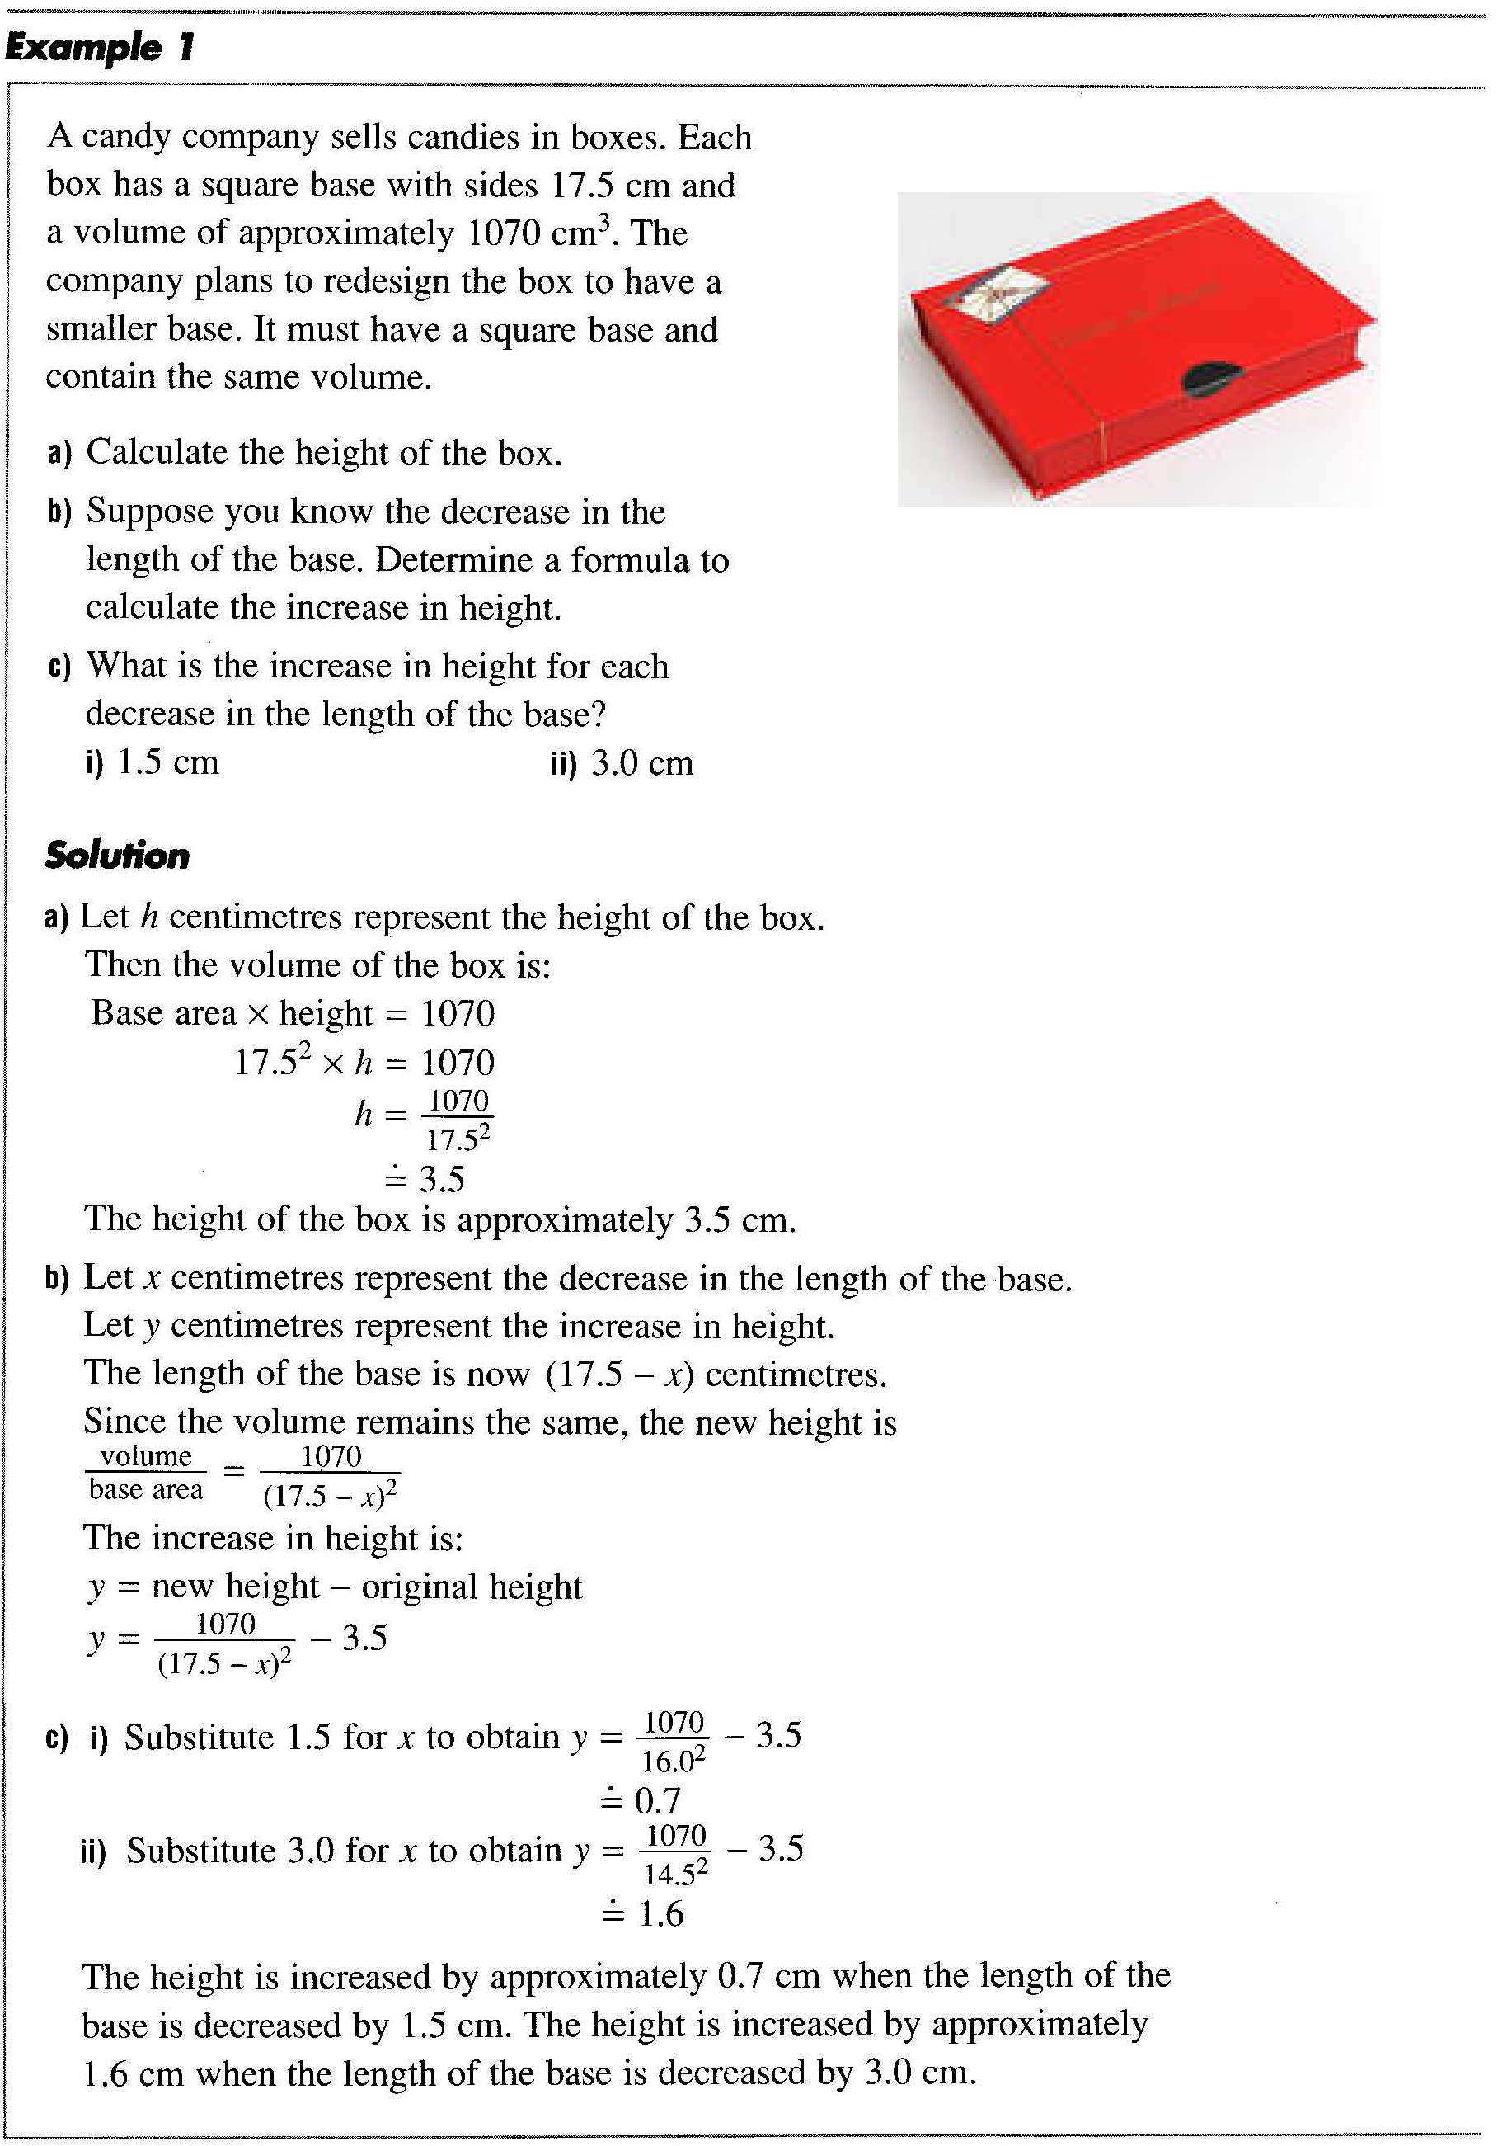
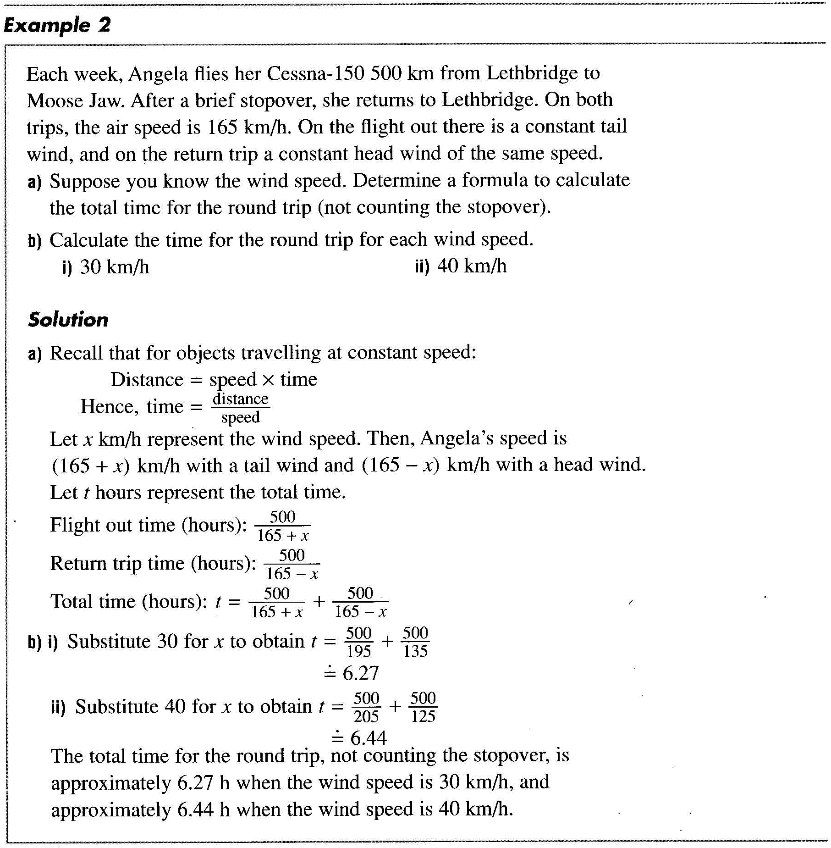
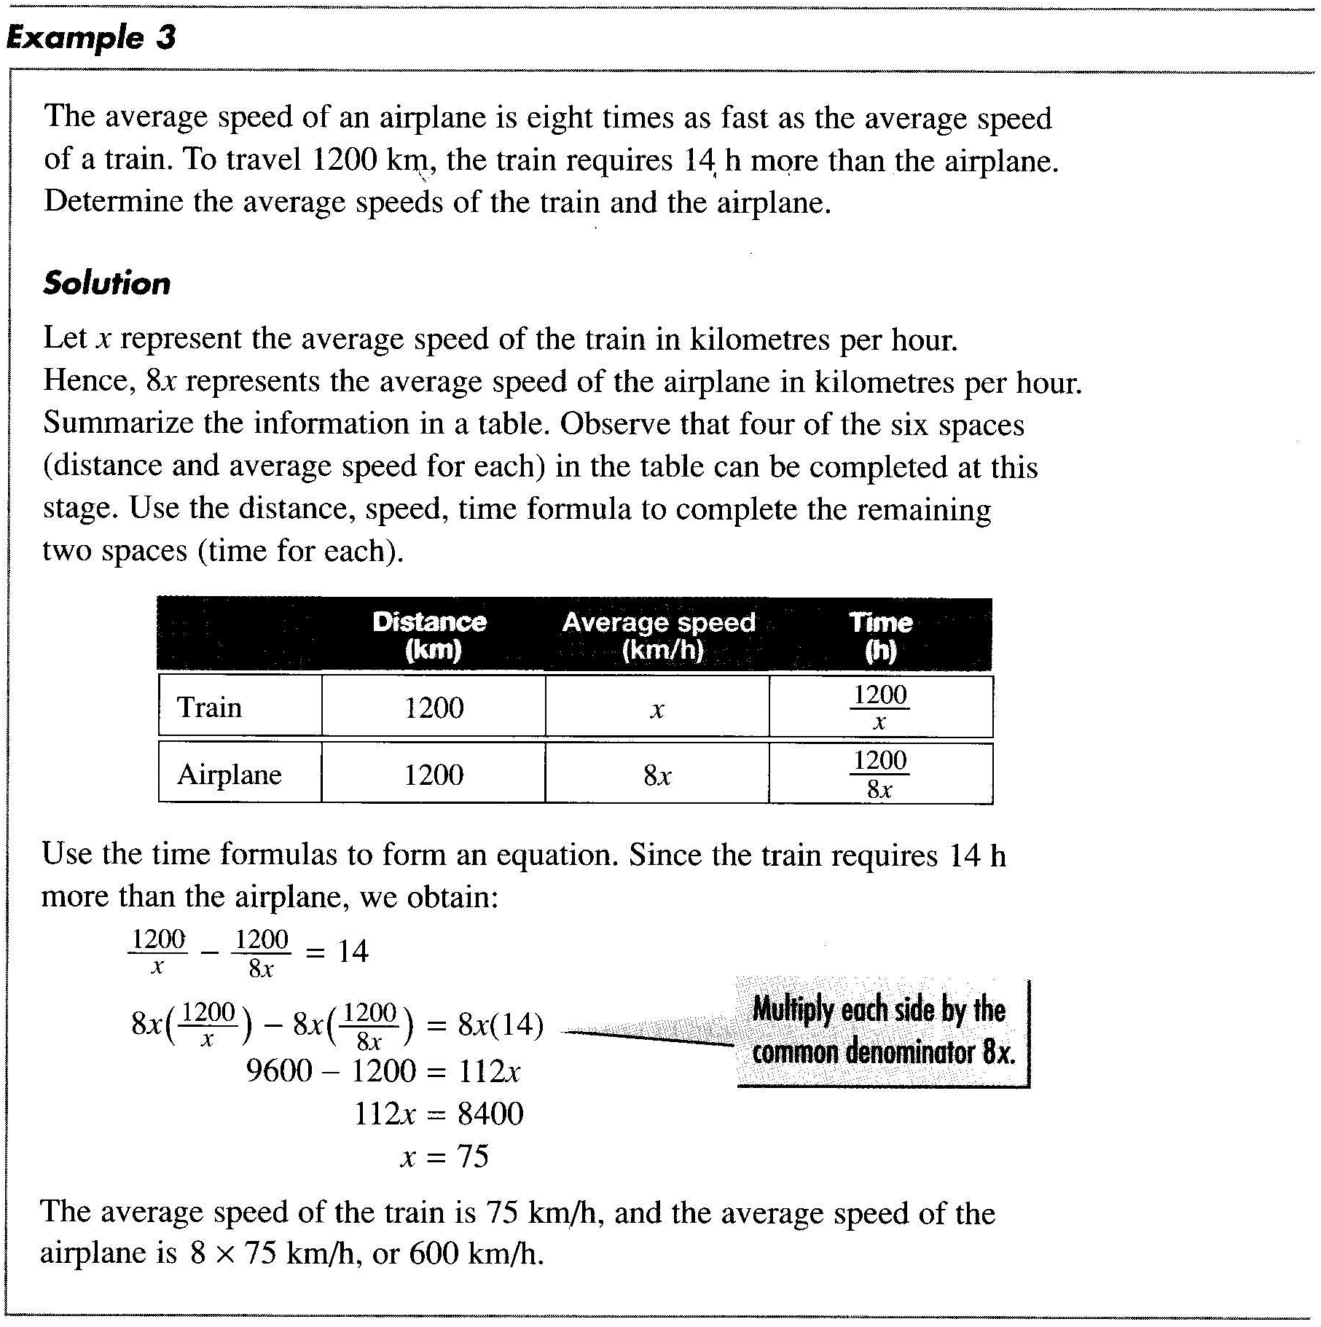

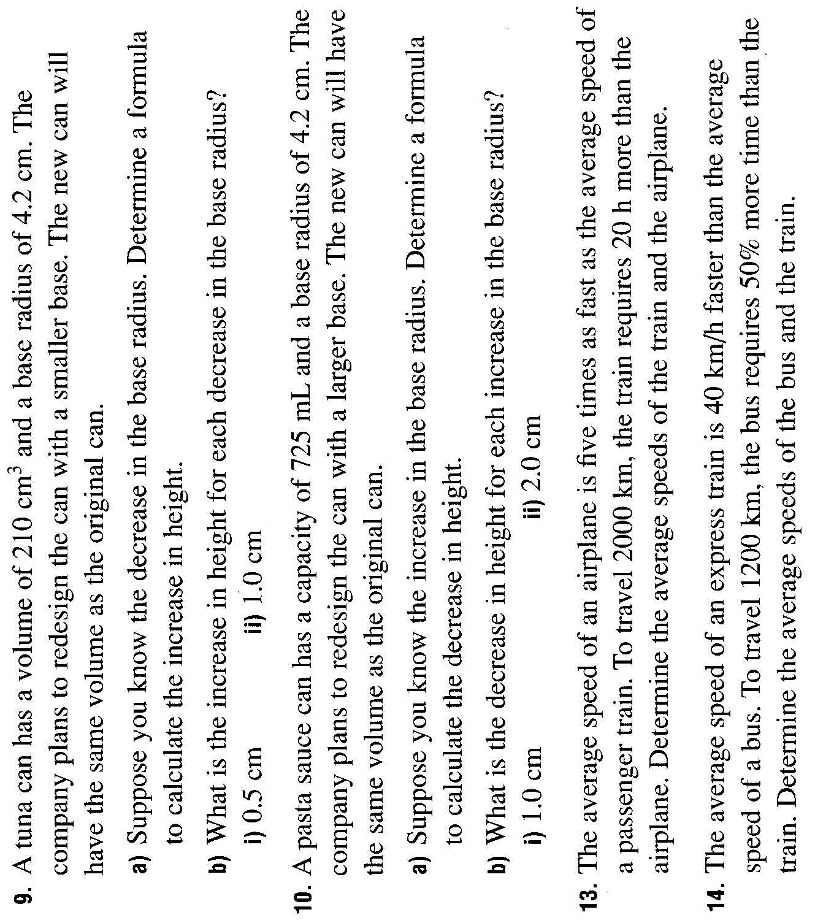  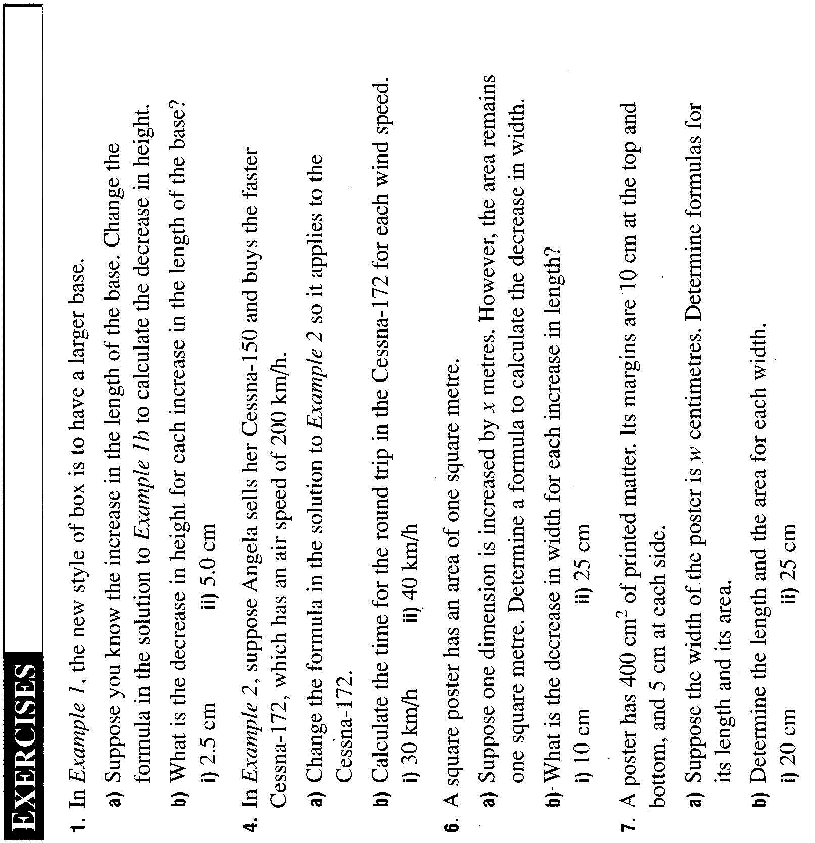 | 

