

## Pre-calculus 11

#### Chapter 3: QUADRATICS FUNCTIONS

**Instructions for Homework**:

* Clearly write your name, class block, and date at the top of your paper.
* Title your page with the textbook section and page #.
* Begin each problem by writing the problem # and copying the question.
* Show all your work clearly. Answers alone will receive no credit.
* Check your own answers in the back of the book with a coloured pen.
* Correct all wrong answers beside your original work. Ask in class or during morning or afternoon extra help times if you need help correcting your own work.

|  |  |  |
| --- | --- | --- |
| **Topics** | **Homework** | **Due Dates** |
| 3.1: Investigating quadratic functions in vertex form (day 1) | DESMOS ASSIGNMENT |  |
| 3.1: Investigating quadratic functions in vertex form (day 2) | Pg. 157 # 1 – 4 (a, c only), 6, 8 – 9 (a, c only), 12, 21 |  |
| 3.2: Investigating quadratic functions in standard form | Pg. 174 # 1, 2, 5, 7, 10, 16, 17 |  |
| 3.3: Completing the Square | Pg. 192 # 3, 5 (a, c), 6, 8a, 9, 12c, 14, 18 |  |

**3.1: Investigating quadratic functions in vertex form (Day 1)**

**Objectives:**

* Define a quadratic function.
* Determine the effects of “p” and “q” on the graph of 

A **quadratic function** is a function of degree 2. (recall: **degree** = highest exponent value).

for example: f(x) = x2 is the simplest form of a quadratic function

In general, a quadratic function is of the form: , where 

Ex. 1: Graph the function  using a table of values.

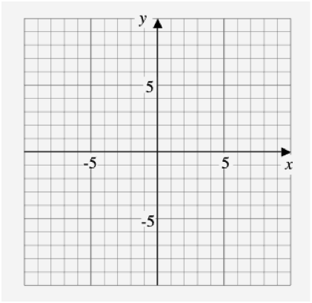



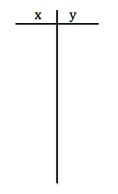



What is the **domain** of this graph?

What is the **range** of this graph?



Definitions:



* **Parabola**: the *shape* of the graph of a quadratic equation



* **Vertex**: the highest (maximum) or lowest (minimum) point of the parabola
* **Axis of symmetry**: the equation of the vertical line that passes through the vertex

(note: vertical line equations are always of the form x = p)

**\* Always graph at least 5 points clearly when graphing a parabola \***



Graphing :

How does q change the graph if y = x2?

Ex. 2: Graph  using a table of values.





State the:

(a) vertex:

(b) equation of the

axis of symmetry:

(c) domain:

(d) range:

Ex. 3: Graph  using a table of values.

State the:

(a) vertex:

(b) equation of the

axis of symmetry:

(c) domain:

(d) range:



Graph both on [www.desmos.com](http://www.desmos.com), how does q change the graph if y = x2?

The “q” value is the *_____________ _________________* of the parabola 

To graph, simply shift the graph of  _____ or __________ by the value of “q”



Graphing :

Ex. 4: Graph  using a table of values.

State the:

(a) vertex:

(b) equation of the

axis of symmetry:

(c) domain:

(d) range:



Ex. 5: Graph  using a table of values.

State the:

(a) vertex:

(b) equation of the

axis of symmetry:

(c) domain:

(d) range:



Graph both on [www.desmos.com](http://www.desmos.com), how does p change the graph if y = x2?

The “p” value is the *_____________________ ____________*of the parabola 

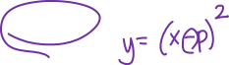

To graph, simply shift the graph of  ____________ or ____________ by the **opposite** value of p.



Ex. 5: Graph  by comparing to the graph of 

State the:

(a) vertex:

(b) equation of the

axis of symmetry:

(c) domain:

(d) range:



Ex. 6: Graph 

State the:

(a) vertex:

(b) equation of the

axis of symmetry:

(c) domain:

(d) range:



Assignment:

1. Insert 6 different  quadratic functions into [www.desmos.com](http://www.desmos.com). Print the graph off, create a legend using different colors and labeling the equation of the function. State the vertex, axis of symmetry, domain, range, and any intercepts for one of the quadratic functions.
2. Insert 6 different  quadratic functions into [www.desmos.com](http://www.desmos.com). Print the graph off, create a legend using different colors and labeling the equation of the function. State the vertex, axis of symmetry, domain, range, and any intercepts for one of the quadratic functions.





* **3.1: Investigating quadratic functions in vertex form (Day 2)**

**Objectives:**

* Determine the effects of “a” on the graph of 
* Graph any quadratic function in vertex form 

Ex. 1: Graph the following on the same grid using [www.desmos.com](http://www.desmos.com).



a) 

b) 

c) 

d) 

* What effect does the value of “a” have on the graph?

If a > 0: the parabola opens ______

If a < 0: the parabola opens ______

The value of a is the “stretch” of the parabola.

We graph  by multiplying the values of  by “a”

For our “new” parabola we graph starting from the vertex and shifting over (x) and up/down the original y times “a”.

|  |  |
| --- | --- |
|  |  |
| |  |  | | --- | --- | | x | y | | 0 | 0 | | 1 | 1 | | 2 | 4 | | 3 | 9 | | |  |  | | --- | --- | | x | y | | 0 | 0 | | 1 | a | | 2 | 4a | | 3 | 9a | |

Ex. 2: Graph  by comparing to 



In general for any parabola in vertex form 

* vertex: (p, q) * note sign change on “p”
* equation of the axis of symmetry: x = p

To graph 

1. Graph vertex (p, q)
2. Graph 2 points on either side of the vertex using the stretch value of “a” compared to .

Ex. 3: Graph 

State the:

(a) vertex:

(b) equation of the axis

of symmetry:

(c) domain:

(d) range:



Ex. 4: Determine the quadratic function written in the standard form **with the given information:

a) vertex ( 3, – 5 ) , and *a* = 2

b) congruent to **, opens down, and vertex (– 3, – 3 )

c) vertex (0, 3), passing through (3, 4)

d) vertex (4, –1), and *y* – intercept 3

Ex.5: Write the equation from Example 3, part a, in general form ()

**3.2: Investigating quadratic functions in standard form**

**Objectives:**

* Determine the vertex, axis of symmetry, domain and range for quadratic functions in standard form.
* Use a graphing calculator to graph quadratic functions.
* Analyze word problems involving quadratic functions.

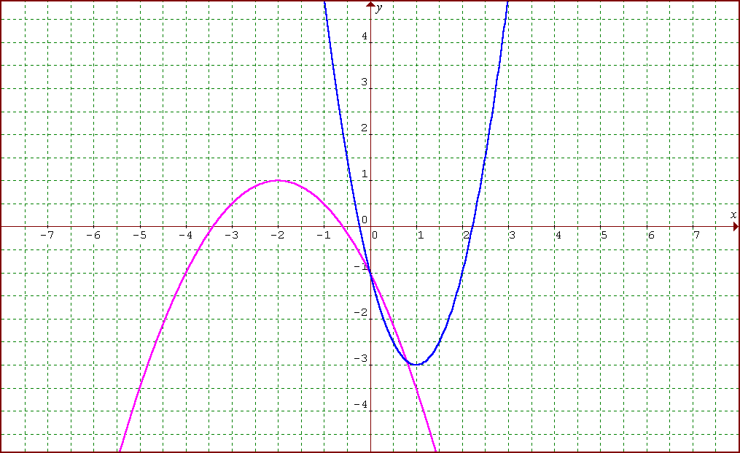

Ex. 1: What are the equations of the functions shown?

**Part 1.** Graph each of the following functions using a graphing calculator. For each function, determine the coordinates of the vertex and any intercepts. Round to the nearest tenth, where necessary for 1 to 4 and to the nearest hundredth for 5.

1. **



*x* [ , ] *y* [ , ] ]

Y1 =

vertex:

the *y*-intercept:

the *x*-intercepts:

2. **



*x* [ , ] *y* [ , ] ]

Y1 =

vertex:

the *y*-intercept:

the *x*-intercepts:

3. **



*x* [ , ] *y* [ , ] ]

Y1 =

vertex:

the *y*-intercept:

the *x*-intercepts:

4. **



*x* [ , ] *y* [ , ] ]

Y1 =

vertex:

the *y*-intercept:

the *x*-intercepts:

5. **



*x* [ , ] *y* [ , ] ]

Y1 =

vertex:

the *y*-intercept:

the *x*-intercepts:

**Part 2. Problem Solving.** Solve using a graphing calculator. Round answers to the nearest hundredth.

1. A rock is thrown off a cliff. The height, in metres, with respect to time, in seconds, is defined by the quadratic function .

a) What is the maximum height? _______________

b) When does it reach this height? _______________

1. How long does it take to reach the ground? _______________
2. How high is the cliff? _______________
3. What is the domain of this function? _______________

2. A rectangular pen is to be built along the side of a barn to house chickens.

1. Find the maximum area that can be enclosed with 60 m of fencing

if the barn is one side of the enclosure*.*  _______________

b) What are the dimensions that gives the maximum area? _______________

**3.3: Completing the Square**

**Objectives:**

* Converting quadratic functions from standard to vertex form.
* Writing quadratic functions to model situations.

Given a quadratic function in standard form  we don’t know how to graph by hand.

* We can RE-WRITE the standard form into vertex form by the method of **completing the square.**

Ex. 1: Rewrite  in vertex form.

* Why do you think this is called **completing the square**? Where is the **square**?

Ex. 2: Rewrite  in vertex form.

To complete the square:

1. Factor out ‘a’ from the two terms with x (if necessary).
2. Add and subtract  inside of the brackets from part 1.
3. Move the subtracts value outside of the brackets by multiplying by ‘a’.
4. Factor x terms inside of brackets.
5. Simplify constant terms outside of the brackets.

Ex. 3: Graph the function  by re-writing in vertex form. State the vertex, axis of symmetry, maximum or minimum and domain/range.



Ex. 4: We will be roping off a swimming area down at Kits Beach for the day. If we have only 100 m of rope and want a **maximized** swimming area, what should the dimensions of the area be?

**4.1: Graphical Solutions of Quadratic Equations**

**Objectives:**

* Determine the **roots** and **zeros** of a quadratic equation by graphing.

“Solutions” of any quadratic equation  are called **zeros** or **roots**. Graphically, they correspond to the x-intercepts (where y = 0).

Possible number of solutions:

  

___________________ ___________________ ___________________

There are 2 methods to solving quadratic equations graphically:

METHOD #1:

* We must first move everything over to one side of the equation so it equals 0.
* We will then find the intersection of the graph with the line y = 0. (This is called finding the roots or zeros!)

Ex. 1: Solve  by graphing.

Move everything over to one side. What equation do you get? ____________________

Now, enter that equation into the Y= screen and GRAPH (use the WINDOW settings below)

*Fill in the screens below:*

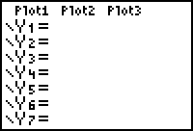 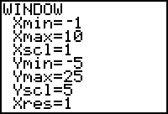 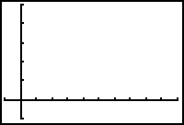

Set the WINDOW to these settings and GRAPH!

Now, use CALC (2nd TRACE) to find the *zero*: ( ____ , _____ ) and ( ____ , _____ )

Solutions are: ________________

Ex. 2: Solve  by graphing.

ZERO: ( _____ , _____ ) ( _____ , _____ )

Answer: X = _____

METHOD #2: Graphing each side of equation and finding the intersection (like a system of equations!)

* Enter the left side of the equation into Y1
* Enter the right side of the equation into Y2
* GRAPH
* Use CALC to find the intersection point

Ex. 3: Solve  by graphing a related system.

*Fill in the screens below:*

 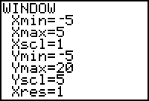 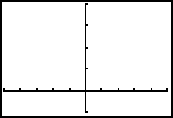

Set the WINDOW to these settings and GRAPH!

Now, use CALC (2nd TRACE) to find the intersection point: ( ____ , _____ )

Ex. 4: Solve  by graphing a related system.

INTERSECTION: ( _____ , _____ )

Answer: X = _____

**Practice Exercises:** Use the methods outlined above to solve the following (try 2 of each!)

1. 
2. 
3. 
4. 

**4.2: Factoring Quadratic Equations**

**Objectives:**

* Factor different types of quadratic expressions
* Solving quadratic equations by factoring

Recall that a quadratic equation is an equation that can be written in the form:  where a, b and c are constants and a ≠ 0

As with last class, we can “solve” a quadratic equation by setting the equation equal to zero and finding the **roots** or **zeros** of the equation. We can do this by factoring.

* How many possible solutions might we have?

Solve the following quadratic equations by factoring. Check your solution(s).

1) (x – 5)(x + 2) = 0 2) 9x2 = 16

3) 4y2 – 8 = 2 4) – 4m2 + 24m = 0

5) x2 – 9x +20 = 0 6) 

Ex. 1 : Solve by factoring . Check your solution(s).

Ex. 2: Write a quadratic equation whose roots are  and  in standard form 

**4.3: Solving quadratic equations by completing the square**

**Objectives:**

* Solve quadratics by completing the square

Sometimes factoring quadratic equations is not practical. We can use the method of **completing the square** from Chapter 3 to help us find the zeros and roots.

Ex. 1: Solve  and check your solutions(s).

Ex. 2: Solve  by completing the square. Express your answers to the nearest tenth.

Solving quadratic equations by completing the square:

1. Set the equation equal to zero and complete the square (follow the steps in section 3.3).
2. Isolate the squared term.
3. Take the positive and negative square root.
4. Solve the 2 corresponding equations for x.

Ex. 3: A wide-screened television has a diagonal measure of 42 in. The width of the screen is 16 in. more than the height. Determine the dimensions of the screen to the nearest tenth of an inch.

An **extraneous root** is a solution that does not satisfy any initial restrictions. This often happens in word problems, since we usually need positive solutions.

**4.4: The Quadratic Formula**

**Objectives:**

* Solve quadratic equations using the quadratic formula
* Use the discriminant to determine the nature of the roots of a quadratic equation

Warm – up: Simplify the following:

1.  b)  c) 

Any quadratic equation written in the form  can be solved using the quadratic formula:

|  |
| --- |
|  |

* When would we want to use the formula?
* How could we check our solution(s)?

Ex. 1**:** Use the quadratic formula to solve the following equations.

(a) 

(b) 

(c) 

The Discriminant is everything under the radical sign in the quadratic formula.

|  |
| --- |
| discriminant = |

* The **sign** of the discriminant determines the types of roots of a quadratic equation

|  |  |  |  |
| --- | --- | --- | --- |
| **Discriminant** | **Quadratic Formula** | **Types of roots (Nature)** | **Graph** |
|  |  |  |  |
|  |  |  |  |
|  |  |  |  |

Ex. 2: Without solving, determine the nature of the roots of the quadratic equation:

(a) 

(b) 

Ex. 3: For what values of k does  have 2 equal real roots?

Ex. 4: A rectangular garden has an area of 324 square metres. Is it possible to enclose the garden on all four sides using 70 m of fencing? Explain.

We now have 4 methods to “solve” quadratic equations:

1. Graphing (either the corresponding function or a related system of functions).
2. Factoring
3. Completing the square
4. Quadratic Formula