**6.2: Multiplying and Dividing Rational Expressions**



**Objectives:**

* Determine the product or quotient of rational expressions in simplest form

**Multiplying Rational Expressions**

Just like multiplying fractions! Include npvs! * multiply **top to top** and **bottom to bottom**!

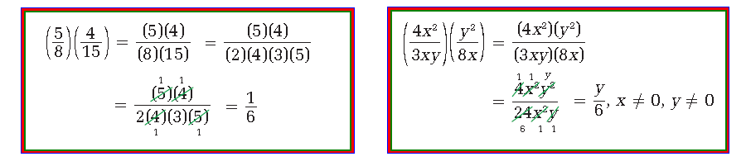

**Dividing Rational Expressions**

Just like dividing fractions! Include npvs! ***\**** *Multiply by the Reciprocal* ***(or KISS AND FLIP!)***

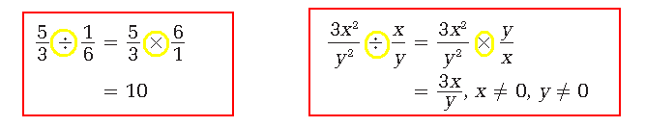

Example 1)

Multiply. Write your answer in simplest form. Identify all non-permissible values first.







a)



Example 2)

Determine the quotient in simplest form. Identify all non-permissible values.







Example 3) Simplify. What are the non-permissible values?



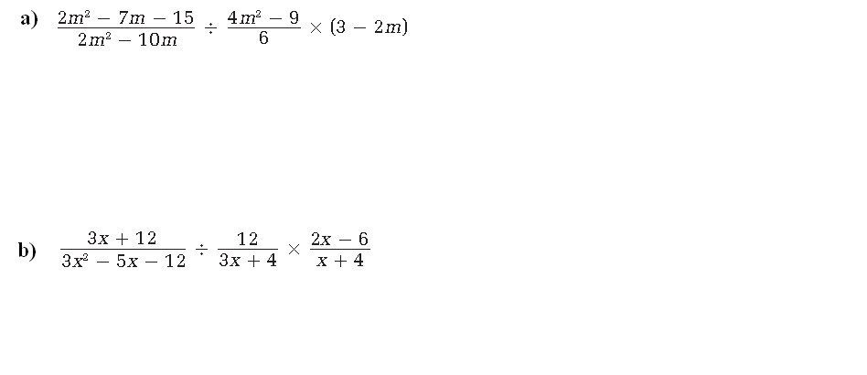



Example 4) Two points on a coordinate grid are M (*p* **–** 1, 2*p* **+** 3) and N (2*p* **–** 5, *p* + 1).

**a)** What is a simplified rational expression for the slope of the line passing through M and N?



**b)** Write a rational expression for the slope of any line that is perpendicular to MN.



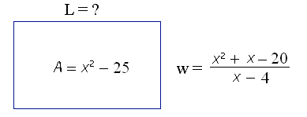Example 5) Write an expression to represent the length of the rectangle. Simplify your answer.

