**Lesson 1: Rational Expressions**

**Objectives:**

* determine non-permissible values for a rational expression
* simplify a rational expression

***Rational Expressions:*** algebraic fractions with a numerator and a denominator that are both polynomials

* Can you come up with some examples?



Whenever you use a rational expression, you must identify any values that must be excluded or are considered **non-permissible values**.

**Non-permissible values**: all values that make the denominator zero.



Example 1) For each rational expression, determine all non-permissible values.





**Simplifying Rational Expressions**

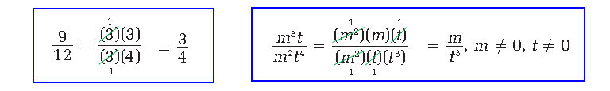

To simplify a rational expression:

* note any **non-permissible values** (npvs)
* divide both the numerator and denominator by any factors that are common to the numerator and the denominator.

Example 2) Simplify each rational expression. State the non-permissible values.







Example 3) Consider the expression



**a)** What expression represents the non-permissible values for *x*?

**b)** Simplify the rational expression.

**d)** Evaluate the expression for *x* = 2**.**6 and *y* = 1**.**2 in two different ways.



Example 4) The area of right **∆**PQR is (*x***2** **–** *x* **–** 6) square units, and the length of side PQ is (*x* **–** 3) units. Side PR is the hypotenuse.



**a)** Draw a diagram of **∆**PQR.



**b)** Write an expression for the length of side QR. Express your answer in simplest form.



**c)** What are the non-permissible values?



Exercises 1 # 2(all), 6(beh), 16(behkn), 18(beh), 19(bcd) Exercises 2 # (4, 11, 12, 17)beh

