Pre– Calculus 11 Ch 1: ***Sequences and Series*** Name:__________________

Lesson Notes 1.5: **Infinite Series.**

Objectives:

• generalizing a rule for determining the sum of an infinite geometric series

• explaining why a geometric series is convergent or divergent

• solving a problem that involves a geometric sequence or series

Ex. For the following geometric series  +  +  +  **………..**

1. Write a formula (in terms of n) to express the sum for the series.
2. Find the sum if there are infinitely many terms.

S1 =

S10 =

S20 =

S30 =

OBSERVATIONS:

As n becomes very large, the value of r, becomes ________________________

The value of Sn for the series eventually approaches _____________________

Let’s look at the formula itself:

What happens if -1 < r < 1 and n is large?

**Convergent Series**

Consider the series 4 + 2 + 1 + 0.5 + 0.25 + **. . .**

S**5** = 4 + 2 + 1 + 0.5 + 0.25 = **7.75**

S**7** = 4 + 2 + 1 + 0.5 + 0.25 + 0.125 + 0.0625 = **7.9375**

S**9** = = **7.9844**

S**11** = = **7.9961**

S**13** = = **7.999**

S**15** = = **7.9998**

S**17** = = **7.9999**

As the number of terms increases, the sequence of partial sums approaches a **fixed value of 8**. Therefore, the sum of this series is 8. This series is said to be a **convergent series**.

**Divergent Series**

Consider the series 4 + 8 + 16 + 32 + . . .

*S***1** = **4**

*S***2** = 4 + 8 = **12**

*S***3** = 4 + 8 + 16 = **28**

*S***4** = 4 + 8 + 16 + 32 = **60**

*S***5** = 4 + 8 + 16 + 32 + 64 = **124**

As the number of terms increases, the sum of the series continues to grow. The sequence of partial sums **does not approach a fixed value**. Therefore, the sum of this series cannot be calculated. This series is said to be a **divergent series**.

**Summary:**

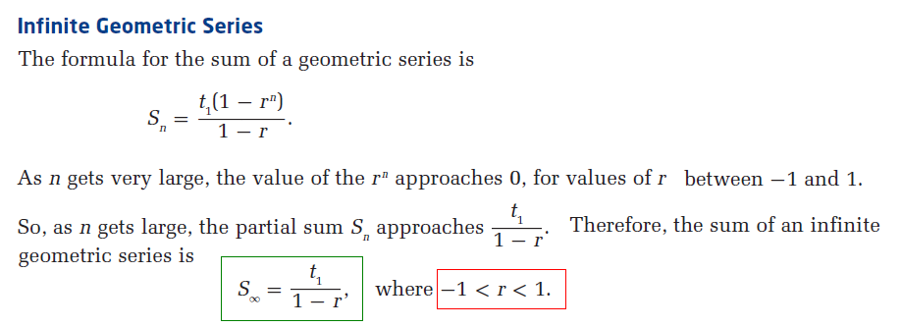

Applying the formula to the series 4 + 2 + 1 + 0.5 + 0.25 + . . .

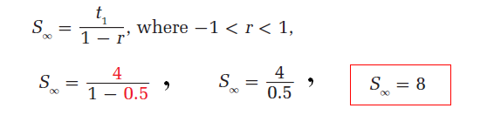

Example 1) Decide whether each infinite geometric series is convergent or divergent. State the sum of the series, if it exists.



Example 2) Assume that each shaded square represents  of the area of the larger square bordering two of its adjacent sides and that the shading continues indefinitely in the indicated manner.

**a)** Write the series of terms that would represent this situation.

**b)** How much of the total area of the largest square is shaded?



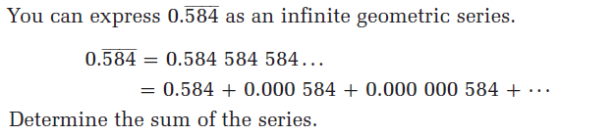Example 3)

Example 4) The ***infinite series*** given by 1 + 2*x* + 4*x***2** + 8*x***3** + . . . has a sum of 6. What is the value of *x*? List the first four terms of the series.

Example 5) The sum of an ***infinite series*** is four times as great as its first term. Determine the value of the common ratio.