Fun with Functions!!!

Create a picture of your choice using functions. There must be at least 5 unique quadratic functions. You may use a function more than once. Using the same quadratic function 5 times is not using 5 different quadratic functions. Print off the final product, ensure it has color and a legend to display the five quadratic functions.
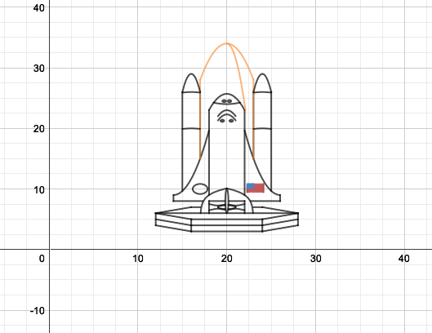
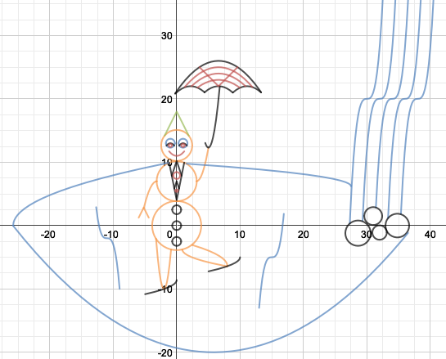

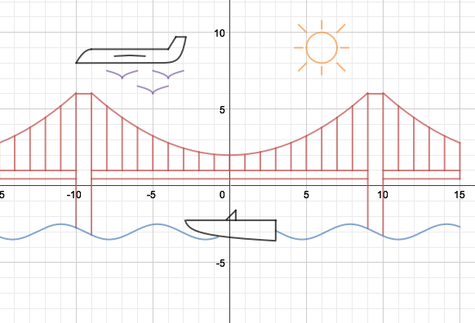

Assessment:

 | Beginning | Developing | Accomplished | Exemplary
Graphs of Quadratic Functions | Three or more components are missing | Two components are missing | Most components are correctly included – one component is missing | All components are correctly included
- At least one quadratic function with a > 0
- At least one quadratic function with a < 0
- At least one quadratic function with p ≠ 0
- At least one quadratic function with q ≠ 0
- At least 5 UNIQUE quadratic functions
Legend | No legend is provided OR a variety of errors were made | A legend is provided for some quadratic functions | A legend is provided for all quadratic functions and it is difficult to recognize which functions represents which graph | A legend is provided for all quadratic functions and it is easy to recognize which functions represents which graph
Originality | Picture is a recreation of an example in desmos | Picture is similar to an example in desmos but no functions are the same | Picture is unique and unlike any graph in desmos
DESMOS Instructions:

- Go to https://www.desmos.com

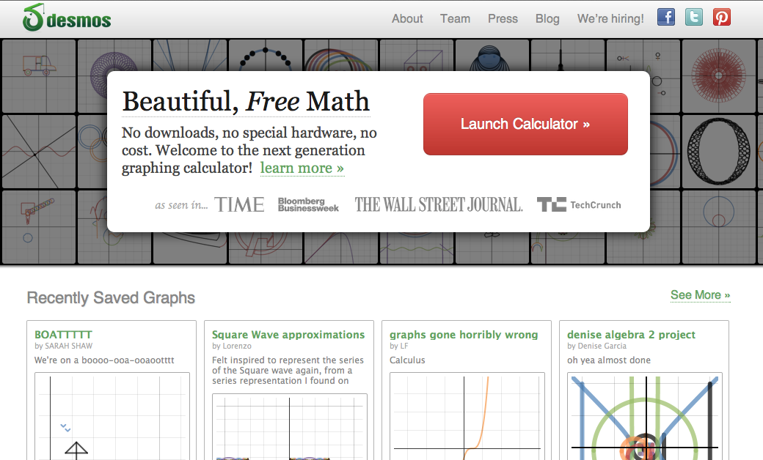

- Click on any of the graphs

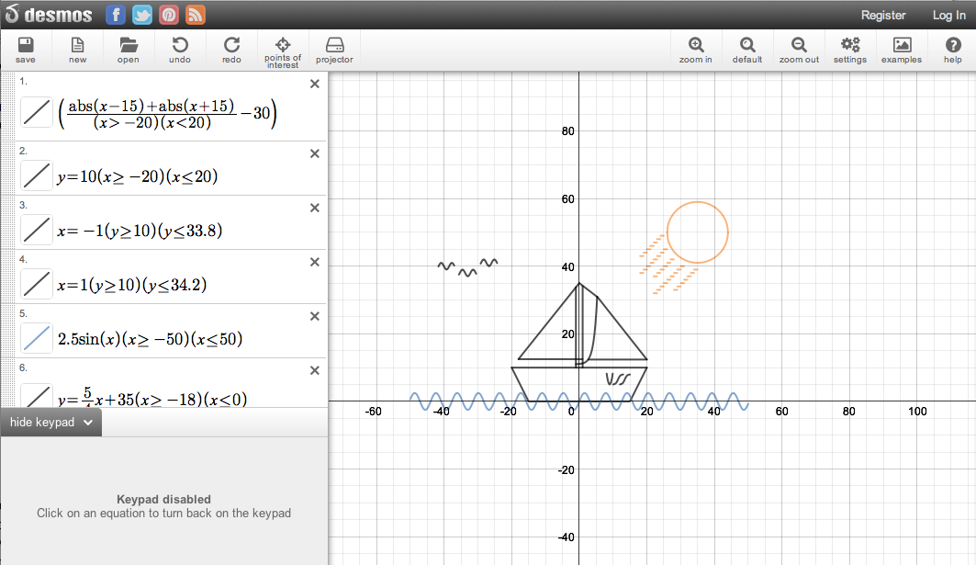

- Click on NEW at the top left hand corner 

- You are ready to begin creating a picture with mathematical functions!

Types of Functions:

Quadratic Functions
Function | What to type in | What it looks like
Parabola  y = x² | y = x 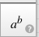 2 | 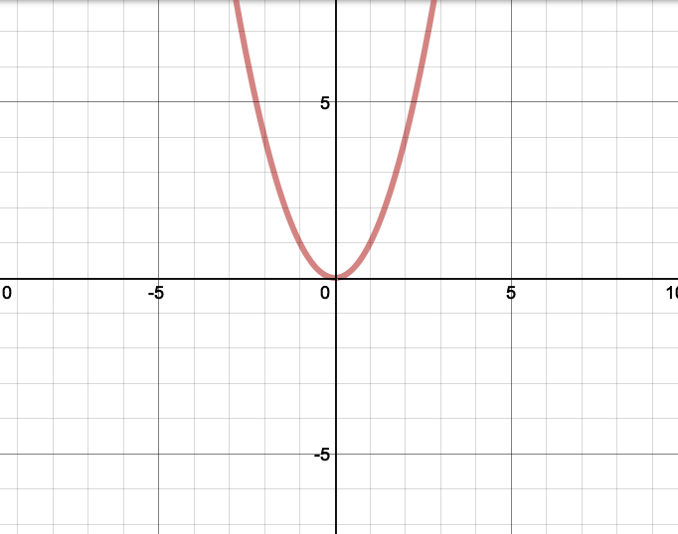
To restrict the domain:  y = x² , -1 < x < 1 | 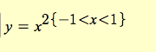 | 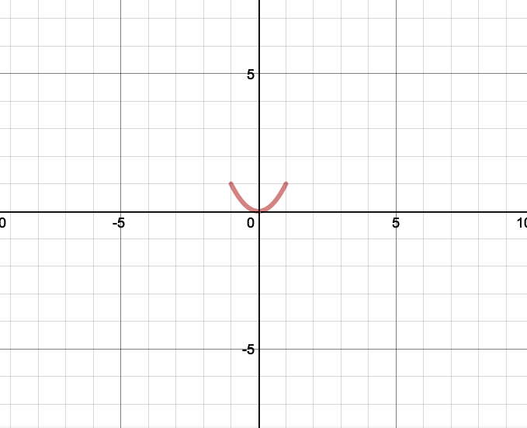
Horizontal/Vertical shift:  y = (x-2)² + 1  (2 right, 1 up) | 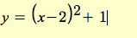 | 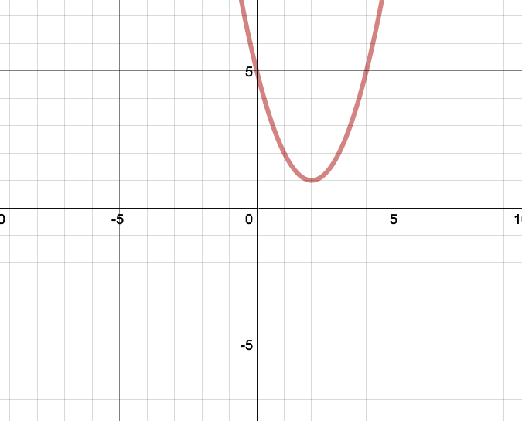
To restrict the domain:  y = (x-2)² + 1, 0 < x < 4 | 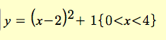 | 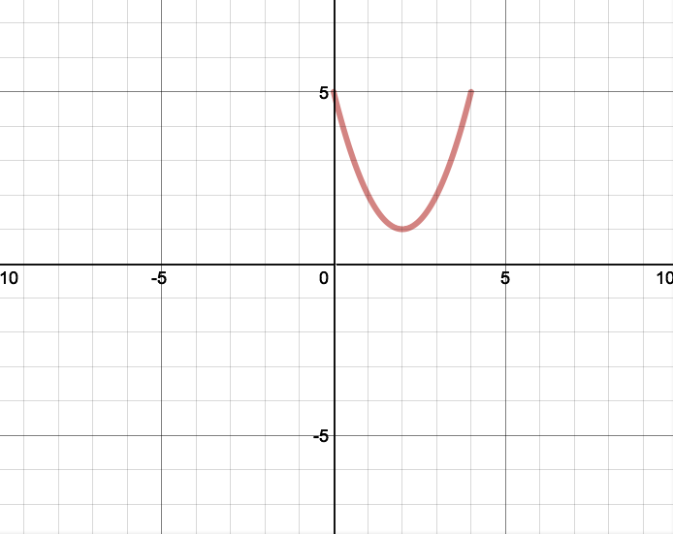
Vertical Expansion:  y = 10x² | 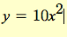 | 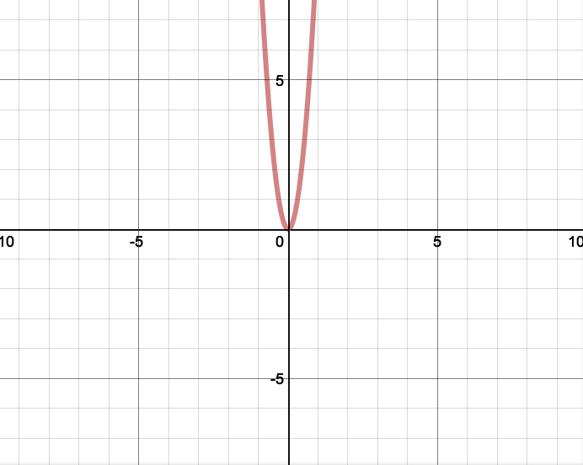
Vertical Compression:  y = x² | 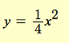 | 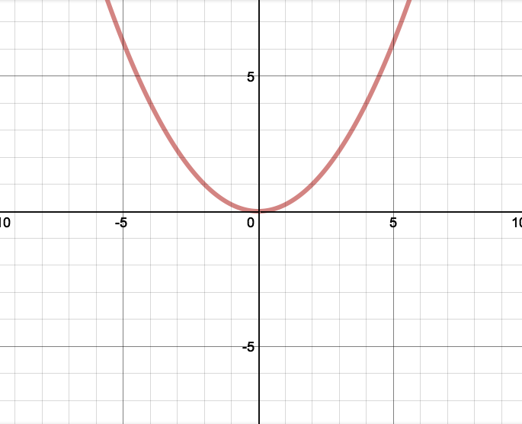
Reflection in the x-axis:  y = -x² | 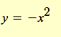 | 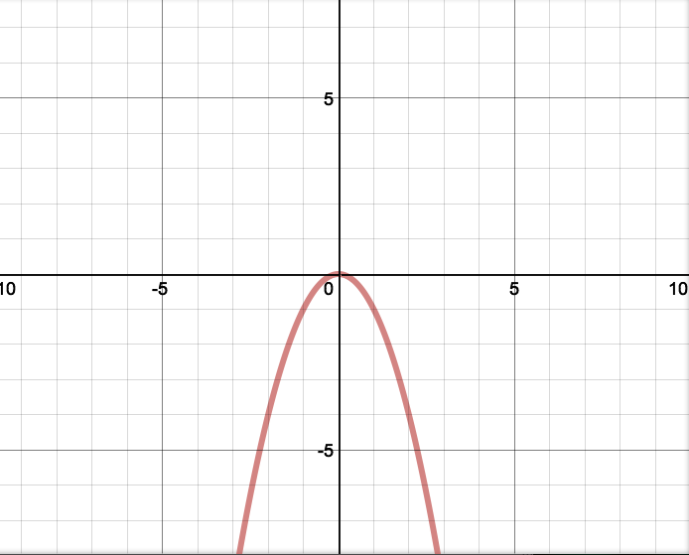
Absolute Value Functions
y = |x| | Use the  button  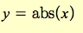 | 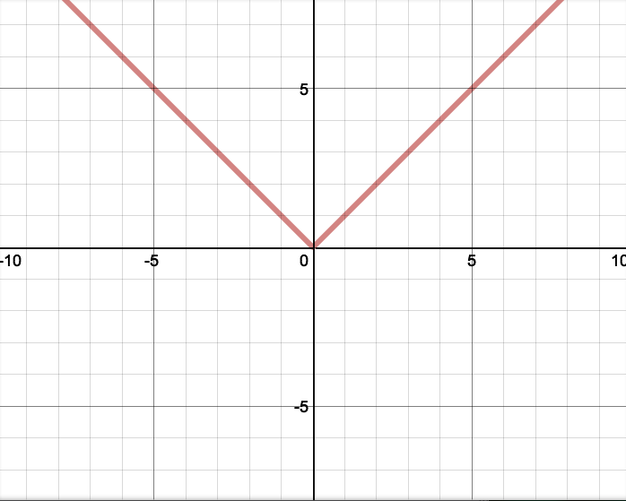
Restricting the domain  y = |x|, -5 < x < 5 |  | 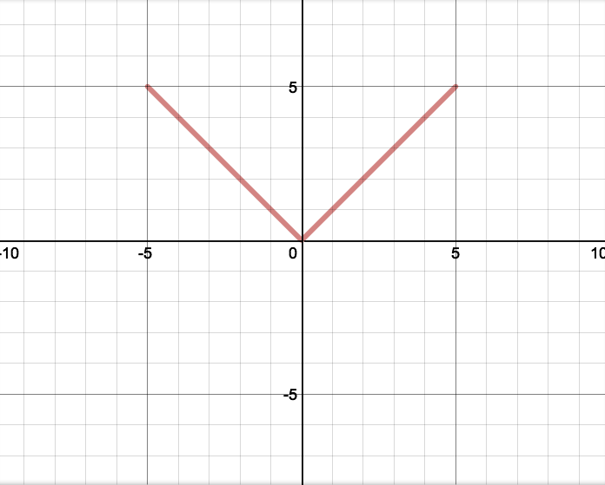
Cubic Functions
y = x³ | 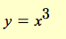 | 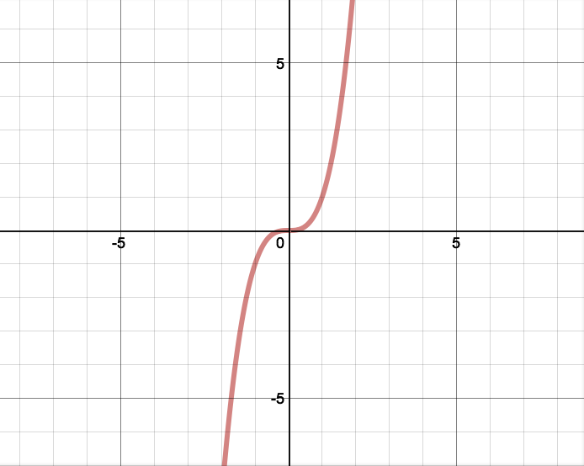
Restricting the domain | 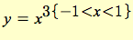 | 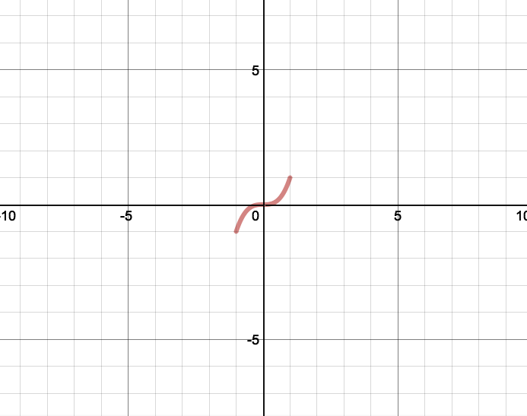
Square Root Functions
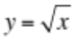 | Use the  button  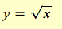 | 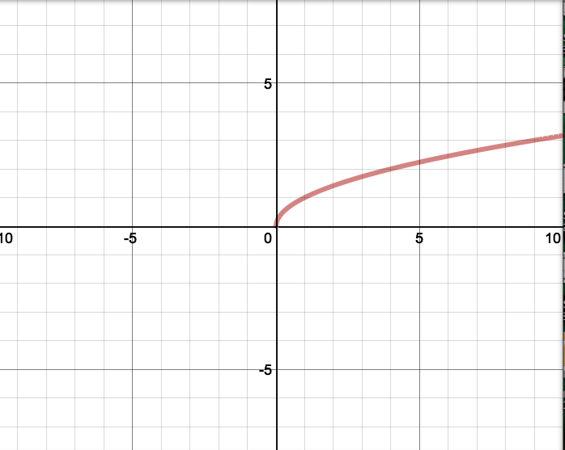
Restricting the domain | 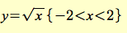 | 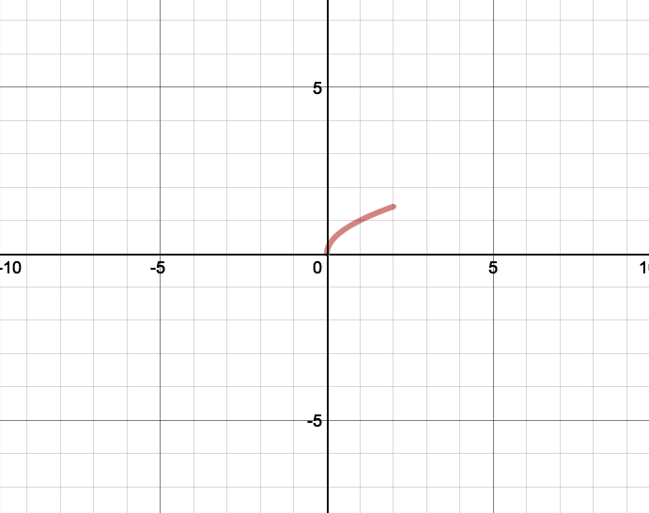
Linear Functions
y = x | 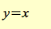 | 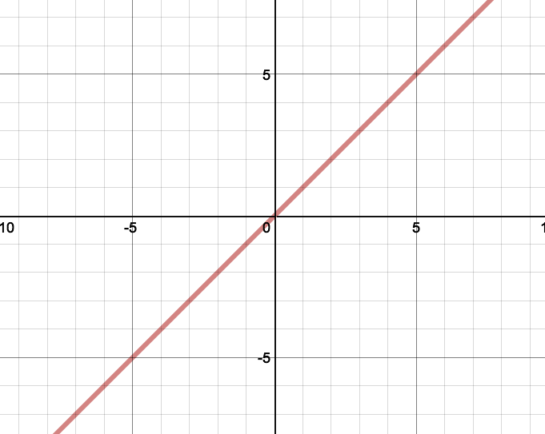

Horizontal lines  y = 3 | 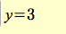 | 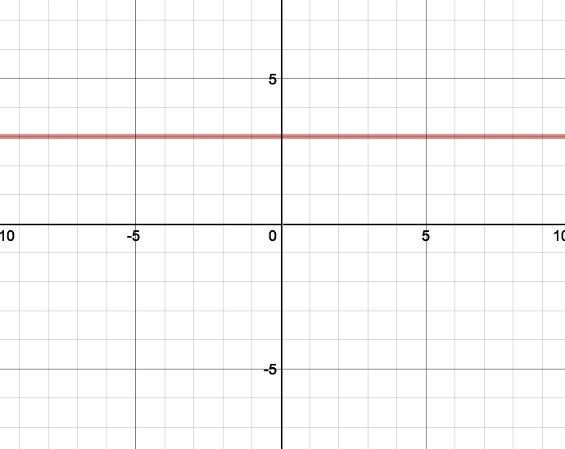
Restricting the domain  y = 1, -3.5 < x < .5 | 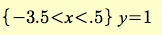 | 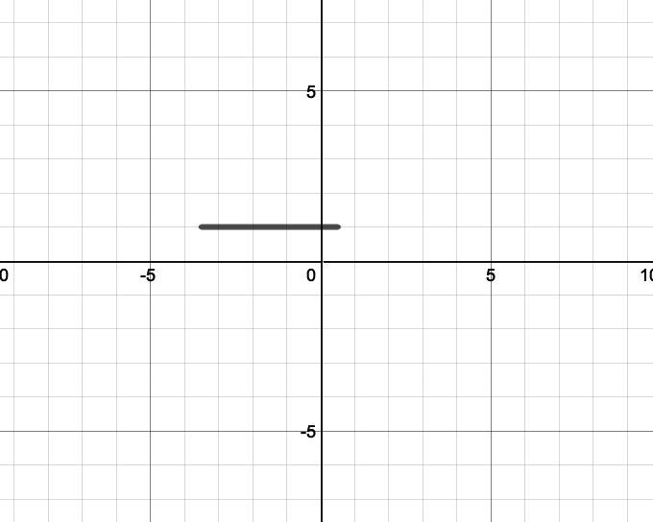
Vertical lines  x = -2 | 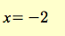 | 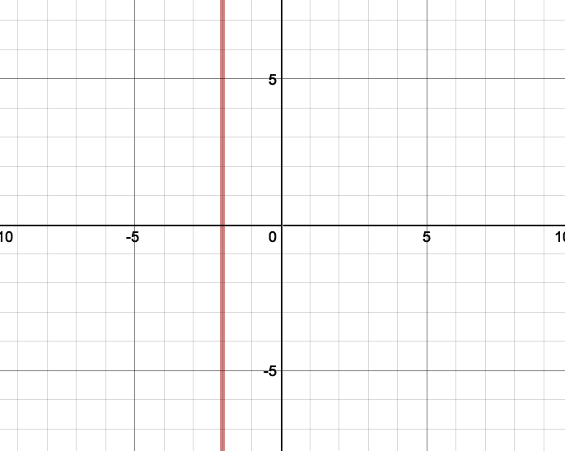
Sinusoidal Functions

y = sinx | 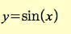 | 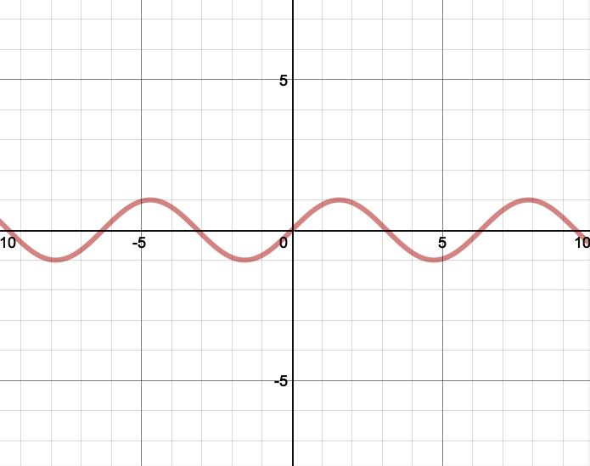
Shading under y = sinx | 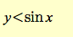 | 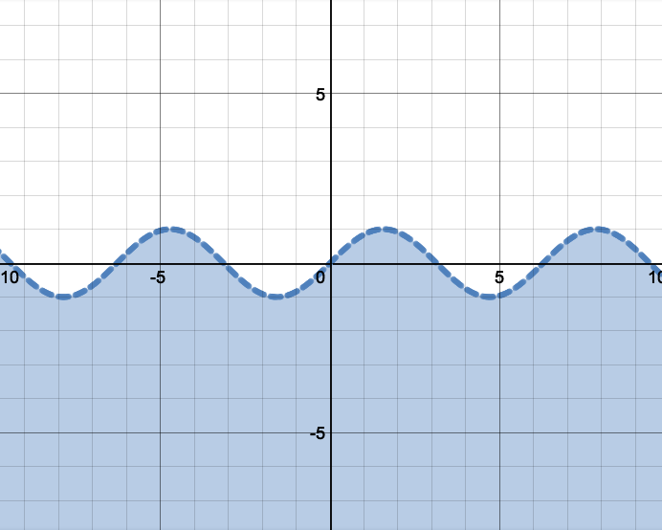
Circles
Circle with a radius 1,  centered at (0,0)  y² + x² = 1 | 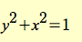 | 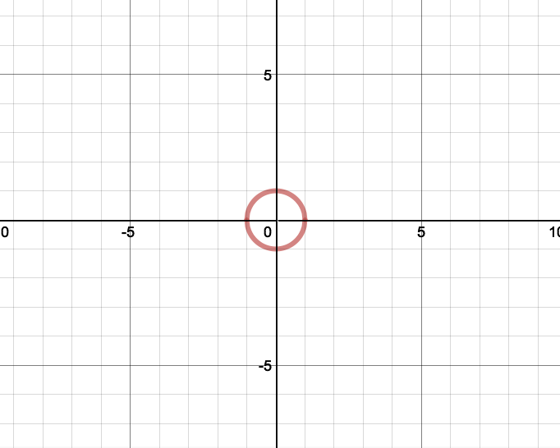
Circle with a radius 4,  Centered at (3,-2)  (y-3)² + (x+2)² = 4 | 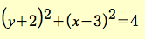 | 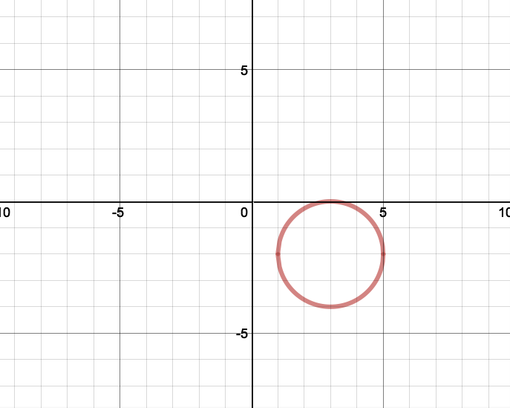

There are many more you can explore as well!

This is not a representation of a successful project. It is an example to show you the types of functions that I needed to create an ocean scene.

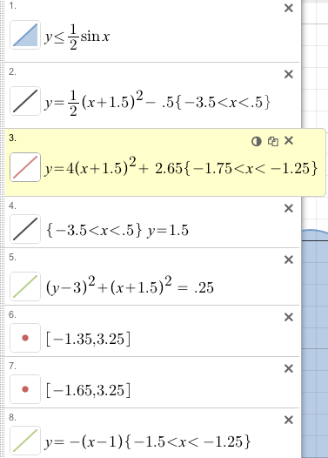
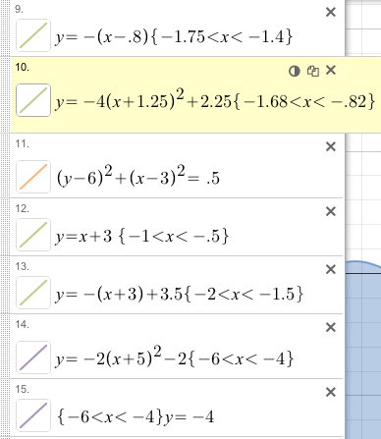
Example: Ocean Scene

- Insert a sin inequality
- Insert a parabola for the boat
- Use a parabola to make a smile
- Use a horizontal line to complete the boat
- Use a circle for the persons head
- Use a point for one eye
- Use and other point for the other eye
- Use two lines for his neck
- Use a parabola for his body
- Use two more lines for his arms
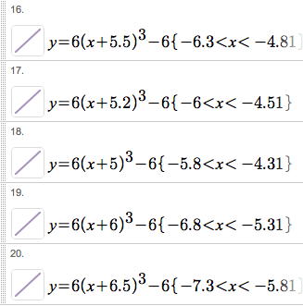
- Use a circle for a sun
- Use a parabola for a large jelly fish
- Use cubic functions for the jelly fish’s stingers


