**Pre-calculus 11 Chapter 5.1 & 5.2 Checkpoint Full Name ____________________**

**DAY ___ PERIOD ____**



**Entire Radical 🡨🡪 Mixed Radical:**



**1.** Express each radical as a **simplified mixed radical**.



a)  b)  c) 



d)  e) 



2. Express each as an **entire radical**.



a)  b)  c) 



**Comparing Radicals:**



3. Order each set of numbers from least to greatest. No calculator – show your work!







**Stating Restrictions:**



4. State the **restrictions** for the variable **x**.



a)  b) 



**Operations with Radicals (Adding, Subtracting, Multiplying & Dividing):**



5. **Simplify** each expression – leave in **simplified mixed radical form**.



a)  b) 



c)  d) 



e)  f) 



**Pre-calculus 11 Chapter 5.1 & 5.2 Checkpoint Full Name ____________________**



**DAY ___ PERIOD ____**



|  |  |  |  |  |  |  |  |
| --- | --- | --- | --- | --- | --- | --- | --- |
| **Concept** | **Question #s** | **B** | **D** | **A** | **E** | **Strengths** | **Area for improvement** |
| Mixed 🡨 🡪 Entire  - Convert radicals from mixed to entire and vice versa  - Compare radicals | 1 – 3 |  |  |  |  |  |  |
| Operations on Radicals  - Solve problems that involve operations on radicals and radical expressions with numerical and variable radicands. | 4 – 5 |  |  |  |  |  |  |

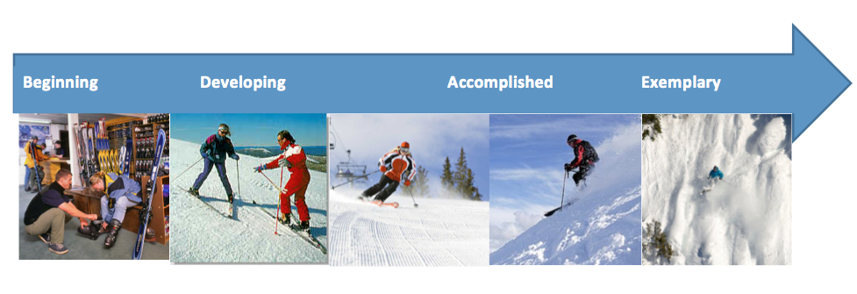

|  |  |  |  |
| --- | --- | --- | --- |
| **Beginning** | **Developing** | **Accomplished** | **Exemplary** |
| Does not demonstrate a basic understanding of concept. Substantial errors throughout. | Basic understanding of concepts. Errors and inconsistency reveal some missing understanding of the concepts. | Solid understanding of concepts. Most answers are correct with only a few errors. | Complete and in depth understanding of concepts. |