**3.1: Investigating quadratic functions in vertex form (Day 1)**

**Objectives:**

* Define a quadratic function.
* Determine the effects of “p” and “q” on the graph of 

A **quadratic function** is a function of degree 2. (recall: **degree** = highest exponent value).

for example: f(x) = x2 is the simplest form of a quadratic function

In general, a quadratic function is of the form: , where 

Ex. 1: Graph the function  using a table of values.

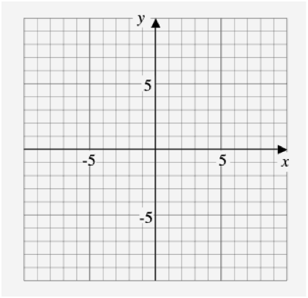

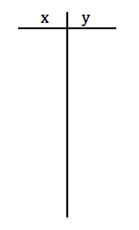

What is the **domain** of this graph?

What is the **range** of this graph?

Definitions:

* **Parabola**: the *shape* of the graph of a quadratic equation
* **Vertex**: the highest (maximum) or lowest (minimum) point of the parabola
* **Axis of symmetry**: the equation of the vertical line that passes through the vertex

(note: vertical line equations are always of the form x = p)

**\* Always graph at least 5 points clearly when graphing a parabola \***



Graphing :

How does q change the graph if y = x2?

Ex. 2: Graph  using a table of values.



State the:

(a) vertex:

(b) equation of the

axis of symmetry:

(c) domain:

(d) range:

Ex. 3: Graph  using a table of values.

State the:

(a) vertex:

(b) equation of the

axis of symmetry:

(c) domain:

(d) range:



Graph both on [www.desmos.com](http://www.desmos.com), how does q change the graph if y = x2?

The “q” value is the *_____________ _________________* of the parabola 

To graph, simply shift the graph of  _____ or __________ by the value of “q”



Graphing :

Ex. 4: Graph  using a table of values.

State the:

(a) vertex:

(b) equation of the

axis of symmetry:

(c) domain:

(d) range:



Ex. 5: Graph  using a table of values.

State the:

(a) vertex:

(b) equation of the

axis of symmetry:

(c) domain:

(d) range:



Graph both on [www.desmos.com](http://www.desmos.com), how does p change the graph if y = x2?

The “p” value is the *_____________________ ____________*of the parabola 

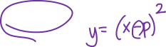

To graph, simply shift the graph of  ____________ or ____________ by the **opposite** value of p.



Ex. 5: Graph  by comparing to the graph of 

State the:

(a) vertex:

(b) equation of the

axis of symmetry:

(c) domain:

(d) range:



Ex. 6: Graph 

State the:

(a) vertex:

(b) equation of the

axis of symmetry:

(c) domain:

(d) range:



Assignment:

1. Insert 6 different  quadratic functions into [www.desmos.com](http://www.desmos.com). Print the graph off, create a legend using different colors and labeling the equation of the function. State the vertex, axis of symmetry, domain, range, and any intercepts for one of the quadratic functions.
2. Insert 6 different  quadratic functions into [www.desmos.com](http://www.desmos.com). Print the graph off, create a legend using different colors and labeling the equation of the function. State the vertex, axis of symmetry, domain, range, and any intercepts for one of the quadratic functions.

**3.1: Investigating quadratic functions in vertex form (Day 2)**

**Objectives:**

* Determine the effects of “a” on the graph of 
* Graph any quadratic function in vertex form 

Ex. 1: Graph the following on the same grid using [www.desmos.com](http://www.desmos.com).



a) 

b) 

c) 

d) 

* What effect does the value of “a” have on the graph?

If a > 0: the parabola opens ______

If a < 0: the parabola opens ______

The value of a is the “stretch” of the parabola.

We graph  by multiplying the values of  by “a”

For our “new” parabola we graph starting from the vertex and shifting over (x) and up/down the original y times “a”.

|  |  |
| --- | --- |
|  |  |
| |  |  | | --- | --- | | x | y | | 0 | 0 | | 1 | 1 | | 2 | 4 | | 3 | 9 | | |  |  | | --- | --- | | x | y | | 0 | 0 | | 1 | a | | 2 | 4a | | 3 | 9a | |

Ex. 2: Graph  by comparing to . Use a table of values.



In general for any parabola in vertex form 

* vertex: (p, q) * note sign change on “p”
* equation of the axis of symmetry: x = p

To graph 

1. Graph vertex (p, q)
2. Graph 2 points on either side of the vertex using the stretch value of “a” compared to .

Ex. 3: Graph 

State the:

(a) vertex:

(b) equation of the axis

of symmetry:

(c) domain:

(d) range:



Ex. 4: Determine the quadratic function written in the standard form **with the given information:

a) vertex ( 3, – 5 ) , and *a* = 2

b) congruent to **, opens down, and vertex (– 3, – 3 )

c) vertex (0, 3), passing through (3, 4)

d) vertex (4, –1), and *y* – intercept 3

Ex.5: Write the equation from Example 3, part a, in general form ()

**3.2: Investigating quadratic functions in standard form**

**Objectives:**

* Determine the vertex, axis of symmetry, domain and range for quadratic functions in standard form.
* Use a graphing calculator to graph quadratic functions.
* Analyze word problems involving quadratic functions.

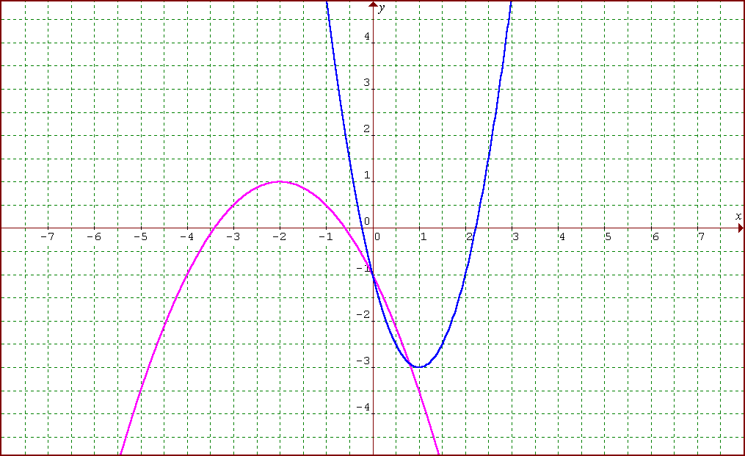

Ex. 1: What are the equations of the functions shown?

**Part 1.** Graph each of the following functions using a graphing calculator. For each function, determine the coordinates of the vertex and any intercepts. Round to the nearest tenth, where necessary for 1 to 4 and to the nearest hundredth for 5.

1. **



*x* [ , ] *y* [ , ] ]

Y1 =

vertex:

the *y*-intercept:

the *x*-intercepts:

2. **



*x* [ , ] *y* [ , ] ]

Y1 =

vertex:

the *y*-intercept:

the *x*-intercepts:

3. **



*x* [ , ] *y* [ , ] ]

Y1 =

vertex:

the *y*-intercept:

the *x*-intercepts:

4. **



*x* [ , ] *y* [ , ] ]

Y1 =

vertex:

the *y*-intercept:

the *x*-intercepts:

5. **



*x* [ , ] *y* [ , ] ]

Y1 =

vertex:

the *y*-intercept:

the *x*-intercepts:

**Part 2. Problem Solving.** Solve using a graphing calculator. Round answers to the nearest hundredth.

1. A rock is thrown off a cliff. The height, in metres, with respect to time, in seconds, is defined by the quadratic function .

a) What is the maximum height? _______________

b) When does it reach this height? _______________

1. How long does it take to reach the ground? _______________
2. How high is the cliff? _______________
3. What is the domain of this function? _______________

2. A rectangular pen is to be built along the side of a barn to house chickens.

1. Find the maximum area that can be enclosed with 60 m of fencing

if the barn is one side of the enclosure*.*  _______________

b) What are the dimensions that gives the maximum area? _______________

**3.3: Completing the Square**

**Objectives:**

* Converting quadratic functions from standard to vertex form.
* Writing quadratic functions to model situations.

Given a quadratic function in standard form  we don’t know how to graph by hand.

* We can RE-WRITE the standard form into vertex form by the method of **completing the square.**

Ex. 1: Rewrite  in vertex form.

* Why do you think this is called **completing the square**? Where is the **square**?

Ex. 2: Rewrite  in vertex form.

To complete the square:

1. Factor out ‘a’ from the two terms with x (if necessary).
2. Add and subtract  inside of the brackets from part 1.
3. Move the subtracts value outside of the brackets by multiplying by ‘a’.
4. Factor x terms inside of brackets.
5. Simplify constant terms outside of the brackets.

Ex. 3: Graph the function  by re-writing in vertex form. State the vertex, axis of symmetry, maximum or minimum and domain/range.



Ex. 4: We will be roping off a swimming area down at Kits Beach for the day. If we have only 100 m of rope and want a **maximized** swimming area, what should the dimensions of the area be?