**Pre-calculus Math 11**

**Chapter 4.3 & 4.4 Checkpoint Full Name ______________**

**DAY ___ PERIOD ____**

**Solving Quadratic Equations by Completing the Square:**

**_____ 1.** Complete the square to find the vertex form of y = 2x2 - 8x + 3?



A. y = 2(x – 2)2 + 3 B. y = 2(x – 2)2 – 5



C. y = 2(x – 4)2 - 29 D. y = 2(x – 4)2 + 3



**_____ 2.** Solve (x + 1)2 = 43.



A. –1 +  and –1 – B. 1+ and 1 –



C.  D. 



**_____ 3.** Identify the error in the solution to the quadratic equation below.



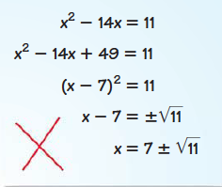



A) STEP 1:



B) STEP 2:



C) STEP 3:



D) STEP 4:



E) STEP 5:



**Solving Quadratic Functions using the Quadratic Formula:**



**_____ 4.** Solve the following quadratic equation using the quadratic formula.



6x2 + 12x = -2

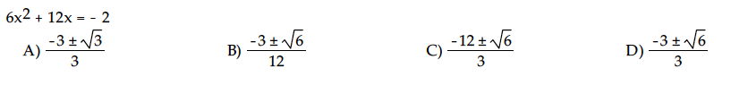



**_____ 5.** Identify the error in the solution to the quadratic equation.



2*x*2 – 4*x* –3 = 0



**A) STEP 1:**



**B) STEP 2:**

**C) STEP 3:**

**D) STEP 4:**

**_____ 6.** Robin Chestnut is a two-time Canadian juggling champion. As part of his act, Robin tosses a ball into the air and lets it drop to the floor. After a ball is tossed, its height, *h*, in metres, after *t* seconds, is modelled by the equation   
*h*(*t*) = – 4.9*t*2 + 12*t* + 1.5. For how many seconds, to the nearest hundredth, is the ball in the air? Use the quadratic formula to solve this problem.



1. 0.12 s C) 2.57 s
2. 0.26 s D) 2.37 s



**Discriminant:**

**_____ 7.** Determine the discriminant of –x2 + 17x – 5 = 0.



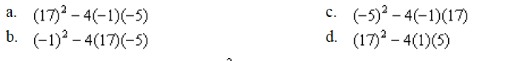



**_____ 8.** Use the discriminant to determine the number of roots of

x2 – 3 = 3x2 + 19x – 14



A) zero B) two



C) one D) three



**Pre-calculus Math 11**



**Chapter 4.3 & 4.4 Checkpoint Full Name ______________**

**DAY ___ PERIOD**

|  |  |  |  |  |  |  |
| --- | --- | --- | --- | --- | --- | --- |
| Quadratic Equations  🡪 Solve quadratic equations | | | | | | |
| **Concept** | **Question #** | **B** | **D** | **A** | **E** | **Area for improvement** |
| - Solve a quadratic equation of the form ax2 + bx + c = 0 by completing the square | 1 – 3 |  |  |  |  |  |
| - Solve a quadratic equation of the form ax2 + bx + c = 0 by using the quadratic formula | 4 – 6 |  |  |  |  |  |
| - Use the discriminant to determine whether a quadratic equation has two, one or no real roots | 7 – 8 |  |  |  |  |  |

|  |  |  |  |
| --- | --- | --- | --- |
| **Beginning** | **Developing** | **Accomplished** | **Exemplary** |
| Does not demonstrate a basic understanding of concept. Substantial errors throughout. | Basic understanding of concepts. Errors and inconsistency reveal some missing understanding of the concepts. | Solid understanding of concepts. Most answers are correct with only a few errors. | Complete and in depth understanding of concepts. |

