**BLM** **8–6** **Chapter** **8** **Test**

**1.** A **2.** B **3.** B **4.** D **5.** A **6.**{(5, 8), (0, 3)}

**7.** Example: An object is released from a launcher on the ground, and a person standing on a platform throws a ball, trying to hit the object with the ball.

**8.** Example: *ay*  *a*(*x*2  6*x*  5), *a*  R

**9. a)** LS  2*x*2  *x*  7 RS  *y*

  2(3)2  3  7  14

  14

LS  RS

LS  3*x*  *y*  23 RS  0

 3(3)  14  23

 0

LS  RS

**b)** (5, 38)

**10.**

**11. a)** *m*  5, *k*  2 **b)** *k*  8, *m*  2

**12. a)** two **b)** *k*  4 or *k*  0

**c)** (5.43, 1.08) or (1.43, 1.08)

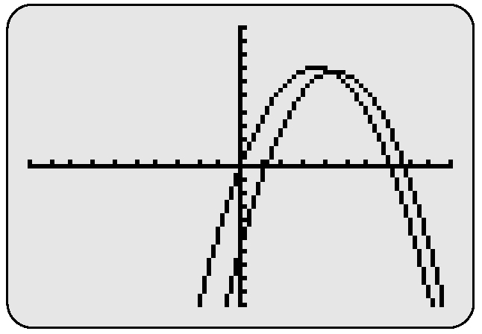**13.** **a)**

{(4.3, 6.8), (21.7, 177.3)}

**b)** The coordinates represent where the two streams of water meet. However, only the (4.3, 6.8) solution makes sense because the distance cannot be negative in this context.

**14. a)** perimeter: 2*y*  4*x*  26;   
area: 3*y*  9  *x*2  13*x*  36

**b)** *x*  7 and *y*  1, or *x*  12 and *y*  11

**c)** Substituting 7 results in a negative dimension,   
so *x* must be 12. The dimensions are 8 units and   
3 units.

**d)** perimeter: 22 units; area: 24 square units