**4.1: Graphical Solutions of Quadratic Equations**

**Objectives:**

* Determine the **roots** and **zeros** of a quadratic equation by graphing.

“Solutions” of any quadratic equation  are called **zeros** or **roots**. Graphically, they correspond to the x-intercepts (where y = 0).

Possible number of solutions:

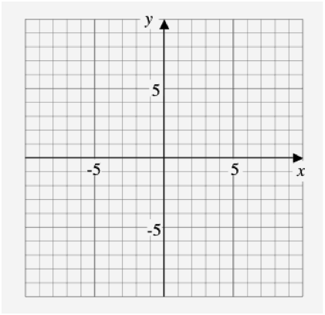  



___________________ ___________________ ___________________



There are 2 methods to solving quadratic equations graphically:

METHOD #1:

* We must first move everything over to one side of the equation so it equals 0.
* We will then find the intersection of the graph with the line y = 0. (This is called finding the roots or zeros!)

Ex. 1: Solve  by graphing.



Move everything over to one side. What equation do you get? ____________________



Now, enter that equation into the Y= screen and GRAPH (use the WINDOW settings below)

*Fill in the screens below:*

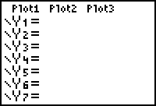 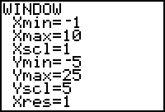 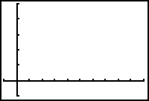



Set the WINDOW to these settings and GRAPH!

Now, use CALC (2nd TRACE) to find the *zero(s)*: ( ____ , _____ ) and ( ____ , _____ )



Solutions are: ________________



Ex. 2: Solve  by graphing.



ZERO: ( _____ , _____ ) ( _____ , _____ )



Answer: x = _____



METHOD #2: Graphing each side of equation and finding the intersection (like a system of equations!)

* Enter the left side of the equation into Y1
* Enter the right side of the equation into Y2
* GRAPH
* Use CALC to find the intersection point

Ex. 3: Solve  by graphing a related system.

*Fill in the screens below:*

 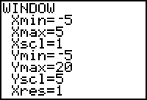 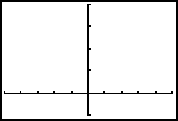



Set the WINDOW to these settings and GRAPH!

Now, use CALC (2nd TRACE) to find the intersection points: ( ____ , _____ ) and ( ____ , _____ )



Solutions are: ________________



Ex. 4: Solve  by graphing a related system.

INTERSECTIONS: ( _____ , _____ ) and ( _____ , _____ )



Answer: X = ___________



**Practice Exercises:** Use the methods outlined above to solve the following (try 2 of each!)

1. 



2. 

