INVESTIGATION: Which is cheaper: a shower or a bath?

Objective: To solve problems which involve linear equations.

Prediction:

Do you think the shower or bath is cheaper? Explain.

_____________________________________________________________________________________

_____________________________________________________________________________________

_____________________________________________________________________________________

_____________________________________________________________________________________

Procedure:

- Watch the video.
- Discuss with your partner the information required to use linear equations in slope-intercept form to answer the question above.
- Ms. Skehill will give you the required information.
- Create linear equations to represent the situations, graph them and uses them to come up with a solution to the problem.
- Complete the discussion questions.

Information Required:

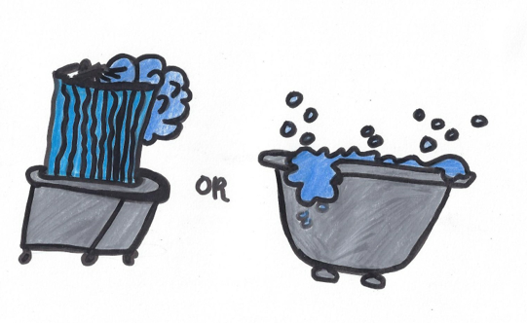

Solution: For the shower and the bath use the slope and intercept to create linear equations in slope-intercept form to represent the two relations. Graph both of the linear equations. Show the calculations involved in answering the inquiry question.
Shower | Bath
Linear Equation: | Linear Equation:
Graph: | Graph:
Calculation: | Calculation:
Which is cheaper: a shower or a bath?

Discsussion Questions:

How would the situation have to change for the answer to reverse itself?

_____________________________________________________________________________________

_____________________________________________________________________________________

_____________________________________________________________________________________

How long of a shower can he have with the same amount of water he used for the bath? Use an equation and show all of your work.

Research 3 ways you can conserve fresh water:
_____________________________________________________________________________________

_____________________________________________________________________________________

_____________________________________________________________________________________

Which is cheaper for you? Collect data on your own shower and bath usage

