Trigonometry
Lesson 1 Trigonometric Ratio’s

Trigonometry is a branch of mathematics that studies triangles and the relationships between the three sides and the angles between these sides. In particular, we can find these angles by calculating the ratios between any two of the three sides.
Using 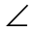A as the designated angle in all three right triangles, we can determine the ratio between the length of its opposite side and its adjacent side.
The ratio above is called the tangent ratio for A. | 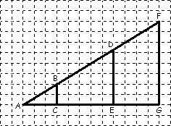
   | ΔABC | ΔADE | ΔAFG
  Ratio | 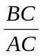= | 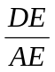= | 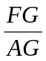=
Using a designated angle, the ratio between the opposite side & the adjacent side is always the same – the size of the triangle does not affect the ratio.
tan | = | length of side Opposite to the angle
 | = | length of side Adjacent to the angle
Or simply:
tan A = | opp | and | A = | tan⁻¹ | opp
tan A = | adj | and | A = | tan⁻¹ | adj
Beside tangent ratio (i.e., the ratio between opposite & adjacent), we also have other ratios.
1. Sine: the ratio between the opposite side & the hypotenuse . → sin = 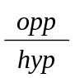
2. Cosine: the ratio between the adjacent side & the hypotenuse. → cos = 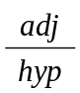
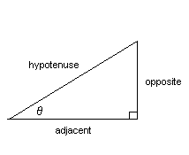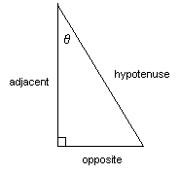
To summarize, we have:
sin = 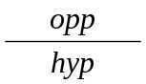 cos = 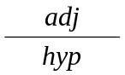 tan = 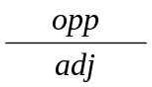

Or, using acronym, we have SOH CAH TOA !
Eg1. For the right triangle below, find the indicated value.

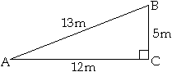 | a) tan A = b) sin B =  A = B =

Eg2. For the given right triangle,
a) Find the tangent ratio if A = 20º  b) Find the cosine ratio ifB = 30º | 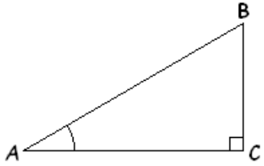

Eg3. Find each angle measure, to the nearest degree, for each tangent ratio.
a) 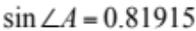 b) 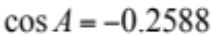

Eg4. For PQR, PQ = 12 cm & PR = 5 cm. Find Q.
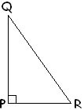

Eg5.
a) Find AB. b) Find P.
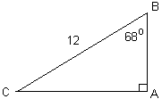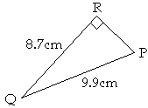

Eg6. JC is standing 8 m away from a tree. If the angle of elevation to the treetop is 35º, how tall is the tree?

Eg7. A kite is being flown at a height of 25 feet above eye level. If the string makes an angle of 42 º with the ground, find the length of the kite’s string to the nearest foot.

Eg8. Surveyors with a highway planning crew measure a section of proposed roadway to be 4.4 km. They measure the angle of elevation over the 4.4 km to be 8.5º. Determine the change in altitude for drivers traveling from one end to the other.

Practices: MHR p.107 # 1–6(a only), 16
Practices: MHR p.120 # 1–6(a only), 7, 10
Trigonometry
Lesson 2 Problems Involving More Than One Right Triangle

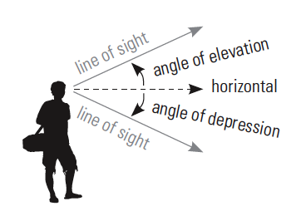
Trigonometry is very useful in mathematics and sciences. It has a very high usage in physics and architecture. Many of them require two right triangles to model the situation.

Let’s start with some terms:

The angle of _________________ is the angle formed between the horizontal and the line of sight looking downward.

The angle of __________________ is the angle formed by the horizontal and the line of sight while looking upward.

Eg1. The angle of elevation to the top of a tower is 27° from a point 19 m from its base. Calculate the height of the tower.

Eg2. From an air balloon 600 m high, the angle of depression to a car is 52°. How far is the balloon directly from the car?

Eg3. From the top of a 200 m-tall office building, the angle of elevation to the top of another building is 40°. The angle of depression to the bottom of the second building is 25°. How tall is the second building?

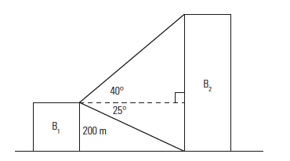

Eg4. Sylvie and Mathieu are bird-watching. They both spot a nest at the top of a tree. Mathieu is 89 m from the tree. The angle between Sylvie’s line of sight and Mathieu is 73°. The angle of elevation from Sylvie to the top of the tree is 35°. What is the height of the nest?
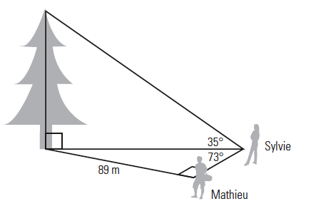

Practices: MHR p.131 # 1ac, 2ab, 3, 6, 8, 11, 14, 15
Trigonometry
Lesson 3 Solving Special Triangles with Ratios

Eg1. For each triangle below, find the indicated ratios in the given order.
a) ΔABC b) ΔPQR
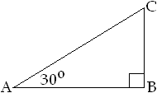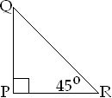

BC:AC PQ:PR

BC:AB PQ:RQ

The following are the ratios between the three sides in triangles with special angles.

30º – 60º – 90º  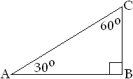 | 45º – 45º – 90º  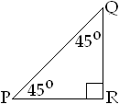 | 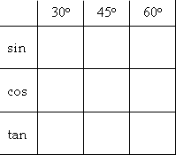

Eg2. Solve the triangles with ratios in exact value.
a) b)
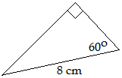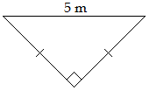

Eg3. An equilateral triangle has side length 12 cm. Find its height in exact value.

Eg4. The above triangle is inscribed in a circle. Find the radius of the circle.

Eg5. The following is an image of a 30 feet wide wooden roof truss, consisting of four 30º-60º-90º triangles and an equilateral triangle. Determine the total wood needed for the truss.

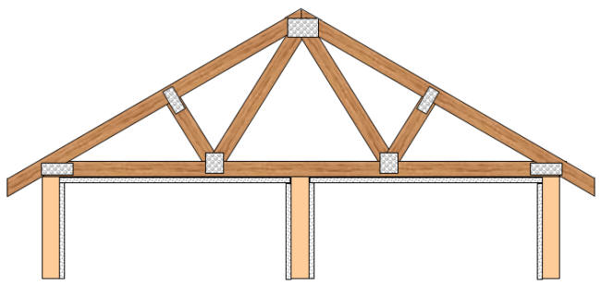

Practices: Worksheet
Worksheet for Special Triangles

1. Find the unknown sides.
a) b)
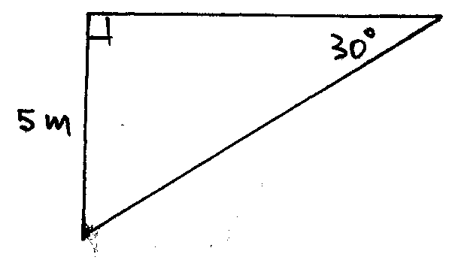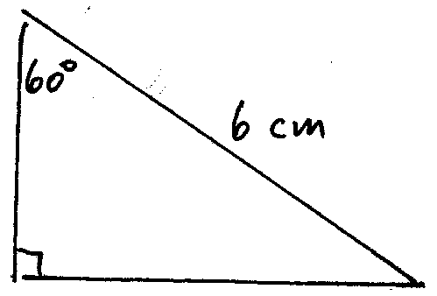
c) d)
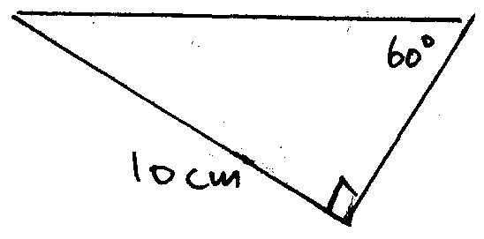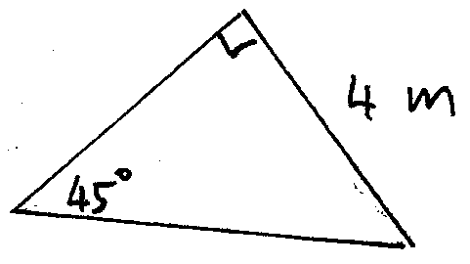
e) f)
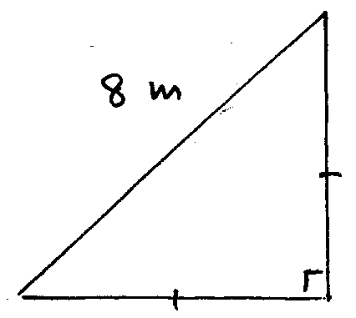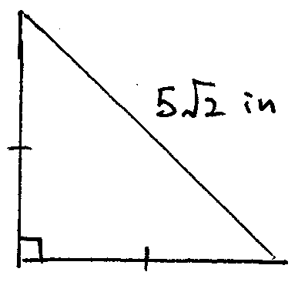
g) h)
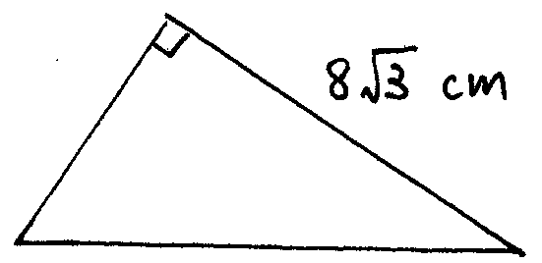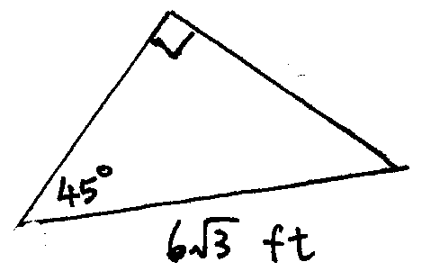

2. Find the length on all missing sides.
a) b)
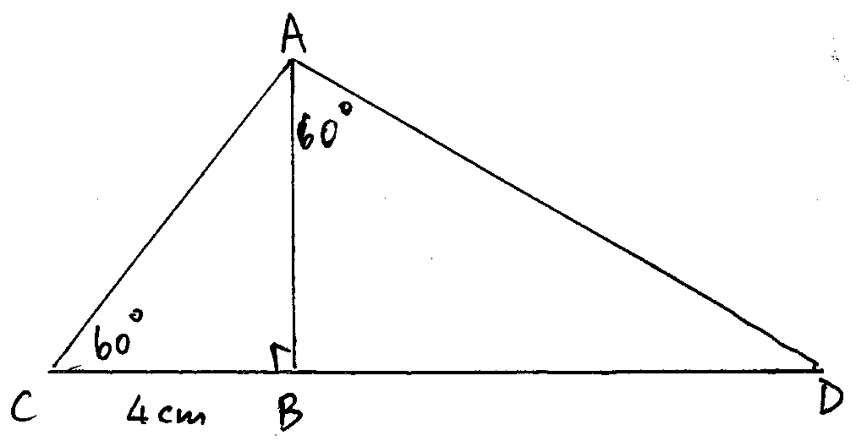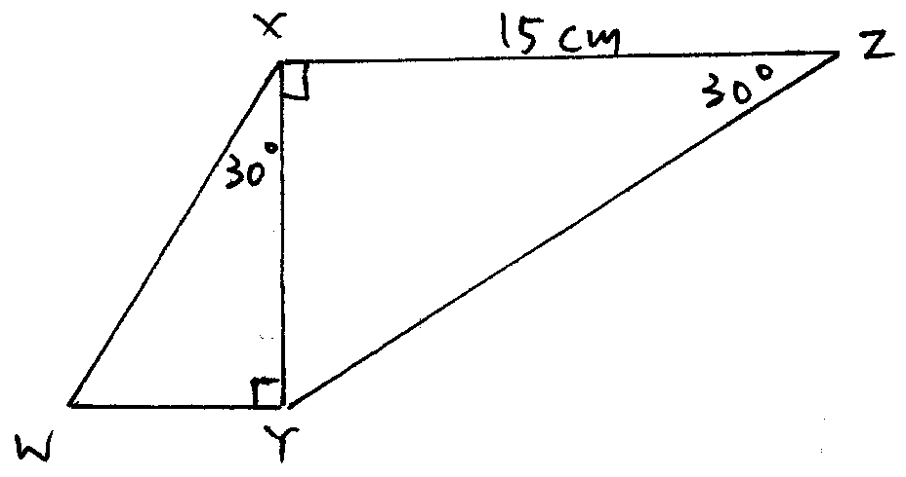

c) d)
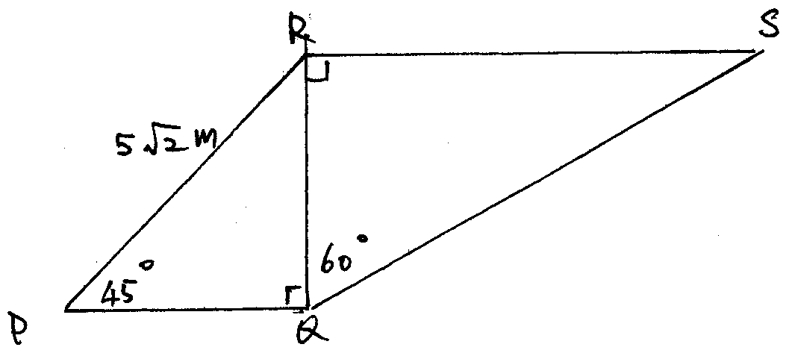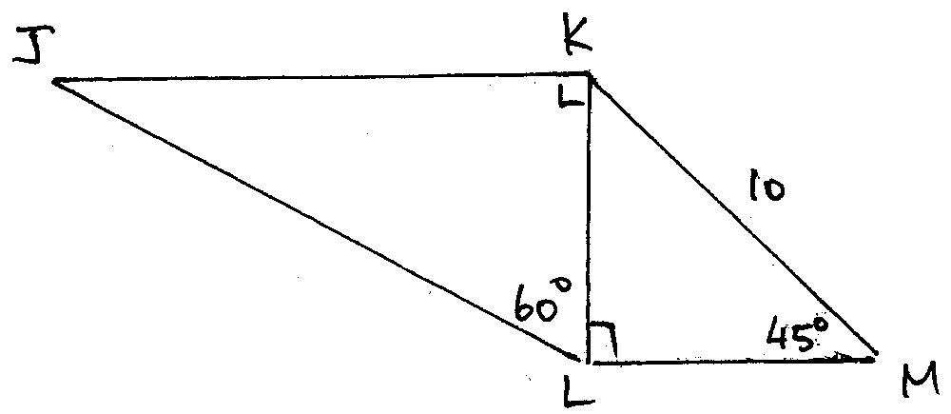

3. An equilateral triangle is inscribed in a circle. Given radius of the circle is 2 cm. Calculate the area of the triangle.  4. Using the same figure again. Given area of the circle is 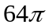 m². Find the area of shaded region. | 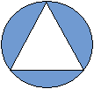
5. A small square has side length 6 cm.  a) Calculate the side length of the larger square.  b) Determine the area of the larger square. | 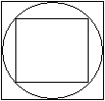
6. A circle is touching all three sides of a triangle at their midpoints. This triangle is also inscribed in a larger circle. The smaller circle inside the triangle has a radius of 3 cm.  a) Determine the radius of the larger circle.  b) Determine the side length of the equilateral triangle. | 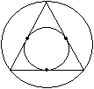

Answers:
1. a) 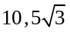 b) 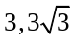 c) 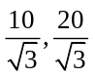 d) 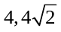 e) 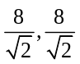 f) 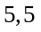 g) 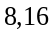 h) 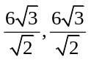
2. a) b) 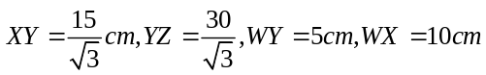
c) d) 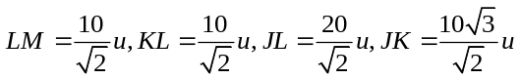
3. 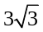cm² 4. 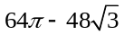m² 5. a) 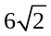cm b) 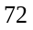cm² 6. a) cm b) 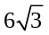cm

