Station 1:

What is the simplified version of the rational expression? State any non-permissible values.



, x ≠ 4

Station 2:

What is  in simplest form? State any non-permissible values.

, 

Station 3:

Simplify .

State any non-permissible values.

 , 

Station 4:

Simplify .

State any non-permissible values.

, 

Station 5:

Simplify the rational expression . Express your answer with positive exponents only. State any NPVs

, 

Station 6:

Express the product  in simplest form. State any NPVs.

, 

Station 7:

Express the quotient  in simplest form. State any NPVs.

, 

Station 8:

A square sheet of cardboard 100 cm by 100 cm is to have corners of side length *x* cut out. These cutouts will create flaps that can be folded up to form a box with no lid. The length and width of the base of the box are given by the expression (100 – 2*x*), and the height of the box is *x*, where *x* is in centimetres.

**a)** Express the volume of the box as a function of *x*.

**b)** Express the surface area of the box as a function of *x*.

**c)** What is a simplified expression for the ratio of the volume of the box to its surface area? Identify any non-permissible values of *x*.

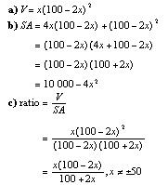

Station 9:

Consider a cylinder of height *h* and radius *r*.

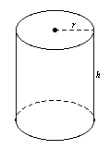

**a)** Determine the ratio of the volume of the cylinder to its surface area.

**b)** What restrictions are there on *r* and *h*?

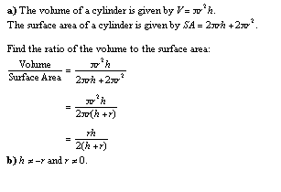

Station 10:

The area of a tennis court can be represented approximately by the function A(x) = 10x2 + 3x - 1, and its length can be represented by l(x) = 5x - 1, where *x* is a distance, in metres.

**a)** Write and simplify a function, *w*(*x*), to represent the width of a tennis court.

**b**) If *x* represent 5 m, what is the approximate width of the court?

