Problem Set # 5

1. The graph shows a linear relation between the altitude of hot air balloon and time.

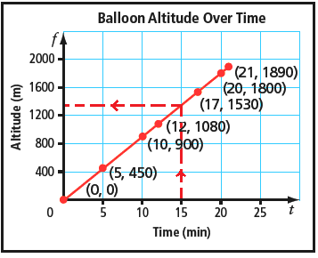



The dotted lines and arrows show the altitude is about 1350 m after 15 minutes. Find the altitudes after the given times: i.) 5 minutes; ii.) 10 minutes; and iii.) 18 minutes.



After how many minutes is the altitude of the balloon: i) 1800 m; ii) 500 m?



2. The graph shows a linear relation.

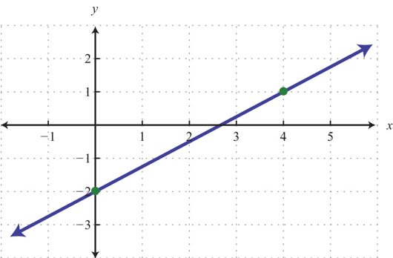

What is the y-coordinate, when x = 0?



What is the x-coordinate, when y = 1?



What is the y-coordinate, when x = 2?



3. Sally paints portraits of people for a living.

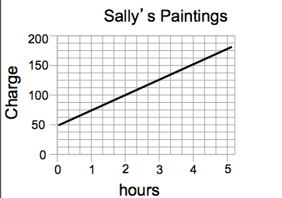

Describe the linear relation illustrated in the graph below.



At 0 hours she charges $50, why?



If it takes Sally 3 hours to paint the portrait, how much will the painting cost?



The graph shows the relationship between the fuel consumption, *f*, in litres (L), and the distance driven, *d*, in kilometres (km).

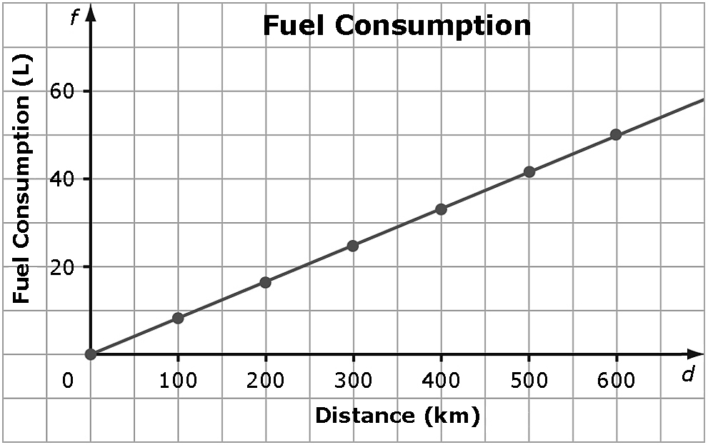



What is this fuel consumption after the following distances: i.) 200 km; ii.) 500 km; iii.) 125 km.



Write the points above as ordered pairs.



Is it appropriate to interpolate or extrapolate values on this graph? Explain.



Assignment: Page 226: 10, 12, 14, 16

