Problem Set # 1



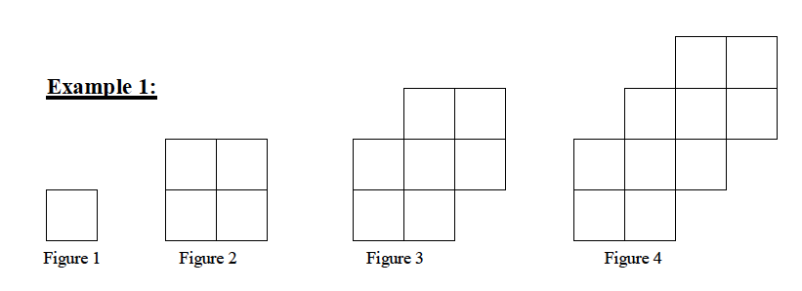1.



a) Describe the pattern:



_________________________________________________________________________________________________



_________________________________________________________________________________________________



b) Create a table to represent the relation:

|  |  |
| --- | --- |
|  |  |
|  |  |
|  |  |
|  |  |
|  |  |

c) Write an equation to represent this pattern.



d) How many squares are in Figure 14?



e) Which figure number has 112 squares?



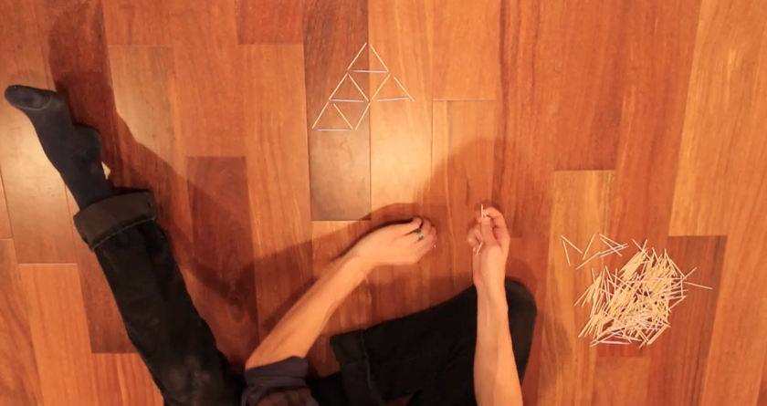

2. Watch Dan Meyer’s Toothpick Video.

How many toothpicks were used for each of the first 3 rows?



How many toothpicks will be in the 20th row? Create an equation to predict the toothpicks in a given row.



What row will have 33 toothpicks in it? Use the equation above to calculate the answer.



Extension: If the container has 250 toothpicks how many rows will you be able to complete?





Problem Set # 2

1. Create an equation that represents the relationship.

a) Price of a Taxi b) Cell Phone



|  |  |
| --- | --- |
| Time (months) | Cost ($) |
| 1 | 460 |
| 2 | 520 |
| 3 | 580 |
| 4 | 640 |

|  |  |
| --- | --- |
| Distance (km) | Cost ($) |
| 0 | 2.50 |
| 1 | 3.00 |
| 2 | 3.50 |
| 3 | 4.00 |



c) d)

|  |  |
| --- | --- |
| x | y |
| 0 | 1 |
| 1 | 3 |
| 2 | 5 |
| 3 | 7 |

|  |  |
| --- | --- |
| x | y |
| 0 | 0 |
| 1 | -4 |
| 2 | -8 |
| 3 | -12 |



e) f)



|  |  |
| --- | --- |
| x | y |
| 0 | 0.5 |
| 1 | -1 |
| 2 | -2.5 |
| 3 | -4 |

|  |  |
| --- | --- |
| x | y |
| 0 | -0.5 |
| 1 | 1.5 |
| 2 | 3.5 |
| 3 | 5.5 |

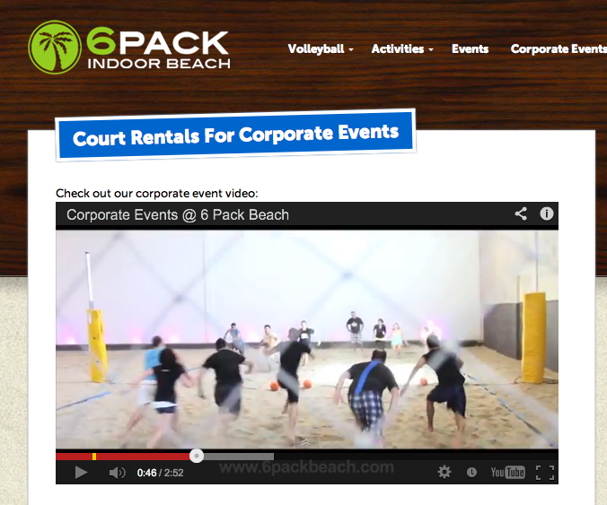

2. You are organizing a grade 9 sports day at the Indoor Beach in Richmond, BC. You have a budget of $4000. The transportation to and from the Indoor Beach costs $300 per bus. Each bus carries 50 students and there are 234 grade 9 students in your school. How many hours will you be able to rent the Indoor Beach facility? Create an equation to show how you would solve this question.

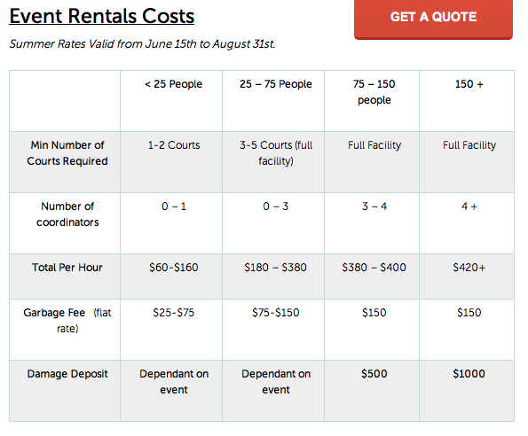



* Coordinators included in the cost



Suppose you want to extend the sports day to 7 hours. How much would you need to charge each student to pay for the additional cost over and above the budget of $4000? HINT: Use the equation above to find out how much it will cost over the budget of $4000.

