Adding Polynomials
Assignment

Objective: To demonstrate an understanding of combing like terms and adding polynomials.

How to do it:
- Go to http://www.glencoe.com/sites/common_assets/mathematics/ebook_assets/vmf/VMF-Interface.html
- Use algebra tiles to create a Christmas picture.
- Show all the tiles algebraically using addition.
- Cancel out zero pairs, combine like terms and show the simplified polynomial that represents the picture.

Performance-Based Assessment:

 | Beginning | Developing | Accomplished | Exemplary
Picture | Three or more components are missing | Two components are missing but the rest are fully included | One components is missing but the rest are fully included | All components are correctly included – detailed and thorough
- Use a minimum of one of each algebra tile
- Combine the algebra tiles to create a picture
- Show an algebraic addition statement that represents the tiles
- Show the cancellation of zero pairs
- Combine like terms to show the simplified version of the polynomial represented by the picture

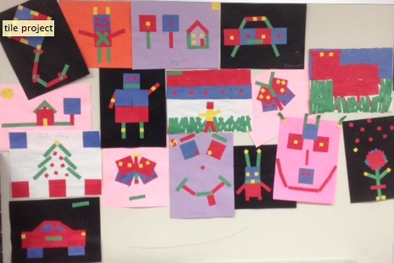
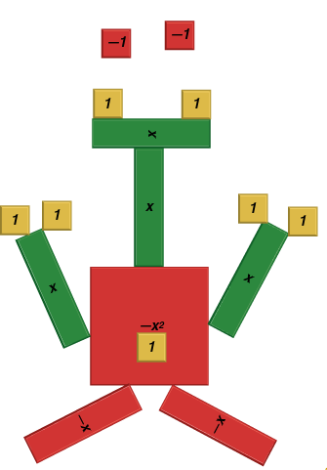
Polynomial Art

-1 + -1 + 1 + 1 + x + x + x +1 + 1 + 1 + 1 + x + x + (-x²) + 1 + (-x) + (-x)

= -x² + 2x + 5

