**Chapter 5: Radical Expressions & Equations**

1. Express  as an entire radical.
2. Express  as a simplified mixed radical.
3. Order the set of numbers from least to greatest.



1. Simplify each expression. Identify any restrictions on the values for the variables.

**a)**  **b)** 

1. Simplify. Identify any restrictions on the values of the variable in part c).

**a)**   **b)** 

**c)** 

1. Rationalize each denominator.

**a)**  **b)**  **c)** 

1. Solve the radical equation  . Verify your anwer(s).
2. On a children’s roller coaster ride, the speed in a loop depends on the height of the hill the car has just come down and the radius of the loop. The velocity, *v*, in feet per second, of a car at the top of a loop of radius *r,* in feet, is given by the formula  , where *h* is the height of the previous hill, in feet.

**a)** Find the height of the hill when the velocity at the top of the loop is 20 ft/s and the radius of the loop is 15 ft.

**b)** Would you expect the velocity of the car to increase or decrease as the radius of the loop increases? Explain your reasoning.

**Chapter 6: Rational Expressions & Equations**

1. Simplify each expression. Identify any non-permissible values.

**a)**  **b)**  **c)** 

**d)**   **f)** 

1. Determine the sum or difference. Express answers in lowest terms. Identify any non-permissible values.

**a)**   **b)** 

**c)** 

1. Sandra simplified the expression  to . She stated that they were equivalent expressions. Do you agree or disagree with Sandra’s statement? Explain.
2. When two triangles are similar, you can use the proportion of corresponding sides to determine an unknown dimension. Solve the rational equation to determine the value of x.

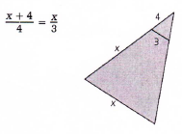

**Chapter 7: Absolute Value and Reciprocal Functions**

1. Order the values from least to greatest.



1. Write the piecewise function that represents each graph.

**a)** **b)**

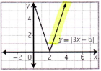 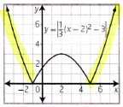

1. For each absolute value function,

**i)** sketch the graph, **ii)** determine the intercepts **iii)** determine the domain and range.

**a)**  **b)** 

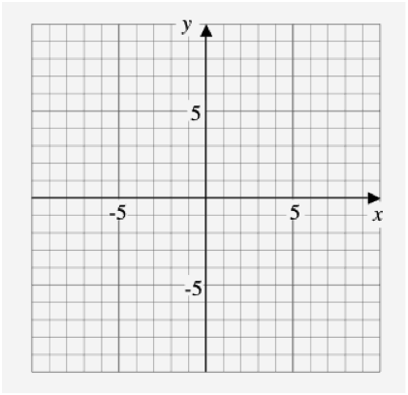 

1. Solve algebraically. Verify your solutions.

**a)**   **b)** 

1. Sketch the graph of  given the graph of  . What is the original function, ?

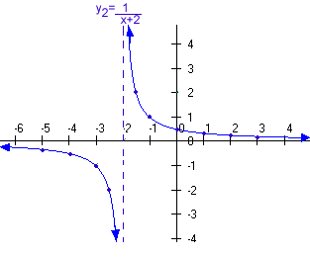

1. Sketch the graph of  given  . Label the asymptotes, the invariant points, and the intercepts.



1. Consider the function  .

**a)** What characteristics of the graph of  are different from those of $y=\left|f(x)\right|$?

**b)** Describe how the graph of  is different from the graph of $y=\left|f(x)\right|$.