**Chapter 3: Quadratic Functions**

1. Match each characteristic with the correct function.

***Quadratic Function***

**A** 

**B** 

**C** 

**D** 

***Characteristic***

**I)** vertex in quadrant III ________

**II)** opens downward ________

**III)** axis of symmetry: x = 3 ________

**IV)** range:  ___________

1. Classify each as a quadratic function or a function that is not quadratic.

**a)**  _________________________

**b)**  _________________________

**c)** _________________________

**d)**  _________________________

1. Sketch a possible graph for a quadratic function given each set of characteristics.

**a)** axis of symmetry: x = -2, range: 

**b)** axis of symmetry: x = 3, range: 

**c)** opens upward, vertex at (1, -3), one x-intercept at the point (3,0).

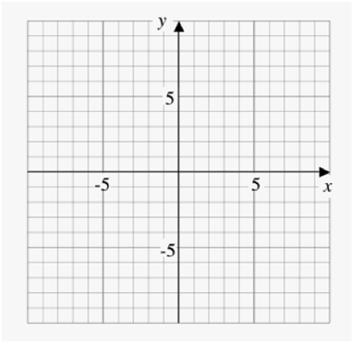

1. Identify the vertex, domain, range, axis of symmetry, x-intercepts and y-intercept for each quadratic function.

**a)**  **b)** 

**c)**  **d)** 

1. Rewrite each function in the form . Compare the graph of each function to the graph of .

**a)**  **b)** 

**c)**   **d)** 

1. **a)** The approximate height, *h*, in meters, of an arrow shot into the air with an initial velocity of 20 m/s after *t* seconds can be modeled by the function . What is the maximum height reached by the arrow?

**b)** From what height was the arrow shot?

**c)** How long did it take for the arrow to hit the ground, to the nearest second?

**Chapter 4: Quadratic Equations**

1. Solve by the indicated method.

**FACTORING**

**a)**  **b)** 

**COMPLETING THE SQUARE**

**c)** 2(*x* – 3)2 – 8 = 0 **d)**

**QUADRATIC FORMULA (leave exact answers please!)**

**e)** 3*x*2 + 19*x* – 14 = 0  **f)** 2*x*2 – 4*x* –3 = 0

1. The sum of the squares of three consecutive integers is 194. What are the integers?
2. The Empress Theatre, in Fort Macleod, is Alberta’s oldest continually operating theatre. Much of the theatre is the same as when it was constructed in 1912, including the 285 original seats on the main floor. The number of rows on the main floor is 4 more than the number of seats in each row. Determine the number of rows and the number of seats in each row.
3. Use the discriminant to determine the nature of the roots for each quadratic equation.

**a)**  **b)**  **c)** 

1. An outdoor hot tub has a diameter of 2 m. The hot tub is surrounded by a circular wooden deck, so that the deck has a uniform width. If the top area of the deck and the hot tub is 63.6 , how wide is the deck, to the nearest tenth of a meter?
2. James Michels produces intricate bentwood boxes. For one particular bentwood box the side length of the top square piece is 1 in. longer than the side length of the bottom. Their combined area is 85 sq. in..

**a)** Write a quadratic equation to determine the dimensions of each square piece.

**b)** Select an algebraic method and solve for the roots of the quadratic equation.

**c)** What are the dimensions of the top and bottom of the box?

**d)** Explain why one of the roots from part b) is extraneous.