**Chapter 1: Sequences & Series**

1. Match each term to the correct expression.

**A** 

**B** 

**C** 

**D** 

**E** 

**I)** arithmetic sequence __________

**II)** geometric sequence __________

**III)** arithmetic series __________

**IV)** geometric series __________

**V)** convergent series __________

1. Classify each sequence as arithmetic or geometric. State the value of the common difference or common ratio. Then, write the next three terms in each sequence.

**a)** 

**b)** 

**c)** 

**d)** 

1. For each arithmetic sequence, determine the general term. Express your answer in simplified form.

**a)**  **b)** 

1. Use the general term to determine  in the geometric sequence  .
2. **a)** What is  for the arithmetic series with a common difference of 3 and  ?

**b)** What is  for a geometric series where  and  ?

1. Phytoplankton, or algae, is a nutritional supplement used in natural health programs. Canadian Pacific Phytoplankton Ltd. is located in Nanaimo, British Columbia. The company can grow 10 t of marine phytoplankton on a regular 11 day cycle. Assume this cycle continues.

**a)** Create a graph showing the amount of

phytoplankton produced for the first five

cycles of production.

**b)** Write the general term for the sequence

produced.

1. The Living Shangri-La is the tallest building in Metro Vancouver. The ground floor of the building is 5.8 m high, and each floor above the ground floor is 3.2 m high. There are 62 floors altogether, including the ground floor. How tall is the building?
2. Tristan and Julie are preparing a math display for the school open house. Both students create posted to debate the following questions:

Does 0.999 … = 1 ?

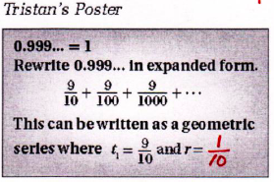 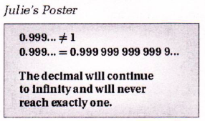

**a)** Finish Tristan’s poster by determining the value of the common ratio and then finding the sum of the infinite geometric series.

**b)** Which student do you think correctly answered the question? Explain.

**Chapter 2: Trigonometry**

1. Determine the exact distance, in simplified form, from the origin to a point P (-2, 4) on the terminal arm of an angle.

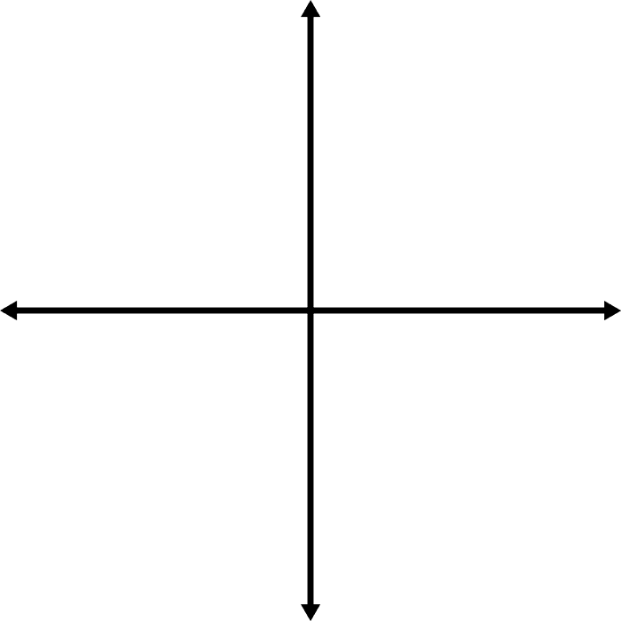

1. Point P (15,8) is on the terminal arm of angle . Determine the exact values for ,  and .



1. Sketch each angle in standard position and determine the measure of the reference angle.

**a)**  **b)**  **c)**  **d)** 

   

1. Determine the **exact** value of each trigonometric ratio.

**a)**  **b)** 

**c)**  **d)** 

1. Radio collars are used to track polar bears by sending signals via GPS to receiving stations. Two receiving stations are 9 km apart along a straight road. At station A, the signal from one of the collars comes from a direction of  from the road. At station B, the signal from the same collar comes from a direction of  from the road. Determine the distance the polar bear is from each of the stations.
2. Waterton Lakes National Park in Alberta is a popular site for birdwatching, with over 250 species of birds recorded. Chelsea spots a rare pileated woodpecker in a tree at an angle of elevation of . After walking 16 m closer to the tree she determines the new angle of elevation to be .

**a)** Sketch and label a diagram to represent the situation.

**b)** What is the closest distance that Chelsea is from the bird, to the nearest tenth of a meter?

1. In , RT = 2 m, ST = 1.4 m, and . Determine the measure of obtuse  to the nearest tenth of a degree.