**8.1: Solving Systems of Equations Graphically**

Recall from Math 10 that a **system of equations** consists of 2 or more equations considered together simultaneously. Any solution must satisfy each equation of the system.

* Graphically, the **intersection** corresponds to the (x,y) coordinates that satisfy each equation.

Ex. 1: Solve by graphing by hand:

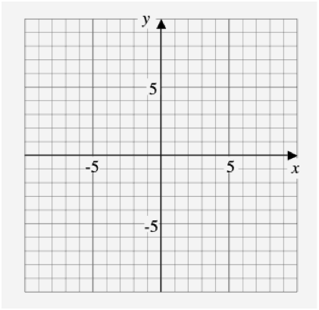







Verify your solutions by plugging into the original equations:



The above is an example of a system of **linear-linear equations**.

We will also be considering **linear-quadratic** systems and **quadratic-quadratic** systems.



Ex. 2: Solve by graphing by hand:











Ex. 3: Complete the following table. Draw a possible diagram for the number of solution(s).



|  |  |  |  |  |
| --- | --- | --- | --- | --- |
|  | **NO SOLUTION** | **1 SOLUTION** | **2 SOLUTIONS** | **OTHER?** |
| **Linear-Quadratic**  **System** | ::url.gif | ::url.gif | ::url.gif |  |
| **Quadratic-Quadratic**  **System** | **::url.gif** | ::url.gif | ::url.gif |  |



Ex. 4: Solve the following system using technology. Verify your solution(s).





*x* [ , ] *y* [ , ] ]







Ex. 5: In a Cirque du Soleil stunt, performers are launched toward each other from two slightly offset seesaws. The first performer is launched, and 1 s later the second performer is launched in the opposite direction. They both perform a flip and give each other a high five in the air. Each performer is in the air for 2 s. The height above the seesaw versus time for each performer during the stunt is approximated by a parabola as shown below.

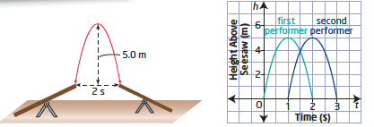



1. Determine the system of equations that models the performers’ height during the stunt.
2. Solve the system graphically using technology.
3. What is the meaning of your solution?



