**7.4: Reciprocal Functions (day 1)**

**Objectives:**

* Determine the definition of a reciprocal function.
* Compare the graphs of a function and its reciprocal.
* Determine the general characteristics for a reciprocal function.

With a partner, complete the activity **Investigate Exchange Rates** on pg. 392 – 393 in your textbook on a separate piece of paper (to hand in).

Given a function , its corresponding **reciprocal function**  is 



**Non-permissible values**: all values that make the denominator zero.



**Ex.1:** Determine the reciprocal of each function. Are there non-permissible values?



(a)  (b) 



**Ex.2:** Sketch the graph of  and its reciprocal function using a table of values.



|  |  |
| --- | --- |
| x | y |
|  |  |
|  |  |
|  |  |
|  |  |
|  |  |
|  |  |
|  |  |
|  |  |
|  |  |



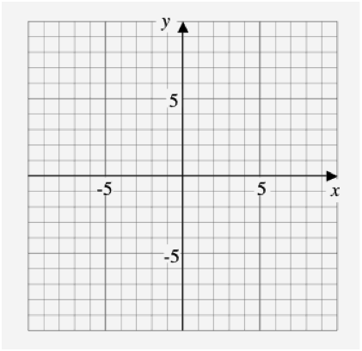



A few questions about example 2)

* Why does the curve approach the y-axis, but never touch it?



* Why does the curve approach the x-axis, but never touch it?



* Recall that **invariant points** are those that are unchanged. What are the invariant points for this pair of functions? What is special about the reciprocals of these values?



**Asymptote**: A line whose distance from a curve approaches zero. (More on asymptotes next class!)



**Ex.3:** Complete the following table:

|  |  |  |
| --- | --- | --- |
| **Characteristic** |  |  |
| Domain |  |  |
| Range |  |  |
| End behaviour (quadrants) |  |  |
| Behaviour at x = 0 |  |  |
| Invariant points |  | |

Assignment: Reciprocal Functions Worksheet