**7.3: Absolute Value Equations (day 1)**

**Objectives:**

* Solving simple absolute value equations algebraically and graphically
* Solving absolute value equations with technology
* Explain why the absolute value equation  for b<0 has no solution

When solving an absolute value equation we must now consider two possibilities:

1. The value inside the absolute value is positive.
2. The value inside the absolute value is negative.

Consider . What is a possible solution?



**Ex. 1:** Solve  both algebraically and graphically.



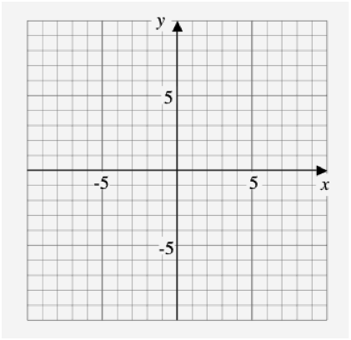



**Solving absolute value equations:**

1. Consider the positive and negative case for each absolute value:

- **CASE +**: replace absolute value bars with brackets

- **CASE -** : multiply the contents of the absolute value bars by -1

1. Solve each case.
2. Check solution(s) by substituting the solution back into the ORIGINAL equation. Reject any that do not work (**extraneous roots!**).

**Ex. 2:** Solve 



**Ex. 3:** Solve 



