**7.2: Absolute Value Functions**



**Objectives:**

* create a table of values for  given a table of values for 
* sketch the graph of  and determining its domain and range
* write an absolute value function in piecewise notation

**Ex. 1:** Graph the functions  and  using a table of values. State both the domain and range of both graphs.



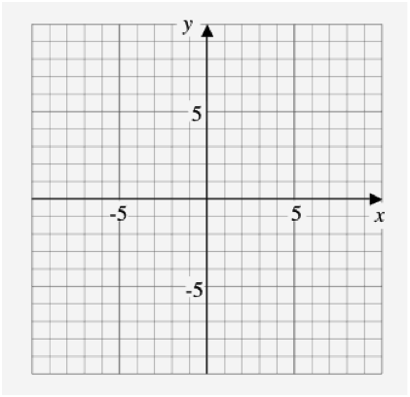

|  |  |
| --- | --- |
| x | y |
|  |  |
|  |  |
|  |  |
|  |  |
|  |  |
|  |  |
|  |  |
|  |  |
|  |  |

|  |  |
| --- | --- |
| x | y |
|  |  |
|  |  |
|  |  |
|  |  |
|  |  |
|  |  |
|  |  |
|  |  |
|  |  |



* Check your graph with a calculator (TI-83 MATH->NUM->abs)

Absolute values will require the use of **piecewise notation**. This is because the function is made up of two or more separate functions with its own domain and range. They will combine to the overall functions.

* What is the piecewise notation for the above graph ?



**Ex. 2:** Consider the absolute value function 



(a) Determine the x and y intercepts.



(b) Sketch the graph.



(c) State the domain and range of the graph.

(d) Express the graph with piecewise notation.





|  |  |
| --- | --- |
| x | y |
|  |  |
|  |  |
|  |  |
|  |  |
|  |  |
|  |  |
|  |  |
|  |  |
|  |  |



An **invariant point** is any point that remains unchanged when a transformation is applied to it.



* Can you name some invariant points in the above example?



**Ex. 3:** Consider the absolute value function 

(a) Determine the x and y intercepts.

(b) Sketch the graph.

(c) State the domain and range of the graph.

(d) Express the graph with piecewise notation.





|  |  |
| --- | --- |
| x | y |
|  |  |
|  |  |
|  |  |
|  |  |
|  |  |
|  |  |
|  |  |
|  |  |
|  |  |

