**6.3: Adding and Subtracting Rational Expressions**

**Objectives:**

* Find the sum or difference of rational expressions

**Adding or Subtracting Rational Expressions**

To add or subtract rational expressions, follow procedures ***similar*** to those used in adding or subtracting rational numbers.

=



Similarly, rational expressions with the same denominator are alike, and you can group them together. (COMMON DENOMINATORS!)

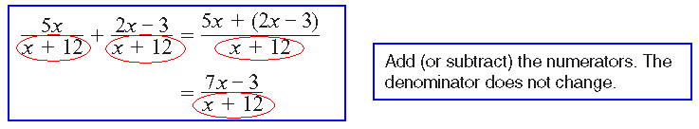



If rational expressions have different denominators, rewrite them as equivalent

expressions with the least common denominator (LCD).

Example 1) Simplify and identify the non-permissive values of the variables.





Example 2) Identify the least common denominator for each group of rational expressions.













Example 3) Simplify. Express your answers in simplest form.



a) 



b) 



) 



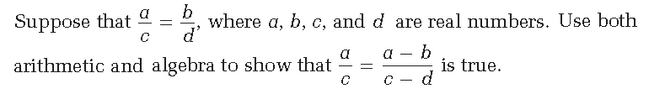

Example 4)