**3.2: Investigating quadratic functions in standard form**

**Objectives:**

* Determine the vertex, axis of symmetry, domain and range for quadratic functions in standard form.
* Use a graphing calculator to graph quadratic functions.
* 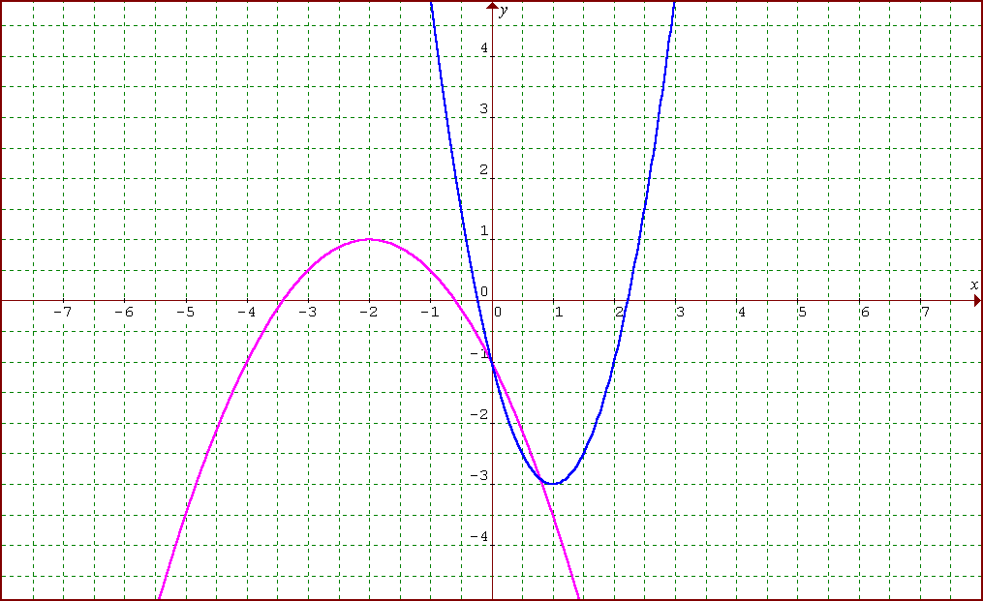Analyze word problems involving quadratic functions.

Ex. 1: What are the equations of the functions shown?

Notice the vertex is (-2, 1) and a = -1/2 therefore the equations is y = -1/2 (x + 2)2 + 1

Notice the vertex is (1, -3) and a = 2 therefore the equation is y = 2(x – 1)2 – 3

**Part 1.** Graph each of the following functions using a graphing calculator. For each function, determine the coordinates of the vertex and any intercepts. Round to the nearest tenth, where necessary for 1 to 4 and to the nearest hundredth for 5.

- To graph the function press Y= button and enter the equation (rearrange for y = if necessary)

- To find the vertex press 2nd TRACE Max or Min depending on the quadratic function, arrow to the right of the max or min and press enter, arrow to the left of the max or min and press enter and then press enter for a third time.

- To find the y-intercept press 2nd TRACE value, press 0 and then enter

- To find the x-intercepts press 2nd TRACE zero, go to the left of it and press enter, go to right of it and press enter and then press enter again (repeat this to find the other x-intercept)

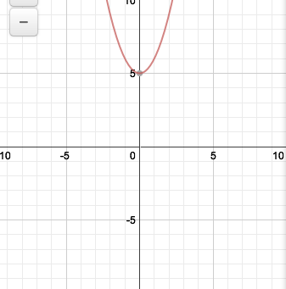

1. **



Y1 = x2 + 5

vertex: (0,5)

the *y*-intercept: y = 5

the *x*-intercepts: None

x [ -10 , 10 ] y [ -10 , 10 ]

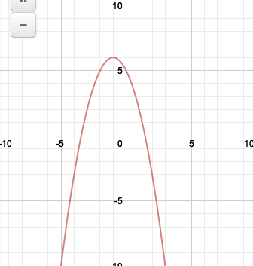

2. **



Y1 = -x2 – 2x + 5

vertex: (1, 6)

the *y*-intercept: y = 5

the *x*-intercepts: x = -3.4, 1.4

x [ -10 , 10 ] y [ -10 , 10 ]

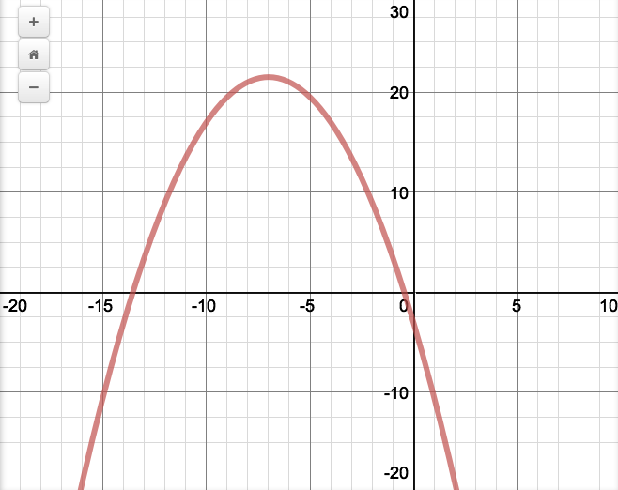

3. **



Y1 = -0.5x2 – 7x – 3

*y = -0.5x2 – 7x - 3*

vertex: (-7, 21.5)

the *y*-intercept: y = -3

the *x*-intercepts: x = -13.6, -0.4

x [ -20 , 10 ] y [ -20 , 30 ]

**Part 2. Problem Solving.**

1. Solve using a graphing calculator. Round answers to the nearest hundredth.

A skier’s jump was recorded in frame by frame analysis and placed in one picture, as shown below.

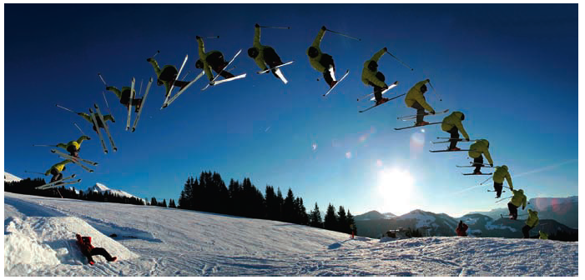

The skier’s coach used the picture to determine the quadratic function that relates the skier’s height above the ground, y, measured in metres, to the time, x, in seconds that the skier was in the air:

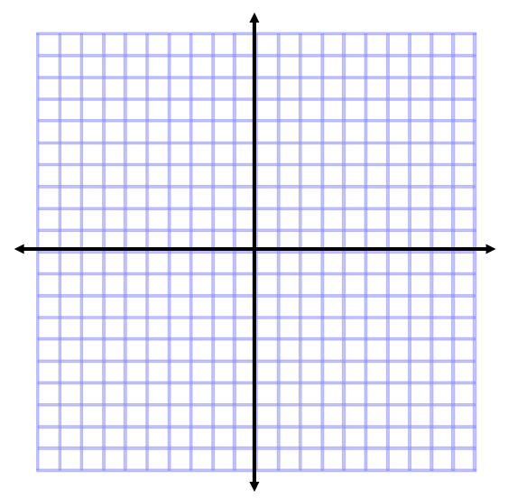

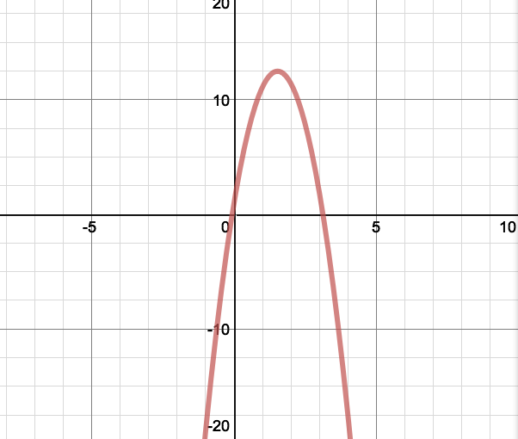y = -4.9x2 +15x + 1

1. Sketch the function
2. Determine the skier’s maximum height

12.48 m

1. After how many seconds does the skier reach his

maximum height?

1.53 s

1. State the domain and range for this context

2. A rectangular pen is to be built along the side of a barn to house chickens.

1. Find the maximum area that can be enclosed with 60 m of fencing

if the barn is one side of the enclosure*.*  ____450 m2___________

P = 2l + w A = lw

60 = 2l + w A = l(60 – 2l)

w = 60 – 2l A = -2l2 +60l (graph this functions and find its maximum)

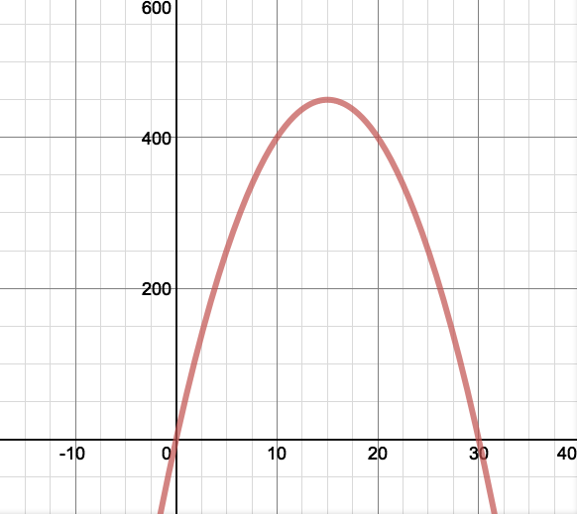

Window x [ -25, 40} y[ -100, 600]

b) What are the dimensions that gives the maximum area? __l = 15 m_____w =30m__

look at the x value of the vertex 🡪 l = 15

then substitute in l = 15 into w = 60 – 2l

w = 60 – 2(15) = 30