Estimation is a very useful skill to have when you are dealing with numbers in everyday life. When we are estimating, we:
1. first want to have a few benchmarks that we remember.
2. make numbers “friendly” so that we can relate them to the benchmarks
3. be able to scale up or down our estimations by powers of ten (ie multiply or divide by 10, 100, 1000 …)

Benchmark calculations:
- Dividing by 2 – (10/2 = 5, 9/2 =4.5, 8/2 = 4…)
- Dividing by 3 – (10/3 = 3.33)
- Dividing by 4 – (10/4 = 2.5)
- Dividing by 5 – (10/5 = 2)

- Multiplying/Dividing by 10 – move decimal point over one place

- Know your multiples of 1, 2, 3, 4, 5, 6, 7, 8, 9, 10, 11, 12

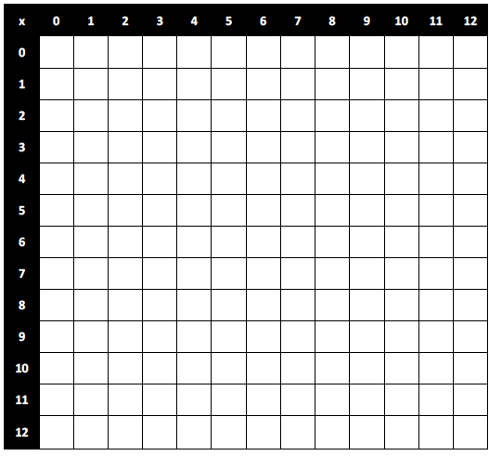
Making friendly numbers
Once we have some benchmark calculations, we want to make our numbers friendly to match some of our benchmarks.

Eg. 1080/52 268/29

530/11 1380/4.5

36 x 21 98 x 30

Mental Math
We are not always going to be able to do calculations with a calculator however; we can make some calculations easier with some tricks.

Eg. 27 x 13 720 x 150

