Pre– Calculus 11 Ch 1: ***Sequences and Series*** Name:__________________

Lesson Notes 1.4: **Geometic Series.**

Objectives:

• deriving a rule for determining the sum of *n* terms of a geometric series

• determining *t***1**, *r*, *n*, or *S****n***involving a geometric sequence

• solving a problem that involves a geometric series

• identifying any assumptions made when identifying a geometric series

A **geometric series** is the expression for the sum of the terms of a geometric sequence, like the following example:

**3** + **6** + **12** + **24** + **48** + **96** + **192** + **384** + **768** + **1536** + **3072**.

One way to calculate the sum of the series is to use a ***formula***. To develop a formula for the sum of a series, List the original series.

S***11*** = 3 + 6 + 12 + 24 + 48 + 96 + 192 + 384 + 768 + 1536 + 3072

Multiply each term in the series by the common ratio, ***r*** = ***2***.

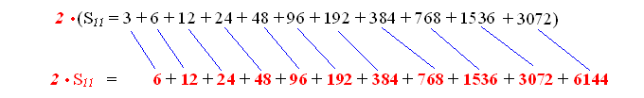



S***11*** = 3 + 6 + 12 + 24 + 48 + 96 + 192 + 384 + 768 + 1536 + 3072 .



You can use the above method to derive a general formula for the sum of a geometric series.

The general geometric series may be represented by the following series.







Multiply every term in the series by the common ratio, *r*.



Subtract the two equations.

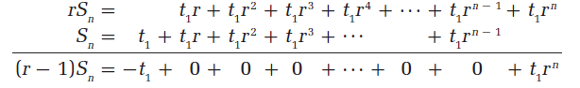



Isolate *S****n***by dividing by *r* – 1.



|  |
| --- |
| The *sum* of a geometric series is can be determined using the formula    where *t***1** is the first term of the series  *n* is the number of terms  *r* is the common ratio  *S****n***is the sum of the first *n* terms. |

Example 1) Determine the sum of the first 10 terms of each geometric series.

1. 4 + 12 + 36 + **. . .**



1. *t***1** = 5, *r* = 



Example 2) Determine the sum of each geometric series.







Example 3)The Western Scrabble™ Network is an organization whose goal is to promote the game of Scrabble™. It offers Internet tournaments throughout the year that WSN members participate in. The format of these tournaments is such that the losers of each round are eliminated from the next round. The winners continue to play until a final match determines the champion. If there are 256 entries in an Internet Scrabble™ tournament, what is the total number of matches that will be played in the tournament?

