**1.2: Rotational Symmetry**



**Rotational Symmetry** is when we rotate an image by around some point.

Examples:

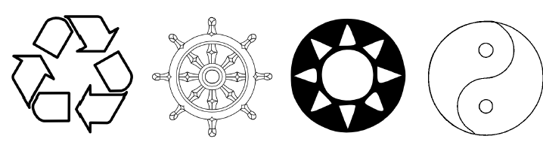



* Locate the center of rotation in each of the diagrams above.



Ex. 1: a) Which letters of the alphabet have rotational symmetry?



b) Which letters have line symmetry?



c) Which letters have both?



<http://www.bbc.co.uk/bitesize/ks3/maths/shape_space/symmetry/revision/4/>

The **order of rotation** is the number of rotations it takes to get a completed image.

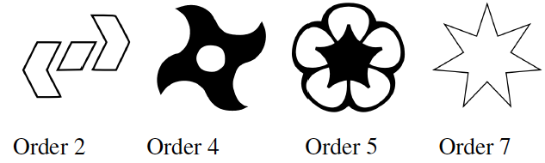

The **angle of rotation** is the fraction of 360° that the object rotates to be completed.

Complete the table for the order given.

|  |  |  |  |  |  |  |  |
| --- | --- | --- | --- | --- | --- | --- | --- |
| **ORDER** | 2 | 3 | 4 | 5 | 6 | 7 | 8 |
| **Angle of Rotation** |  |  |  |  |  |  |  |

Note: Order 7 gives an awkward angle and is not a “nice” symmetrical number.

**Translations** are when a basic element is recreated by using a repeated shift.

Example: Olympic Rings

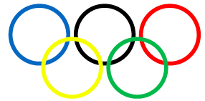

**Tessellations** are an example of using translation/reflection/rotation in art!

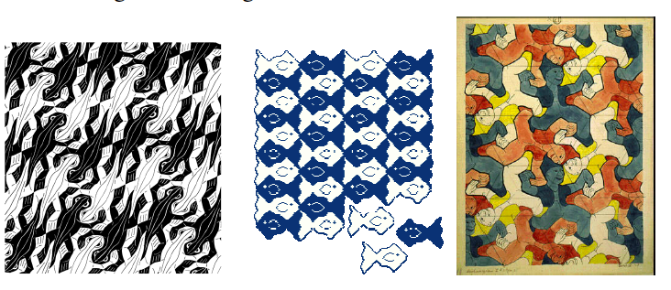

**PRACTICE:** Pg. 21 – 22 #4, 5, 6, 7, 10, 11

<http://www.mathsisfun.com/geometry/symmetry-rotational.html>

