**1.1: Line Symmetry**

**Line symmetry** is when you can reflect or fold across a line and have an identical image on either side of the line.

Examples: HSBC Logo Biohazard symbol

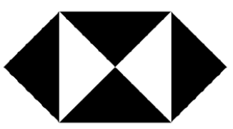 



Many symbols have more than one line of symmetry.



Ex.1: Draw in all of the different lines of symmetry for the objects above and below.



 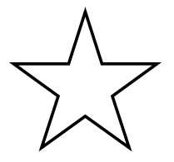



Coordinates and Line Symmetry (across axis)



* Label the vertices (corners) of the diagram and reflect across the y axis.

Can you make a general rule for this reflection?

* Reflect across the x axis and make a rule.

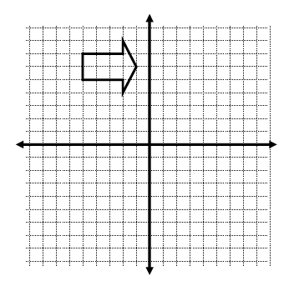



Finding a line of symmetry

An image and reflection has a line of symmetry that is the perpendicular bisector of matching points

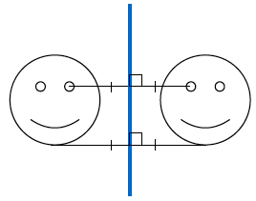

Ex. 2: Draw the reflection line for the following images:

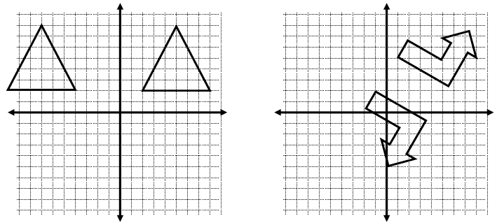



Reflections across y = x and y = -x

* Draw the line y = x, label the coordinates of the vertices (points) and find its reflected image.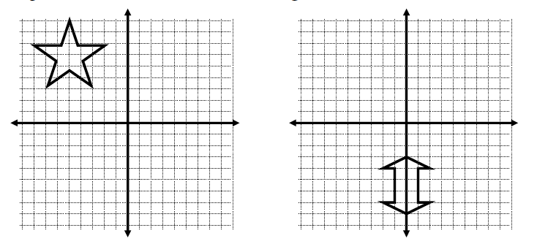



What generalizations can you make about a reflection across y = x?



* Draw the line y = -x, label the coordinates of the vertices (points) and find its reflected image.



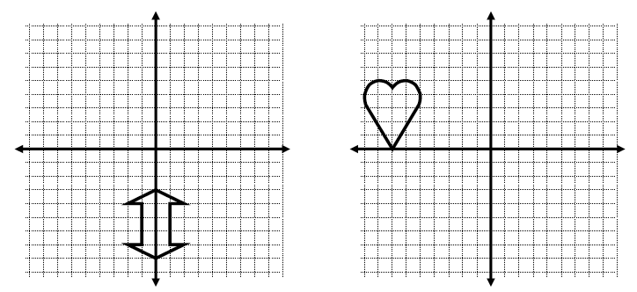



What generalizations can you make about a reflection across y = -x?



**PRACTICE:** Line Symmetry Worksheet

<http://www.mathsisfun.com/geometry/symmetry-artist.html>