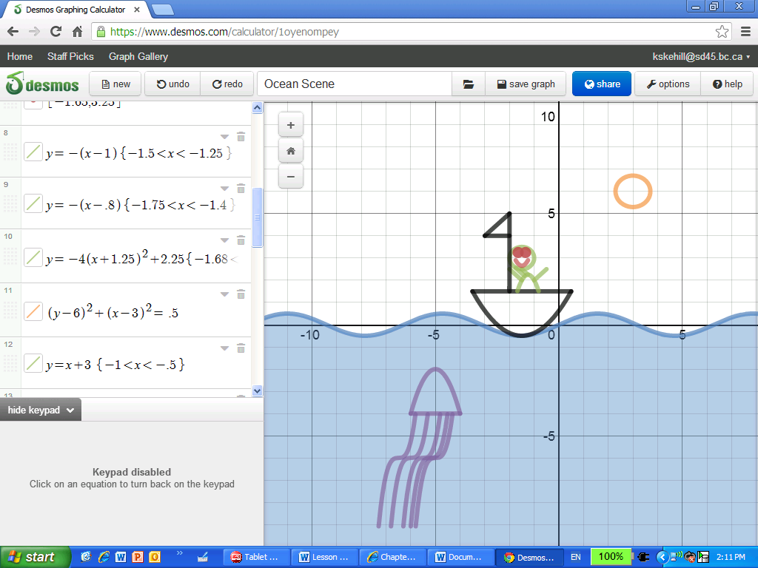

Legend:

Bottom of the boat

**y = (x+ )2+ , D:{x|-3.5 < x < .5}**

Body of Jelly Fish

**y = -2 (x+ 5 )2 – 2 , D:{x|6 < x < - 4}**

Three more quadratic equations required!