**Math 9 Chapter 8.4 Checkpoint Name ____________________**



**DAY ___ PERIOD ____**

**Solving Equations 🡪 ax = b + cx**



____ **1.**  Solve 4x = 3 + 2x?



A) x = 1.5 B) x = 2 C) x = 3 D) x = 6

Solve for the variable. Show all steps. Round to the nearest hundredth if necessary.



**2.**  - 7x + 21 = - 4x **3.** 2n – 1.125 = 0.5n **4.** 



**Solving Equations 🡪 ax + b = cx + d**



____ **5.**  What is the solution of 7t – 5 = 3t + 11?



A) - $\frac{3}{2}$ B) $\frac{3}{2}$ C) $\frac{8}{5}$ D) $4$



Solve for the variable. Show all steps. Reduce any fractions to lowest terms.

**6.**  6x + 7 = 8x – 13 **7.**  **8. $28 – 2.2y = 11.6y + 262.6$**



**Solving Equations 🡪 a(bx + c) = d(ex + f)**



Show all steps. Reduce any fractions to lowest terms. Solve for the variable.



**9.**  -8(4 + 9x) = 7(-2 – 11x) **10.** 2(a – 1) = (4a + 6)



|  |  |  |  |  |  |  |
| --- | --- | --- | --- | --- | --- | --- |
| **Concept** | **Question #s** | **B** | **D** | **A** | **E** | **Area for improvement** |
| Solving Equations  - solve linear equations in the form ax = b + cx | 1 – 4 |  |  |  |  |  |
| Solving Equations  - solve linear equations in the form ax + b = cx + d | 5 – 8 |  |  |  |  |  |
| Solving Equations  - solve linear equations in the form a(bx + c) = d(ex + f) | 9 – 10 |  |  |  |  |  |

MATH 9: Chapter 8.4 Checkpoint

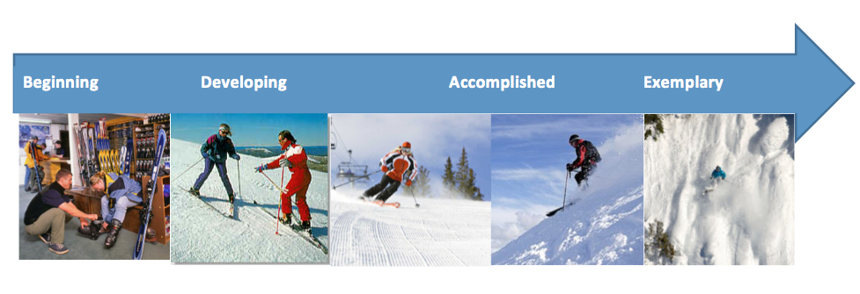

|  |  |  |  |
| --- | --- | --- | --- |
| **Beginning** | **Developing** | **Accomplished** | **Exemplary** |
| Does not demonstrate a basic understanding of concept. Substantial errors throughout. | Basic understanding of concepts. Errors and inconsistency reveal some missing understanding of the concepts. | Solid understanding of concepts. Most answers are correct with only a few errors. | Complete and in depth understanding of concepts. |