Measurement
Lesson 1.1 Referent & Estimation

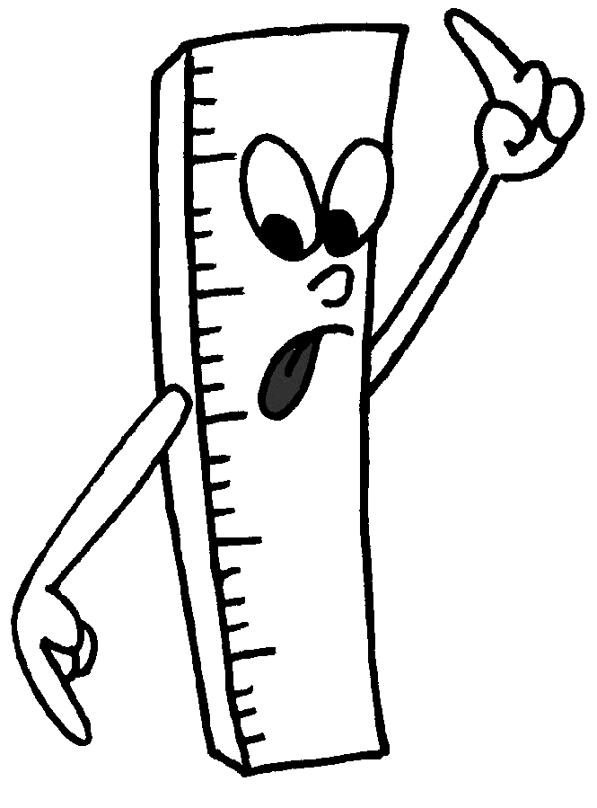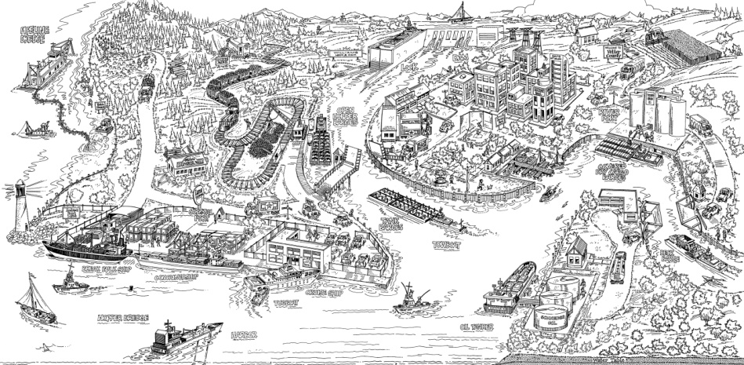

Objective: After this lesson, you will...
1. use appropriate objects/referents to estimate linear measurements
2. use referents to estimate measurements of unfamiliar objects.

Discussions:
1. We always use ruler to measure the length of an object. How is your ruler calibre? (Or similarly, what is the unit of measurement on your ruler?)

2. What are some other units of measurement for length?

3. A referent is a non-standard measuring unit, such as the width of your pinky, the diameter of a twoonie, or anything concrete. If you are to describe the length for each unit of measurement (e.g., 1 cm) using an object of your choice, what would they be?

1 mm 1 inch

1 cm 1 ft

1 m 1 yd

1 km 1 mi

Facts to know:
In Canada, we use only half of the units discussed. If we are to categorize these units, we will end up with two systems for measurements:
1. the SI Measurement – used by most of the countries in the world (including Canada)
2. the Imperial Measurement – used by only three countries in the world (who are they?)

A Table of Comparison:
 | SI Units | Imperial Units
Length | centimetre, metre, ... | inch, foot, ...
Weight | gram, kilogram, ... | ounce, pound, ...
Volume | millilitre, litre, ... | pint, gallon, ...

Questions:
1. Estimate the thickness of your Mathematics 10 textbook without measuring it.

2. By using a different measurement unit, estimate the height of the classroom door.

3. Estimate the dimension (length & width) of the whiteboard with two different units.

4. Why is it useful to know both SI and Imperial? How would it help you in the future?

Applications:
1. Some people use their expanded hand (from thumb to pinkie) for informal measurement. How big can your hand be expanded (a) in inches? (b) in centimetres?

2. Use your hand to estimate the dimension of your desk. How many “hands” do you need for the length and the width of your desk?

3. Convert your desk’s dimensions from hands to centimetres. Check for accuracy by actually measuring your desk’s dimensions. How accurate is your estimation in percentage?

4. Convert your desk’s dimensions again. This time, from hands to inches. Does your measurement in inches result in similar accuracy as in centimetres?

Practices & Extensions:
1. Read p.8, 9, 11, 13, 14 on SI Measurement and work on p.15 # 1ab, 2, 6, 8
2. Read p.22, 23 on Imperial Measurement and work on p.31 # 5, 19
3. Google SI Measurement and Imperial Measurement respectively to learn more about them

Measurement
Lesson 1.2 International System (SI) of Units

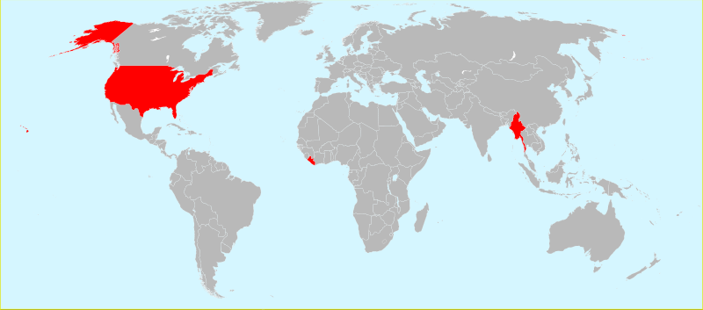

Objective: After this lesson, you will...
1. solve problems using instruments such as rulers, callipers or tape measures
2. convert units within the SI system
3. solve problems using ratios and proportions

Discussions:
1. In Canada, and for the most part of the world (see the above map), people use metre in the SI system to measure length. Can you name a few more SI units related to metre?

2. Of the above mentioned, which one gives us the longest length? the shortest length?

3. Estimate the thickness of a page in your Mathematics 10 textbook.

4. How do you convert the above measurement to a different SI unit, such as centimetre?

Facts to know:
Many measuring instruments give measurements to the nearest millimetre (1 mm), such as your rulers, the teacher’s metre sticks, and the measuring tapes in your science class. For higher precision and accuracy, we can use a caliper. A caliper can measure to the nearest tenth of a millimetre, or 0.1 mm. Follow the steps below to read a caliper.

1. Read the value on the fixed (upper) scale. The pointer should either be located at the zero or to the left of the zero on the moving (lower) scale.

2. If the value is located to the left of the zero, identify the line on the moving scale that aligns with a line on the fixed scale. Read the value on the moving scale.

For better illustration, the following examples used an enlarged 50 mm caliper.

1. The first caliper has a reading of 15.0 mm.
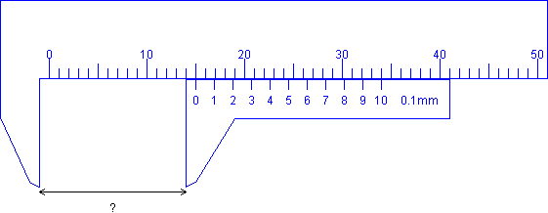

2. The second caliper has a reading of 8.6 mm.
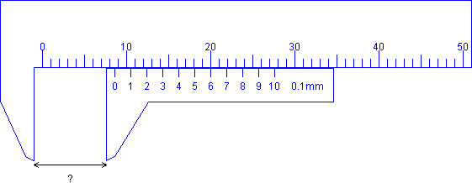

3. The third caliper has a reading of 22.3 mm.
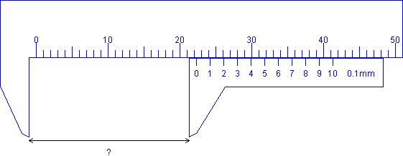
Questions:
1. Give the reading on the following calipers.
a)
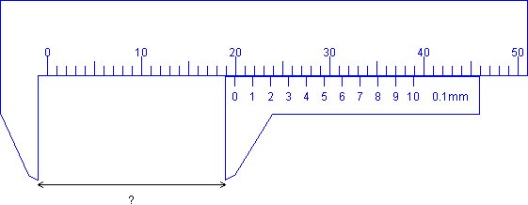

b)
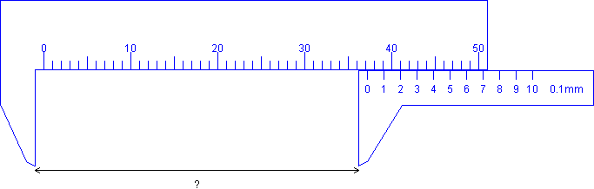

For more practices on using the caliper, go to the following website:
http://www.phys.hawaii.edu/~teb/java/ntnujava/ruler/vernier.html

Facts to know:
Units such as millimetre (mm), centimetre (cm), and metre (m) are commonly used for relatively small measurements. For large measurement, we need other units such as kilometre (km). The following is a list of measurement for length in the SI system.

 |  |  | metre = 1 m |  |  |  | metre = 1 m
 | 1dam | deca-metre | 10¹ = 10 m |  | 1dm | deci-metre | 10⁻¹ = 0.1 m
 | 1hm | hecto-metre | 10² = 100 m |  | 1cm | centi-metre | 10⁻² = 0.01 m
 | 1km | kilo-metre | 10³ = 1000 m |  | 1mm | milli-metre | 10⁻³ = 0.001 m
 | 1Mm | mega-metre | 10⁶ = 1000000 m |  | 1μm | micro-metre | 10⁻⁶ = 0.000001 m
 | 1Gm | giga-metre | 10⁹ = 1000000000 m |  | 1nm | nano-metre | 10⁻⁹ = 0.000000001 m

For mass and weight, 1 tonne (t) = 1000 kilogram (kg) = 1000000 gram (g)
1 kilogram (kg) = 1000 gram (g)

For area, 1 hectare (ha) = 10000 square metre (m²)
For volume, 1 litre (L) = 1000 cubic centimetre (cm³)

Questions:
1. The Earth is nearly spherical and has an average radius of 6371 km. Convert this measurement to metre using unit analysis.

2. The approximate thickness of a piece of paper is 0.1 mm. Convert this measurement to metre using proportion.

3. There are approximately 1.3x10⁹ GL of salt water on Earth. Convert this volume to mL.

4. Given 1 L has 1000 cm³, determine the volume of salt water on the Earth in cm³.

Applications:
1. A particular map has a reduction ratio of 1:2000. If the distance between two points on the map is 8.5 cm, how far in reality are they apart? Express the distance in kilometres.

2. Assume the goldfish in this fish tank has an approximated height of 16 mm. Find the water height in the fish tank.
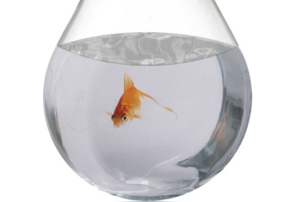

3. Some critics argue that there was as much as 16000 kilo-litres of oil leaked into the Gulf of Mexico per day (16000 kL/day) in the summer of 2010. Using a 2-litre Cola bottle as a referent, how many bottle of oil had leaked into the Gulf in each second?

Practices & Extensions:
1. Read p.10, 12–14 on SI Measurement & work on p.16 # 3, 5, 7, 9–12, 16, 19
2. Search for Metric Conversions on YouTube to see how others convert units

Measurement
Lesson 1.3: Imperial Measurement

Objective: After this lesson, you will...
1. solve problems using instruments such as rulers, callipers or tape measures
2. convert units within the imperial system and using referents

Facts to know:
Similar to a metric caliper, an imperial caliper can accurately measure the length of different objects. For a review of reading a caliper in both Imperial and Metric System, refer to the site here: http://www.swtc.edu:8082/mscenter/mthsci/genmath/04meas/pcaliper.pps

Questions:
1. Give the reading on the following 10:100 (decimal) imperial caliper.
a)
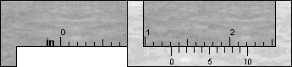
b)
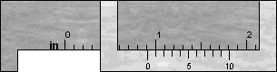

2. Give the reading on the following 8:64 (fractional) imperial caliper.
a)
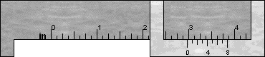
b)
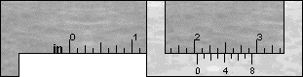

To get yourselves familiar with the two types of imperial caliper, try the following site: http://www.members.shaw.ca/ron.blond/Vern.APPLET/

Facts to know:
The unit “inch” is a relatively small unit for length under the imperial system. Other imperial units for length are as follow.

 | mile |  | yard |  | feet |  | inch
 | 1 mi | = | 1760 yd | = | 5280 ft | = | 63360 in
 |  |  | 1 yd | = | 3 ft | = | 36 in
 |  |  |  |  | 1 ft | = | 12 in

Note that both foot and inch can be expressed as abbreviation or symbol.
foot: ft or ‘
inch: in or “

For mass and weight, the most commonly used units under the imperial system are ounce (oz), pound (lb), and ton (t).

 | ton (t) |  | pound (lb) |  | ounce (oz)
 | 1 t | = | 2000 lb | = | 32000 oz
 |  |  | 1 lb | = | 16 oz
Questions:
1. How many inches is equivalent to 1 foot? Find a referent of your choice for a foot.

2. Ms. Skehill is 5’6’’ tall. Express this measurement in inches only.

Applications:
1. The Matchbox Corvette ZR-1 image below has an exact length as the toy car. It follows a ratio of 1:64 of the real street car. Find the actual length of the real street car in inches.

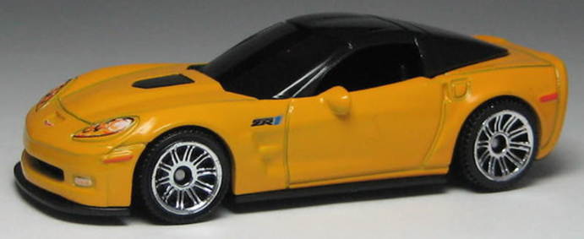

2. Many artworks, including the Mona Lisa parody by Columbia painter Fernando Botero, are proportioned according to the golden ratio (approximate 4:3 for length to width or for base to height) due to its aesthetically-pleased viewing. If the width of the parody is 10 inches wide, determine (a) its height in inches and (b) its area in square feet.

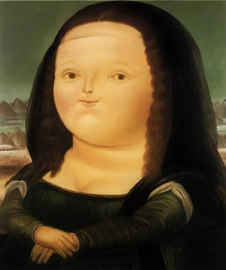

Practices & Extensions:
1. Read p.24–28 on Imperial Measurement & work on p.29 # 1ab, 2, 3ab, 5–11
2. Google Golden Ratio and learn more about it

Measurement
Lesson 1.4 Conversion between SI & Imperial Measurement
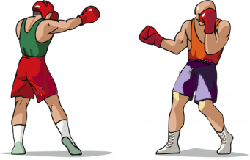
Metric (SI)
Imperial
Objective: After this lesson, you will...
1. convert a measurement between metric (SI) and imperial systems

Discussions:
1. Karen is 164 cm tall while Jason is 5’10’’. Who do you think is taller?

2. Which of the following is faster: 100 mph or 100 km/h? Explain your choice.

Facts to know:
In reality, we compare measurements of different system all the time. Being able to convert units between metric and imperial is important for us to make smarter decisions.

Length: | 1 mile ~ 1.609 km | Mass: | 1 pound ~ 0.454 kg | Volume: | 1 gallon ~ 3.785 L
 | 1 yard ~ 0.9144 m | (Weight) | 1 ounce ~ 28.35 g
 | 1 foot ~ 0.3048 m
 | 1 inch ~ 2.54 cm

Questions:
1. Convert the following as stated.
a) 10 L into gallon

b) 5’10’’ into centimetre

2. Steve Nash is 1.91 m tall. State his approximate height in feet and inches.

Applications:
1. A barrel of crude oil was averaging $75 in the market during August 2010. If a barrel has 42 gallons, how much was it per litre?

2. A tourist from the States driving along the Trans-Canada Highway (Hwy 1) mis-read the 100 km/hr speed limit as 100 mph, resulting in a police pursuit.
By how much, in km/hr, is she over the speed limit?

3. A Hollister polo shirt is selling for $24.80 USD at Bellis Fair. The same polo shirt is selling for $29.80 CDN at Pacific Centre. If the exchange rate for USD to CDN is 1:1.041, which one is better buy?

Practices & Extensions:
- Read p.37–41 on Converting Between SI and Imperial Systems
- Do p.42 # 1–8, 10, 16

